Rabbi form Jerusalem speaking on Zionist Independence Day

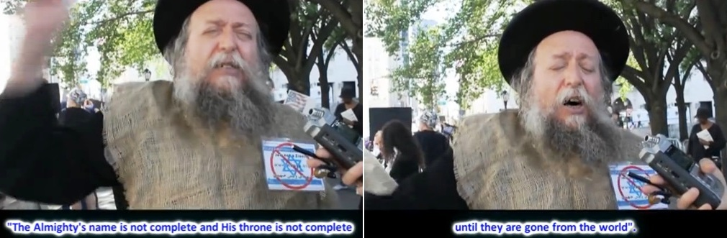

https://www.youtube.com/watch?v=6J1tRCvaME8

Gepubliceerd op 28 dec. 2015

Rabbi Chaim Yosef Gotlieb from Jerusalem speaking at an anti-Zionist rally on the side line of the Solute To Israel parade on fifth Avenue in Manhattan, New York City, in 2013. The Rabbi is speaking in Yiddish, with English subtitles.

