PROJECT 2010-2011:

“Habla ps”
-Biblioteca –

Persons in charge of “habla ps” project:
- Evia Corina Carrasco De Ucañan
- Emily Buescher
- Wouter Verschelden

In favor of:
- Aldea Infantil “San Antonio”, Cajamarca (Peru)

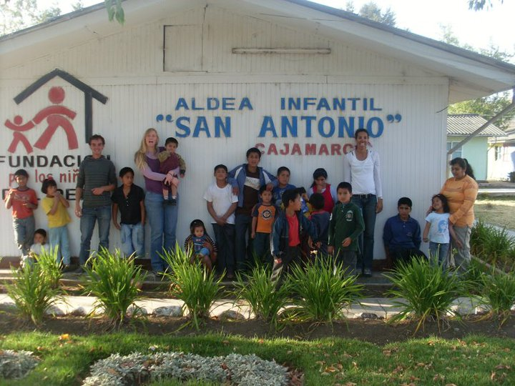

Some of our 35 children and the responsables for the library Project.

Intoduction of the Project:

Problems encountered right now in the library
- The books are not listed, classified nor registered.
- The current location where all the books are being stored is not a place you would like to spend much time in, the atmosphere is not inviting nor does it encourage children to want to pick up a book and read, and it is not equipped with multimedia devices.
- A lack of reading habit among the children.
- Little comprehension of what they read.

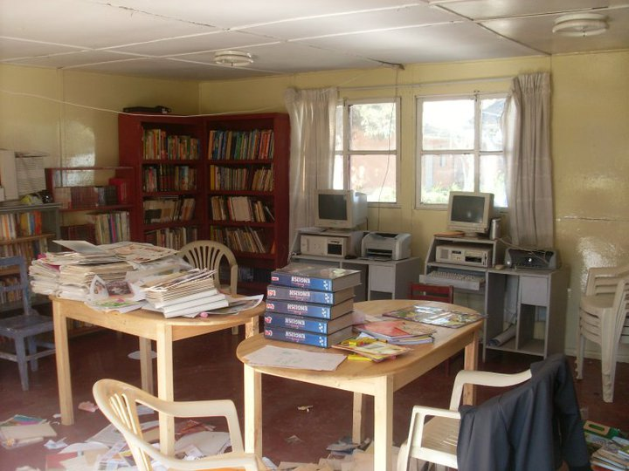

Measure to solve these problems
- Listing, classifying and registering of books
- Checking which books are usable and in good condition and afterwards classifying all.
- Inventorying all the books.
- Classifying all books into categories (fiction, non-fiction, children books, text-books (English, Spanish, Math, Economics, History, Geography, IT, Sciences, etc.))
- Codifying all the books
- Creating a library checkout system, in which every child will have his/her own library card and can checkout books for a period of time. Each library card will be marked with which book has been checked out, the condition of the book and the date in which the book must be returned.

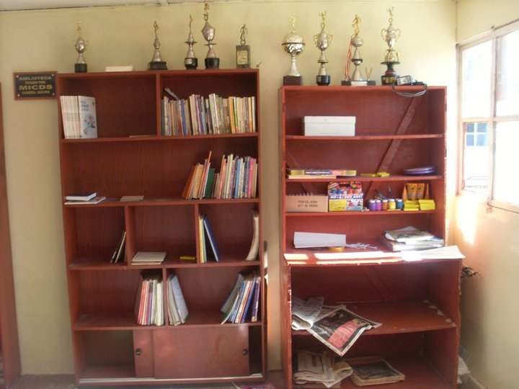

- Refurnishing and painting the library so that it becomes a place that invites and encourages the children to want to be there.
- Painting it cheerful and bright colors so it will become an attractive place for the kids.
- Buying and/or installing new or used furniture (tables, chairs, reading lamps, cushions to put on the floor) for increased comfort
- Divide the library in different reading corners depending on the book category
- Install a modern computer for different applications (registration of all books, controlling which books are on loan to whom and all other useful multimedia applications)
- After having checked all books, we will make up a list of missing books, which are really essential to have in the library, and hopefully can purchase these.
- Install a decent TV and DVD set so the children can watch educational videos.

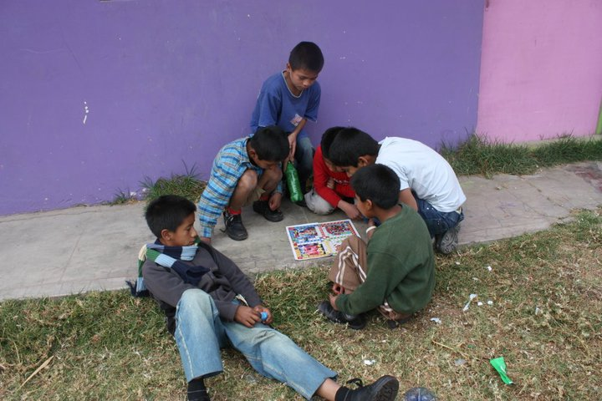

- Motivate the children to read by organizing different activities
- Theater festival: The children have to form groups of (2 to 4 persons) with which they have to perform a play, based on a book they’ve read together. The 2 best groups get a reward.
- Reading Workshop: During fixed hours individual children will get help and tips from the supervisor in the library on how to read and comprehend in a fast and effective way
- I’ve read the most: A reading contest to see who has read the most books in a week. The winner is the person who has the most book resumes in his own words and gets a reward.

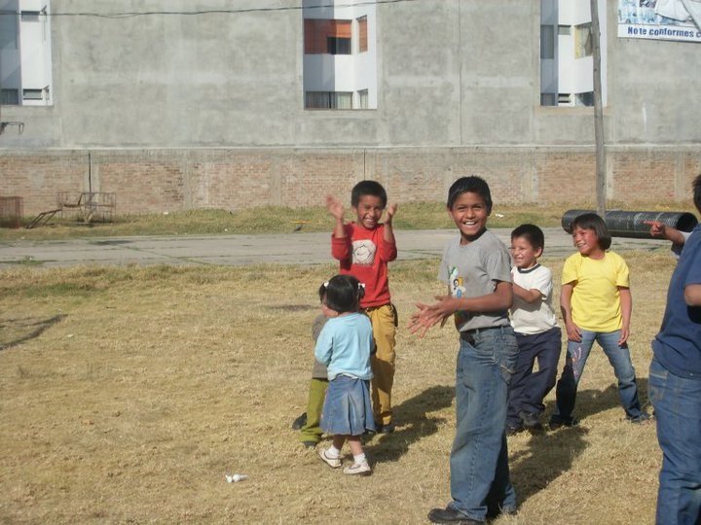
- Helping the children to improve their reading comprehension skills by different activities
- Hold an interpretation contest in which the children first can pick a book of their interest, read it, analyze it, understand it, describe it, make a report about it and afterwards make a drawing of the part that impacted them the most.
- Pre- and post-reading activities (anticipate, foretell, ask questions about the title and further on while they are reading, interfere, ask what they’ve just read when they return a book)
- Making it clear that they can ask questions when they don’t understand what they are reading
- Respect taste and preferences

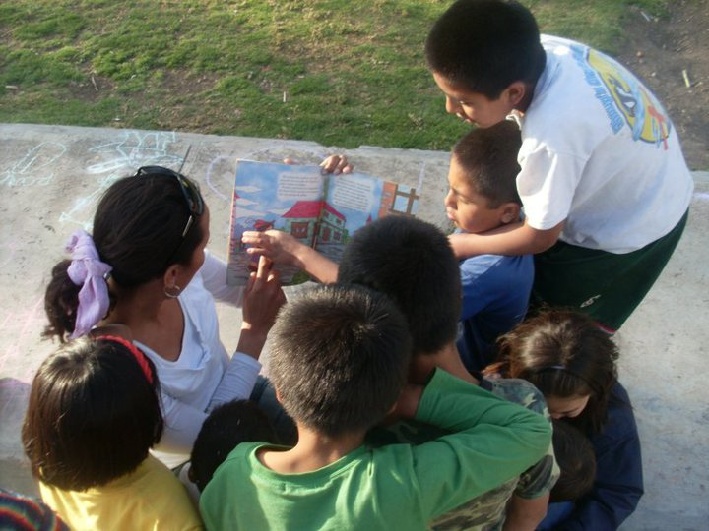

“Habla ps” is a term youngsters frequently use and is easy to remember

Target public: Children of Aldea San Antonio
- Primary target: children between 8 and 17years old
- Secondary target: all the children of the Aldea

