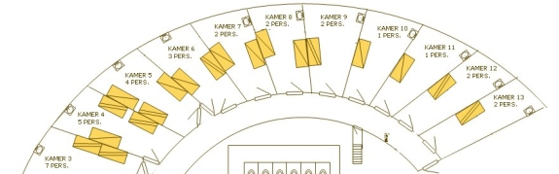

**Kamer 4**: Siham, Khadija, Kathy

**Kamer 5**: Imane, Nisrine, Ghizlane

**Kamer 6**: Abdellah, El Madhi, Yassine

**Kamer 7**: Juf Kathleen

**Kamer 8**: Amina, Yousra

**Kamer 9:** Hajar, Soraya

**Kamer 10:** niemand

**Kamer 11**: Juf Chris

**Kamer 12**: Fahri, Arsen

**Kamer 13**: Ariana, Safae