

**Donderdag 20 januari 2011**

3x **Château Paul Mas**

Coteaux de Languedoc

Clos des Mûres

Van deze wijn was er 2004, 2007 en 2009. Aan het proefpanel om de juiste analyse te maken en het juiste jaartal bij het juiste glas/fles te zetten.

Het kleur verraadde al veel. Jaargang 2004 is al merkelijk bruiner. Ook tussen de andere twee was er reeds een klein verschil merkbaar.

De meesten hadden de opdracht dus ook tot een goed einde gebracht.

Verder in dit verslag wat meer uitleg over deze wijn en de streek van herkomst.

Om de avond te vervolledigen was er ook nog het volgende wat we proefden:

**Seigneur de Lauris**

2007

AOC Côtes du Rhône

14,5%vol

Grenache 65%, Syrah 35%, rijping op eik.

Fruitig in de neus met kruidige toetsen en hints van vanille.

Krachtig, fruitig en genereus.

**Château Castera l’Estrade**

AOC Bordeaux 2006

(entre deux mers)

12,5%vol

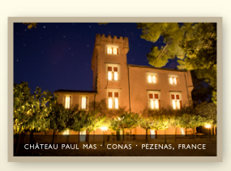

**AOC Coteaux du Languedoc**

First established in 1985, central to the Languedoc is the huge AC Coteaux de Languedoc, a nursery for future appellations. The Coteaux du Languedoc is the largest and one of the most significant viticultural regions of the Mediterranean vineyards. It is believed that this region will follow in the footsteps of Burgundy and Bordeaux with the development of a tiered system over the next several years.

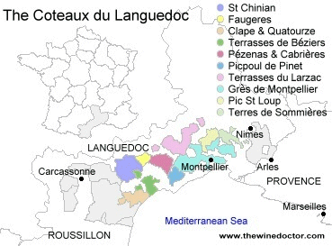

Château Paul Mas is part of the Domaines Paul Mas estates and now covers a surface of 18 hectares located on the hills between the Hérault valley and the Mediterranean coast, near the villages of Montagnac and Sète. The vineyard enjoys a South, South west exposure with the cooling influence from the sea. The « Clos des Mûres » vineyard is a specific vineyard of 11 hectares, part of the Château Paul Mas, surrounded by wild mulberry (mûres) plants. This wine has been crafted by Michel Mas and Jean Claude Mas, inheritors of the more than 100 years old winemaking tradition of their family.

**Château Paul Mas**

Coteaux de Languedoc

Clos des Mûres

**CHARACTERISTICS**   
-  **Blend** : *Syrah 83%, Grenache 12%, Mourvedre 5%.*   
-  **Soil and Vineyard** : *Gravel, fossils, clay and limestone. Full sun exposure because of the location of the vineyard on a " plateau ". Mediterranean climate with hot days and a cooling sea breeze influence thanks to the unique location of the vineyard. The Syrah vines are between 24 and 44 years old, the Grenache 45 years old.*   
-  **Average 2004 Yield** : *42 hl/ha.*   
-  **Alcohol %** : *13.8%.*   
-  **Harvest** : *Hand picking and grape selection.*   
-  **Vinification** : *Grape destemming, pre-fermentation cold maceration for 3 days, separate vinification for each varietal. Fermentation lasted 5 days for the Grenache and Syrah at a maximum temperature of 26 degree Celsius. Traditional maceration for the 2 varietals: 14 days for the Syrah and 12 days for the Grenache and Mourvedre. We only use stainless steel vats and lined new cement vats under temperature controlled conditions.*   
-  **Ageing** : *40% of the blend has done its malolactic fermentation in oak barrels. The 60% remaining has been put in oak barrels after malolactic fermentation. The wine is then aged for 9 months in French and American Seguin Moreau and François Frère oak barrels 30% new oak barrels, 35% 1 year-old oak barrels, 35% 2 year-old oak barrels.*

**TASTING NOTES**   
-  **Colour** : *intense garnet red with purple tints.*   
-  **Nose** : *Complex with cherries, roasted coffee and blackberry aromas evolving towards violette notes and spices.*   
-  **Palate** : *well balanced and smooth tannins, full bodied. Strong fruity character with a long finish evolving towards vanilla and toasted notes. Elegant and refined with long lasting finish.*

**GASTRONOMIC RECOMMENDATIONS**   
-  **Serving Temperature** : *17° celsius.*   
-  **Food and Wine** : *best served with grilled red meat, rack of lamb, pasta, game and soft cheeses.*

