Guido Gezelle (1830-1899)
Guido Pieter Theodorus Josephus Gezelle ( Bruges , May 1 1830 - there, 27 November 1899 ) was a Belgian lyrical and hate poet and translator. He was born the eldest child of Monica Devrieze (1804-1875) and Pieter Jan Gezelle (1791-1871), a Flemish gardener to Bruges . His birthplace is now the Museum of Guido . Guido was also the uncle of the famous Flemish author Stijn Streuvels (Frank Lateur).
He is known for his subtle poems about nature, his expressive language and language as a virtuoso artist. We have chosen for “The legend of farmer Naas” a poem which he has created at the end of the 19th. Century.

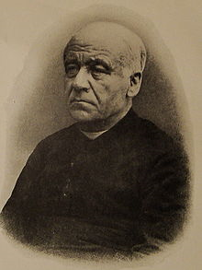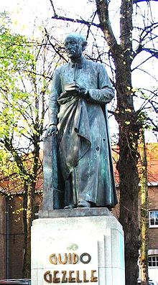

Guido Gezelle Guido at the square named after him in Bruges

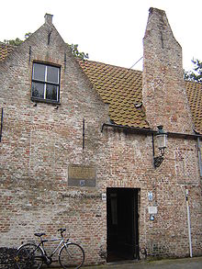

Birthplace Guido (now museum)

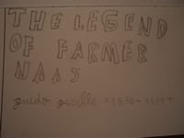
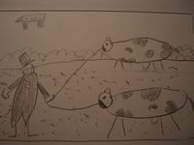
The legend of farmer Naas.
Who has heard about the story?
The story of farmer Naas.
And though he was no lionhearted,
He was no fool.

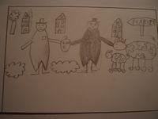
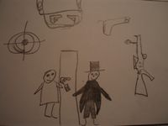
Farmer Naas went to the market
to sell two cows
for them he received 600 euro
And so he went back home

Mr. Naas although he was a farmer,
he was aware of the existing danger
He bought a gun with seven bullets
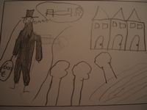
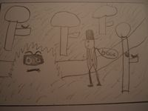
Than farmer Naas went home,
with a lot of money,
It was already late
and he was dreaming of his bed
Than he heard a noise,
Behind the bushes.
Did he saw something moving there?
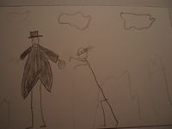
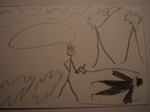
Something jumped on his back
before knowing what happened,
before he could react,
he was on the ground.

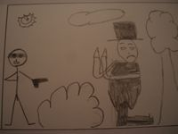
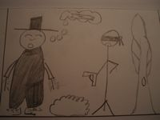
He was not aware what happened to him
lying on the ground
and than he saw the gun pointed at him
and heard a voice saying: “Your money or your live”

The voice said:” I will shoot if you will not give
me all your money
and if you move
than that will be your last time.

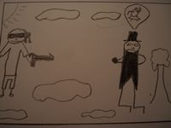
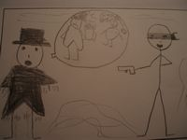
Farmer, Naas who was very catholic
prayed every day 6 times to live
a long and healthy live,
Knew that he was in a deep trouble

“What shall my wife say” he said
“ when a will return at home?”
“she shall think that a spend all the money,
again as a drinker”
“Please my friend, show some compassion,
show me that you are human.
Shoot me a bullet through my hat
So my wife will believe me

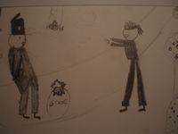
“i will tell here, when i return home
that they robbed my money,
and i had some luck,
otherwise a bullet through my hat
The thief who liked the money more
than the blood of Naas
shoots quickly a bullet through
The top of his hat.
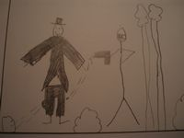
“Thank you” said Naas and he took the slip
of his jacket, “please shoot one through
my coat.
And the thief did what he was asked for.

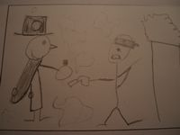
“And now one through my trousers” said Naas
than my wife will think that,
i escaped by miracle
of my death

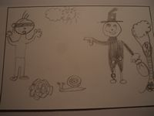
The thief shoot and says: “ Now i want the money,
and quickly because,
I have no time and bullets anymore…”
“oh” says Naas “ i do”

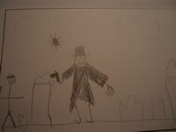
He takes his gun and says,
“Now i give you 3 seconds to run,
run far from here, otherwise
I will shoot you…”
“…i will shoot, if you come closer,
your stupid head off,
and if you want to rob Farmer Naas again,
take next time your brain with you!”
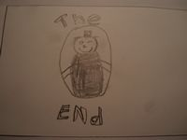
And the robber ran,
as quick as he could,
so quick that i can’t follow
as quick as i write”
Here the story takes an end
The legend of farmer Naas,
It is true, he was no lionhearted,
But he was indeed no fool.

