Oefentoets Godsdienst

.../50
Thema 8: Het Kerkelijk Jaar

Benoem de delen die aangegeven zijn door een letter of een cijfer. (.../12)

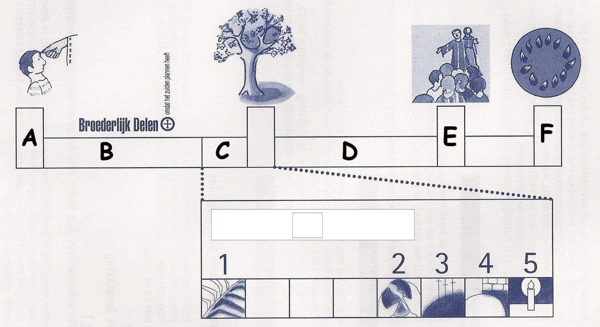

A = ....................................................
B = .................................................... = ....................................................
C = ....................................................
D = ....................................................
E = ....................................................
F = ....................................................

1 = ....................................................
2 = ....................................................
3 = ....................................................
4 = ....................................................
5 = ....................................................

Wat is de naam van deze kring? (.../1)

....................................................

Benoem de delen die aangegeven zijn door een letter. (.../6)

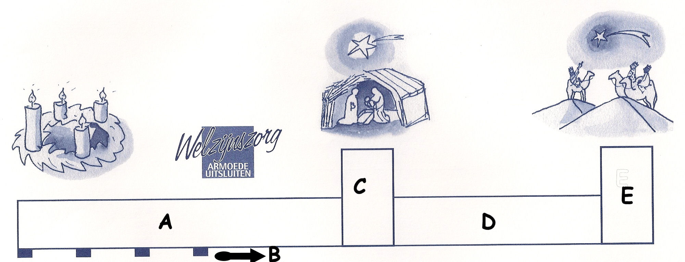

A = ....................................................
B = ....................................................
C = ....................................................
D = ....................................................
E = .................................................... = ....................................................

Wat is de naam van deze kring? (.../1)

....................................................

Hieronder zie je de 4 liturgische kleuren. Wat is hun gevoelsbetekenis? Wanneer worden deze kleuren gedragen? (.../16)

Kleur | Betekenis | Wanneer gedragen?
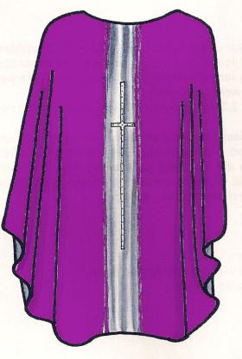 | ...................................... | - ......................................  - ......................................  - ......................................  - ......................................
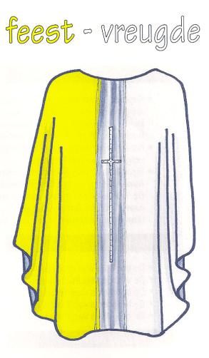 | ...................................... | - ......................................  - ......................................  - ......................................  - ......................................
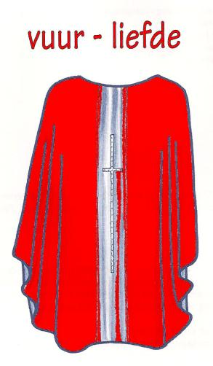 | ...................................... | - ......................................  - ......................................  - ......................................
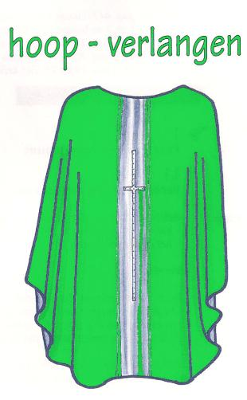 | ...................................... | - ......................................

Wat vieren we met Kerstmis? (.../1)

................................................................................................................................

Leg uit: “Feest van de Openbaring” (.../1)

................................................................................................................................

Waarmee start de vasten? (.../1)

................................................................................................................................

Wat herdenken wij tijdens de Goede Week? (.../1)

................................................................................................................................

Waarvoor staan volgende dagen symbool? (.../7)

Palmzondag: ......................................................................................................
Witte Donderdag: ......................................................................................................
Goede Vrijdag: ......................................................................................................
Stille zaterdag: ......................................................................................................
Pasen: ......................................................................................................
Hemelvaart: ......................................................................................................
Pinksteren: ......................................................................................................

Wat vieren wij op... (.../2)

2 februari: ......................................................................................................

15 augustus: ......................................................................................................

Wat vormt de start van het kerkelijk jaar? (.../1)

......................................................................................................

Veel succes!

