Reflective Journal

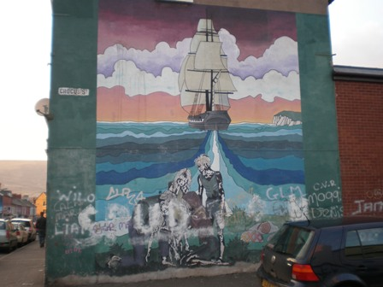
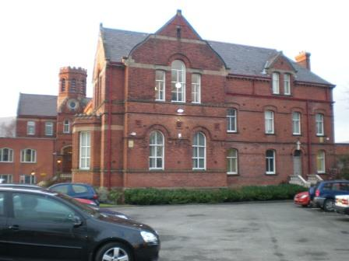

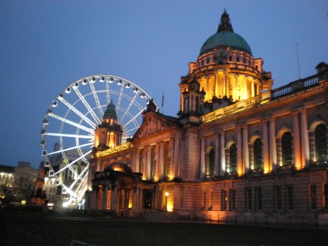
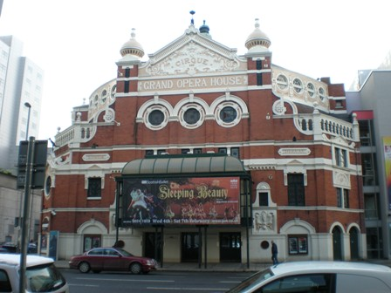

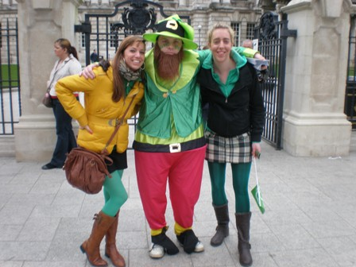

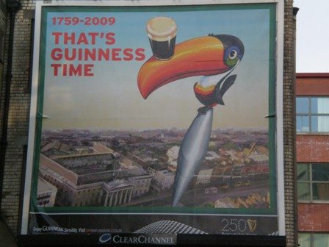


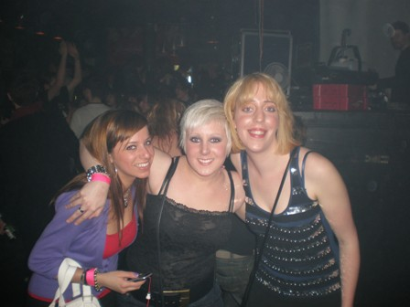
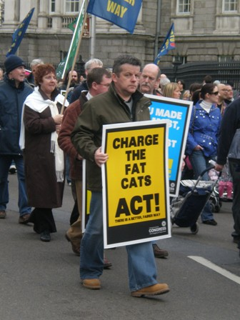

Preface

Before I came to Belfast, I had little knowledge about the country and its history. Of course I heard of the Troubles, but I never did any research on it. Before I left for Belfast, I googled Belfast to get a general view. Once here, my curiosity for Ireland in general and its history grew. By intercultural meetings, classes and school based work, I gained a better view on Ireland and the political issues.
I chose Ireland because English is one of my subjects in school. I thought this experience would help me to improve my English. But that is not the only reason. I also chose Ireland to improve my knowledge of the Irish culture. As a language teacher, it is interesting if you could show your pupils bits an pieces of the culture of the English speaking countries. Another reason is that the international experience is a good way to start my independent life. In September, hopefully, I will graduate and start working in a school as a teacher and it will also be the start of a new independent life. At home, everything, well almost everything is done for you and here you’re on your own, no more “Hotel Mummy”. Here you work together with you housemates. You have to respect each other and to adapt yourself in a way. Although I already knew my housemates for 3 years, we now know each other in a different way, on a deeper level. We became a real little family. I will miss the midnight conversations, the dinner parties, etc.

Academic Study

The academic study is an important part of the international experience, not only because of the credits we had to gain, but also to broaden your horizon.
My subjects in St. Mary’s College were: Irish Film studies, the International week, Comparative education, Reflective journal and School based work for a four week period.

Irish Film Studies: Through Irish Film Studies I learnt about the Irish myths, legends and history. Most films were about the Troubles. This provided me with extra information and insights in this matter. Bloody Sunday together with Tir na Nog were my favourites films. Bloody Sunday gave a really realistic view on what happened that day. I heard of Bloody Sunday but I never knew the exact facts. It’s an excellent movie to use in class, if you want to teach your pupils about the Irish history and the Troubles.

International week: The International week had a varied educational and social programme. The educational programme offered me opportunities to learn about other education systems, for example the Basque system and the Danish system. Back home we only learn about the French, German and Dutch system, so it was very interesting to learn more about other school systems. Also some other lectures were rather interesting. I remember the session about PE for special needs. It was actually a session about how to cope with special needs in a PE-lesson, but there were some useful tips for other subjects. Nowadays there are more and more inclusive classrooms and as a teacher it’s important you know how to handle with this matter.
I think the concept of the International week is a concept to take home. It would be nice to organise a similar week in our college at home. I think our college would benefit from it. Maybe I can even organise an international week for my pupils later. It’s good to meet people from over the world and to learn more about their culture and education.

The social activities gave me an opportunity to see more of Ireland, for example the trip to the Giant’s Causeway. The bus took the coastal road towards the Giant’s Causeway. We could enjoy the beautiful scenery of the coast. Ireland still has a lot of untouched nature and that is something we don’t really have at home. When we got to the Giant’s Causeway we could see what Finn McCool had done with our own eyes. It was a nice walk through nature.

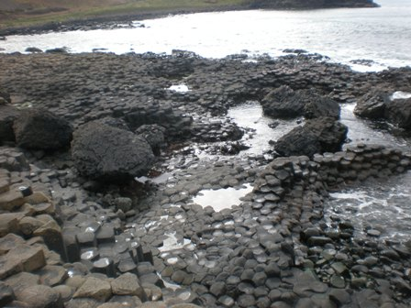
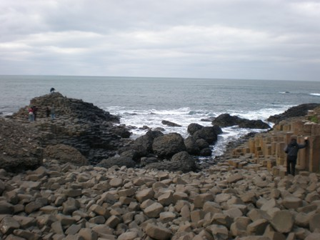

Another activity was the visit to the Bushmill distillery. Although I don’t like whiskey, it was nice to see the production process of it.
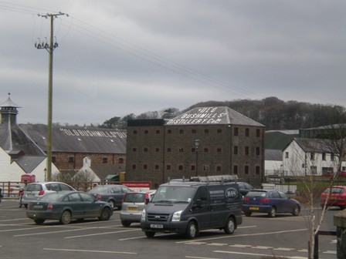

Other social activities of that week were the historical pub tour and the Eurovision contest. These were great activities to spend time with your friends and to create new friends. Students and teachers finally mingled. And not to forget, finally after so many years, Belgium won the Eurovision Contest!

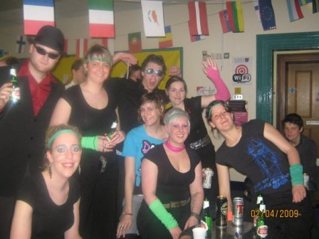

Comparative education: This course was a self-study course where we had to write an essay in the end. We had to compare three school systems. The international week provided a few sessions about the school systems of the Netherlands, Denmark, Switzerland and the Basque school system. The good thing about this course, was that in order to write the essay you had to talk to the other Erasmus students about their school system. We were educating each other in a way.

School based work: I did my school based work in St. Kieran’s Primary school in Poleglass. My class was P7C. First of all I must say that I was quite nervous to start my teaching practice in primary school. First of all my mother tongue isn’t English and I wasn’t used to the Irish accent yet, but the main cause of my fear was that I normally teach in secondary school. There is a rather big difference between teaching in primary school and teaching in secondary school. The level of the pupils is different, you have to adjust your teaching style and the behaviour of the pupils is also quite different. In secondary school the pupils all sit in pairs and face the teacher. That helps you to control the class better. In my school here, the pupils were sitting in groups and not all of them faced the teacher. This makes it difficult sometimes to keep an overview. Once I met my teacher and my pupils, most of my fears went away. I got the time to adapt myself and to integrate in the class. My mentor was really friendly and helpful. I really learnt a lot. In June I will graduate and if I’m placed in the first year of secondary school this helps me to get a better view on pupils coming from primary school.
I mainly taught the pupils Dutch and something more about Belgium. The pupils were really exited to learn a new language and they cooperated really well. This was a great motivation for me. My pupils were enjoying my lessons and I enjoyed it too. I tried to find a way to be a teacher for them but also somebody who listened to them. I think it’s important that there is mutual respect. I saw other teachers shouting at pupils for no real reason and I think that’s absolutely not a good approach. If there is a form of mutual respect and you try to solve conflicts or problems alternatively, not by shouting and immediately punishing, you’re on the way to become a respectable teacher.
In my teaching school I had the opportunity to work with a smart board and there was internet available too in the classroom. In Belgian schools smart boards are very rarely and I never used them before.
Not only teaching in my class helped to develop my teaching skills but the overall experience enriched me. The staff in the school was really friendly. They didn’t see us as students but as real members of their team. If you’re graduating in a few months it’s also important that you learn how to behave and work in a school team.

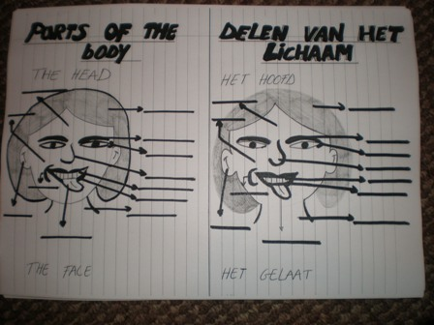
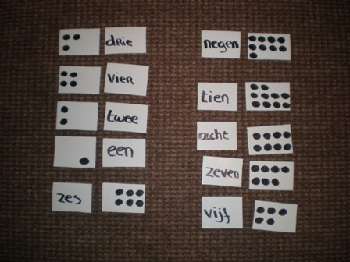

Cultural Programme

If you’re given the opportunity to study abroad, it’s only natural that you take that chance to do some travelling and visiting in the city and in the country.

Belfast

First of all I explored the city of Belfast. First of all I thought it was rather a small city, but now I realise it has so much to offer. The first days of my stay in Belfast I walked the city together with my housemates in order to see as much as possible of the city centre. Shopping was of course a distracting factor, but in the end we managed to let the shops aside and continue our cultural programme: Albert Clock, Custom house, International wall, Opera-house, some historical pubs, the Botanic Gardens, the river Lagan, the Waterfront hall ...
After a few weeks in the city, we discovered the murals in the Shankill. It is very interesting to see the differences between the protestant and the catholic murals. The protestant murals are so hostile. You can see a lot of blood and weapons on them The use of mainly blue and red is also noticeable, while the catholic murals often contain different shades of green. You could really feel the tension under the ground when you walked passed the murals in the Shankill Road. The Troubles are still in everybody’s memory and people are still living in separate areas. The owner of the B&B in our street warned us before going to the Shankill. He told us not to mention that we lived close to Falls Road because that would get us into trouble. This proves there is still tension between the two.
Another visit, worth while to mention is Cavehill. It’s not something for the faint-hearted but it’s definitely worth while to take the effort. First of all we walked to the castle and looked around it’s beautiful gardens. After that we started our trip up the mountain. Unfortunately we decided to talk the longest walk. As I said it was not for the faint-hearted and we had to stop sometimes to rest a few minutes. Once we reached the top, we were treated with a beautiful view on Belfast. We could see the entire city.

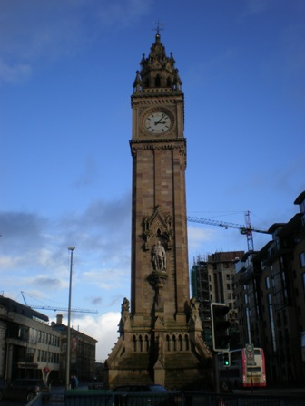
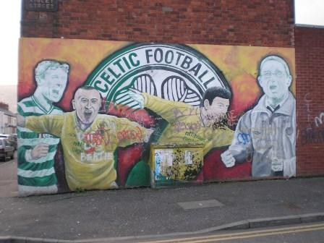


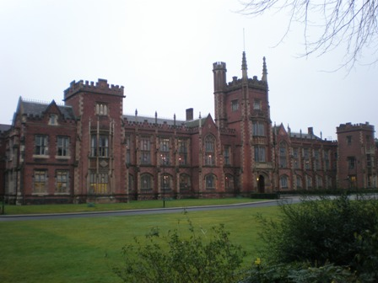
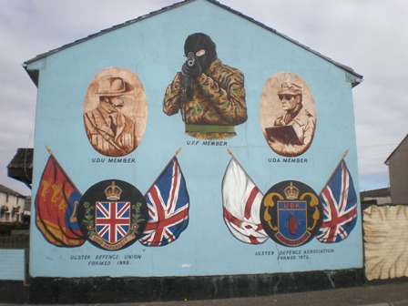

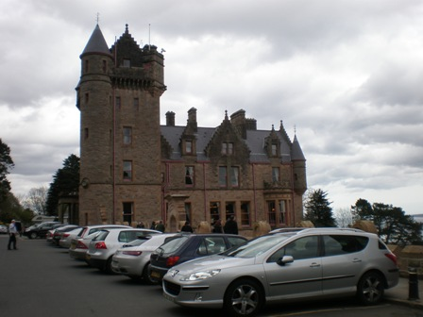


Giant’s Causeway and the Bushmill Distillery

During the International week we paid a visit to the Bushmill Distillery and the Giant’s Causeway.
Although I’m not really fond of whiskey, it was interesting to see how the whiskey was made. I still remember the penetrating smell of the unfinished product. At the end we even get the chance to taste from the selection of whiskeys. I’m not into liquor, so I just drank a coke, how ironic.
The trip to the Giant’s Causeway was a wonderful experience. The scenery, the cliffs and the views were absolutely gorgeous. I really enjoyed the walk down to the actual Causeway where you could see the odd shaped stones. The actual Causeway was nice to see, but the scenery made a much bigger impression on me. It was such a peaceful environment, where you could relax and become one with nature.

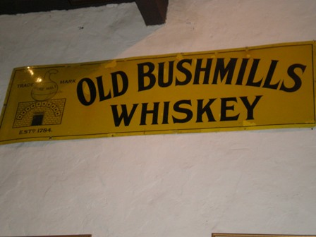
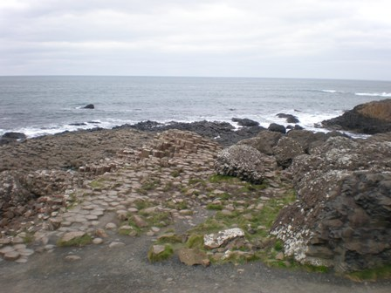

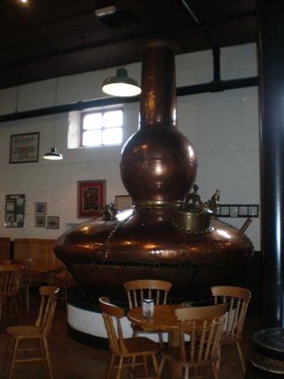

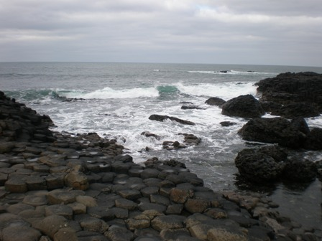

Dublin

Together with my housemates Sigrid and Anneloes we decided to go to Dublin for a day by bus. You can’t compare Dublin with Belfast. Dublin is a big city and of course one day wasn’t enough to explore the entire city. When we arrived in Dublin we suddenly were in the middle of a hugh protest march, so that kind a messed up our plans a little bit. We visited Trinity college, the famous Temple Bar Street, Dublin Castle and Christ Church Cathedral. The atmosphere in Temple Bar Street in the evening was nice. You could see and hear people playing music in the streets and even fortune tellers made their debut.
To conclude I can say that I had the impression that Dublin is a colder city. People are more distant to each other than the people in Belfast.
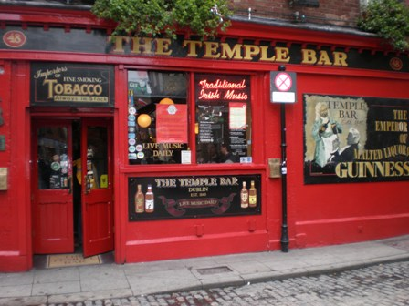
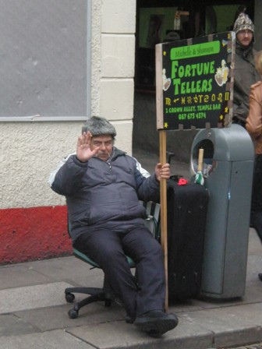
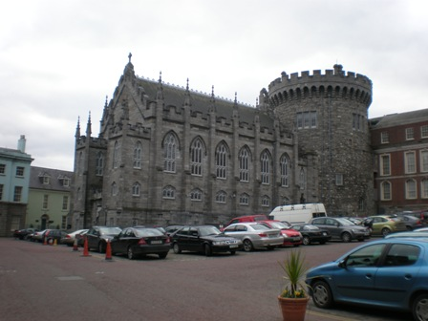
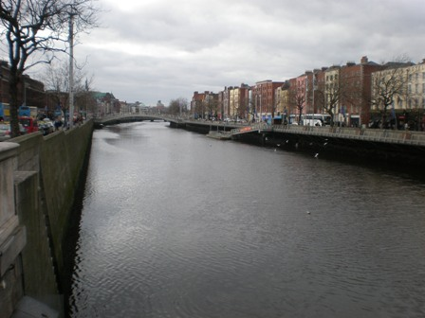
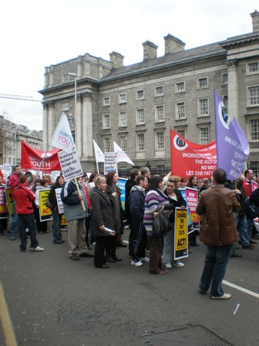
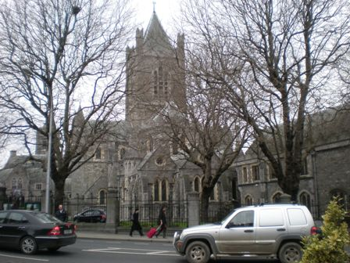

Road trip: Derry – Donegal – Sligo

During the first week of the Easter holidays, my housemate Sigrid and me used the opportunity to do some travelling.

We started our road trip with a trip to Derry. Derry is known as the walled city. We made our way into the walls and walked through the small centre towards Bishop Gate, the other end of the walls. After that, we made our way out the walls, into the catholic area. Here you could see a lot of murals and memorials referring to Bloody Sunday. The murals and the visit to the Free Derry Museum made a big impression on me. In the museum they played a track in the background recorded on Bloody Sunday. It gave me the shivers, to hear everything that happened. You could hear the start of a peaceful march and a few minutes later you hear dreadful noises, screaming and bullets killing people. The man that ran the museum told us that most of the killings happened outside the museum’s door, in that street.

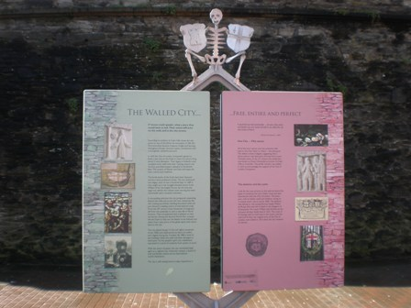
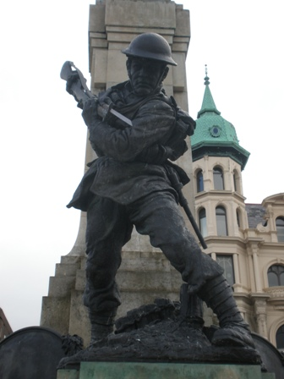
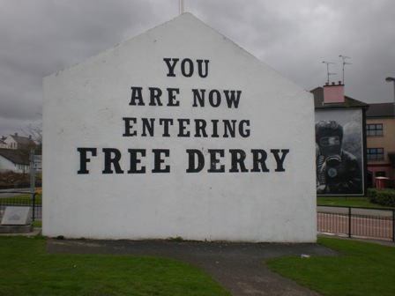
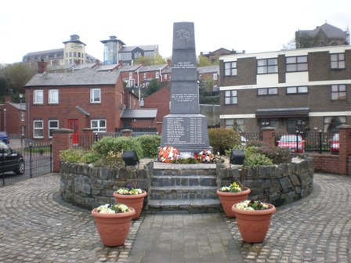
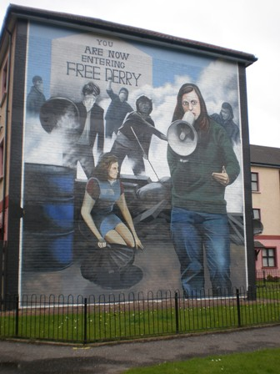
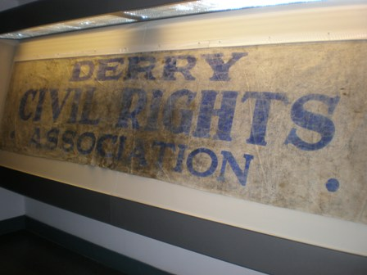

Our next stop on our way was Donegal. First we had to search for a place to sleep. When we finally find a cosy B&B with a view on the lake, we could make our way into town in order to find a nice place to grab a bite. We ended up in The Harbour.
The next day we joined Sigrid’s brother in his rented car and drove around. First thing we visited was Grainan Ailligh, a large stone-walled fort on a hilltop, commanding views over Loughs Foyle and Swilly and counties Donegal, Derry and Tyrone. From the top of the fort, you had a magnificent view.
Around noon we drove to a seaside where we had a real picnic with the ocean under our feet. Strengthened by the picnic we drove further to the Glenveagh National Park. We stopped at the remains of the Dunlewey Church of Ireland. It’s history was rather remarkable. A lady called Jane Smith Russel had built this church as a memorial for her husband James Russel. James Russel was laid to rest in a vault under the church floor.
When we arrived at the Glenveagh National Park, the weather wasn’t on our behalves, so we couldn’t do the 5 kilometres walk to the castle through the magnificent gardens. Instead we took the minibus to the castle. In the castle we did a guided tour and in the end, when the sun finally arose, we walked through the gardens.
When we arrived back in Donegal town, Sigrid and I took the last bus to Sligo.

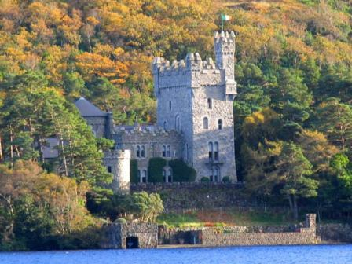
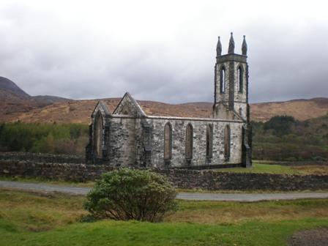

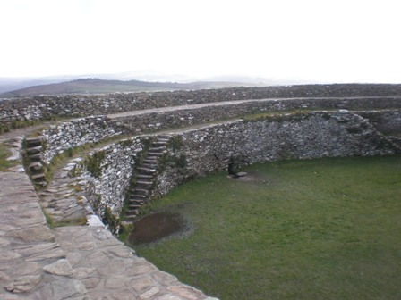

We arrived in Sligo at half past nine and we didn’t have a place to spend the night. After a long walk, we finally managed to find a suitable B&B. Well suitable? The lady of the house looked really creepy and apparently she didn’t really trust us. But we had no time to worry about that, we were exhausted and we just needed a place to sleep. The next morning we had breakfast and made our way into town. The first thing we visited was Sligo Abbey. When we bought our ticket in the visitor centre we could choose between a guided tour or a normal visit. We thought a guided tour would be a good idea. After two minutes it appeared to be a bad idea. The tour guide had some useful and interesting information for us, if only he would swallow between his words and sentences. Besides the Abbey we walked aside the river into the centre. We saw the Yeats monument and the Famine memorial monument. Around four o’clock it was time to return to Belfast. The last bus left then, so we couldn’t afford to miss it.

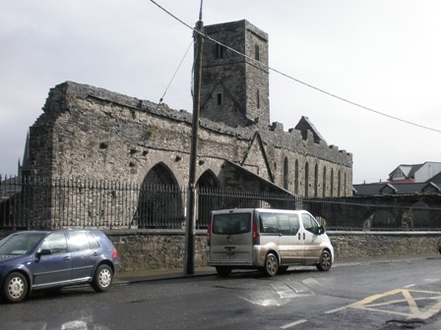
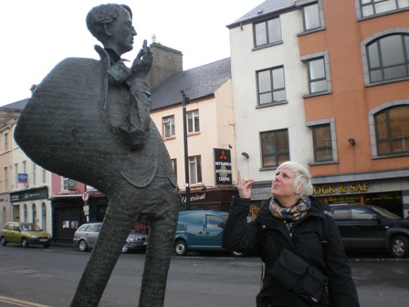

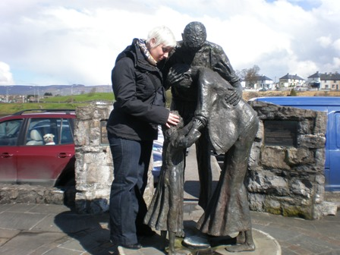
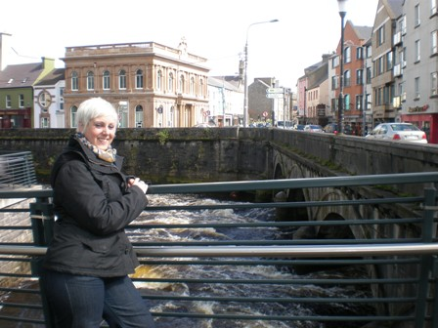

Social programme

Living as a student in Belfast, there are so many opportunities to go out. There are many good places to entertain yourself and to have a good night out. You can choose between the more traditional pubs and the trendy clubs. I would recommend them both. If you’re staying here, you should at least visit a traditional pub with traditional Irish music once. The atmosphere is just wonderful. Everybody is friendly and everybody is there for the same reason, to enjoy themselves, to dance to Irish music and of course to drink a pint or two. The opening hours though are rather different here. At first I was surprised by most pubs and clubs closing at around one o’clock. Later I fined out, this is because of the Church. Politically, the Church still has a lot to say here, and they think closing early helps to prevent youngsters from drinking too much. Well, you’ll soon find out this isn’t really a way to prevent it. I noticed most men and yes even women are already drunk at eleven o’clock. You can find few clubs that are opened till five o’clock. Those are the more big clubs of Belfast. But closing early also has its advantages. At home, we don’t leave the house before, let’s say half past eleven and we return in the early morning. The consequence is that the day after a night out, you’re a total wreck. You probably sleep till noon or even later. Here you leave early, return on a decent hour and the next day you’re still fit to enjoy the day. So, everything has its advantages, you only have to look for them.
Except for the many pubs and clubs, the college also organises some activities. I already mentioned the trips to the Giant’s Causeway and the distillery, but they also organise events like a Country Night, A Eurovision Contest and a historical pub tour. At the Country night every country had to bring some typical food or drinks that represented the country. The historical pub tour was organised during the international week. A guide brought us to 6 different pubs and told us something more about the history of it. Of course we stopped in a few to have a drink. Some pubs like the Crown have that nice authentic atmosphere. The Crown also has snugs. At first I was surprised by these separate boxes, but when you know the history behind them, it’s nice that some pubs have kept them.
I mentioned the pubs, clubs and activities organised by the college, but there’s more. I have to mention the many house parties given by the students. Often the house parties are organised round a theme, for example an 80’s party where you have to dress like they did in the 80’s, or an ABC party ( anything but cloths) and not to forget the T-party. At the T-party you had to dress up like something or someone beginning with the letter T. There was a tooth fairy, Tombraider, Tinkerbell, Tintin, mister T, twins …

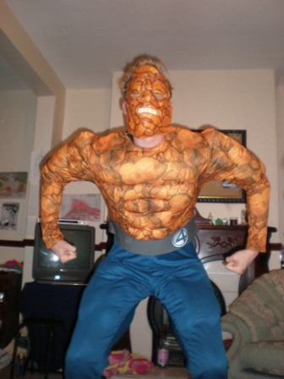
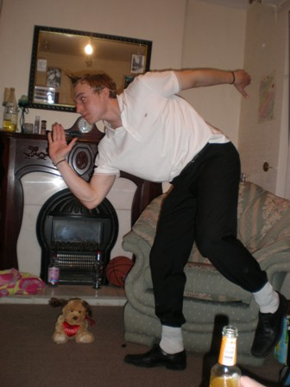
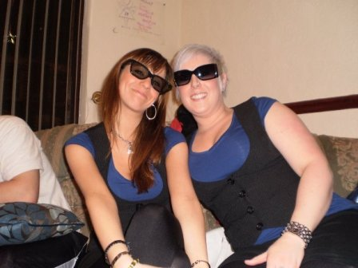
Guidelines for future students

- Leave your summer clothes at home, it’s freezing in Belfast.

- Bring your raincoat, warm clothing, umbrella and comfortable walking shoes.

- The weather changes frequently. Don’t be surprised when you experience the 4 seasons in one day. One minute there can be sunshine, the other minute it rains and after that it will snow.

- If you go out, mind the dress code of the Irish ladies: the less, the better.

- Save enough money to pay the gas bill, heating is very expensive and without it, it’s very cold.

- Take the opportunity to travel across the country. Ireland has beautiful nature and wonderful historical places.

- Visit the murals in both the Shankill and the Falls and compare them. Watch out though, don’t mention your from the Falls in the Shankill. If you do so, run!!

- Look at where you walk, always look at the pavement. There are a lot of smelly and sticky surprises.

- Don’t panic if you see dogs crossing the street on there one. They manage just fine. Dogs here know how to do it, they even walk themselves.

- Don’t walk home alone at night, it’s not always safe.

- Don’t expect your house to be luxurious. It’s all about the experience.

- Prepare to do a lot of cleaning when you arrive in your house.

- Keep a close eye to some of your housemates when they use electric appliances. Our housemate always forgot to turn things off. You don’t want to set the house on fire.

- Yes it’s true, even in the middle of winter, the ice-cream truck passes your street.

- If you don’t feel like dressing, just go to the supermarket in your pyjamas, that’s the Irish way to do it.

Overall reflection

My stay in Belfast was a wonderful experience. It really broaden my horizon, improved my English and I learnt more about the Irish life, culture and history. It’s also a good opportunity to become more independent and to learn more about your own personality. I will truly never forget my experiences, encounters and friends in Belfast, Ireland.
International experiences also have a positive influence on pupils in school. I hope I can project my experiences on my pupils and create opportunities for them to experience the same in forms of international projects.
To conclude I can say I made a whole bunch of new friends from over the whole world and learnt more about their culture.
I want to thank everybody who made this experience possible for me. It made me another person. Thank you!

