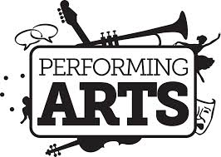
Logboek
Sturm Sarah
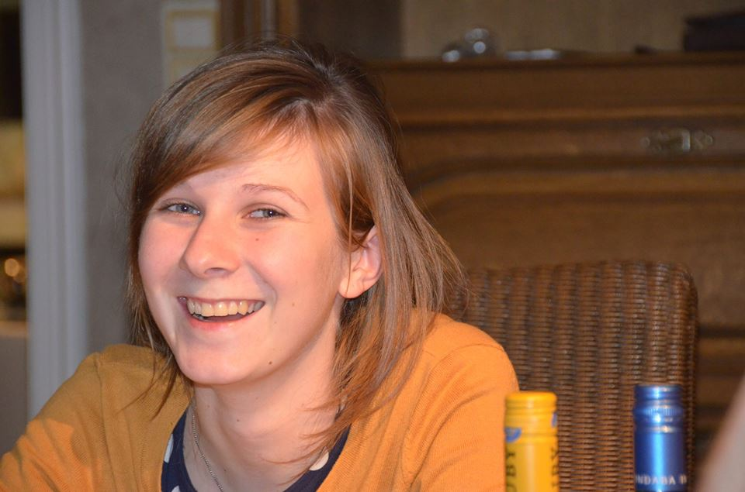

Erasmus 2014

05/02/2014
- DRAMA
Today in class we were told a scenario in which we had to freeze in de position of the scenario when the teacher said “Freeze”. We had to use facial expressions and we can also use interactions with other people. In the beginning a lot of people where laughing, but the more we did the scenarios the more serious we got. It was a nice starter, we had a lot of fun. Also was it nice to see that everybody has their own perspective on the scenario. I am becoming a teacher for pre-primary and I think this is certainly useful to use it witch the children of this age group.

The next thing we had to do was make little groups and make an accident out off 3 freeze frames. We had a few minutes to think about our scenario and practice. Afterwards we played our 3 freeze frames and looked to the other groups. After we saw another group the teacher asked use what we thought what was the scenario behind the 3 freeze frames. With only 3 freeze frames we could understand the hole scenario. It was not that hard and not so long so it was a nice first role playing with each other. I think it was also good for the more shy people because you don’t have to say something or don’t have to move a lot. If a think about it if I can use it in my class than I probably will say no. Maybe it is possible if I do it with a small group of children from the oldest ages group, 3 maybe 4 children is certainly more than enough.
- MUSIC
We started the music part off performing arts with a short kind of song. The teacher read a line off the song and we repeated. It was not a song that means something, it wasn’t even in one of our mother languages. So it where just letters that formed a sort of new words. The fist lines where easy but the closer to the end how harder it gets to repeat the lines. The teacher broke down the difficult lines and repeated them slowly so that we could ‘practice’ and that everybody could pronance the line correctly. We has a lot of fun every time when we where repaeting the song because it was a real tongtwister. When everybody knowed the song we repaeted the song with a lot of differants emotions. In the beginning it was very nice, but for me it tokes a little bit to long. This is a nice lesson to do in pre-primary whit the children of class 2 and 3, here group 1 and 2, because you are working with emotions. The oldest chilfren they can show and deal with the emotions but for the yongest one is this to hard. Also you schould make clear to the children that they can laugh (in the biggining) but that the meaning is that they have to try to say the lines with the right pronontiations. If you don’t do that than the children only are gone laugh and don’t try anymore.

Next we where seperated in small groups and we ha d to think about our experiences about the Neterlnads until now and made a rap about this. In the beginning we had a lot of trobles. We where thinking to much, the sentences where to long and to difficult. But with help from the teacher we had at the and a nice rap that we liked. In pre-primary we also make sometimes our owh song. This is only possible with theoldest children, because they must be able to hear some words rhyme with each other.

After the songs the teacher let us listening to a song on the computer and gave us the assignment to put a few pictures in the right order. So we had to listen very good to what they were saying in the song. When I learn the children from my school placement in Belgium a new song, most of the time I use this technique. For the children is this much easyer to remember the song with those visualisations.

12/02/2014
- DRAMA
Today we started the drama les with an activity in 4 groups. Each group had a few words (every group had the same words), the words on the papers where al professions. One person of the group had to act the word out without using words and the other people of the group had to guess the word. When the word was guessed another person of the group toke a little paper and act the word out. The group who finished as first al the words was the winner. It was very nice to do and certainly very nice to see how people where acting the words, we had a lot of fun in our group. I already uses this in my internship in Belgium, the children love to do this activity. When you just have a few more minutes until the bell rings, this is also a nice game to play. Just whisper a word in the ear of one child, this child is going to act this word out and the other children have to guess which word it is. The children from my internship like to act as animals the most.

After we were acting the words out we had to act a phrase out. It was something like the freeze frames activity from last week. After we acted our phrase the audience had to guess what was standing on our paper. This is maybe a little bit too difficult to use in pre-primary school, but I can always try it with the oldest children and use very easy phrases.

- MUSIC
The teachers started with a powerpoint about the course Performing Arts. We’ve get more information about what is drama, music and visual arts. They explained to use what we have to do for the logbook and for the final reflection, so how we can pass this course. Amanda continued with a powerpoint about ‘visual arts’.I recognized a lot of things/aspects from in my lessons ‘muzische voordracht’ in Belgium, it was a good refreshing.

Also we made today our groups for the performance on the 9th of april. We had to make a group whit al people from different countrey’s.I make a group with Theresa from Austria, leanna from England and Funda from The Netherlands.

At the end of the lessons Theresa let us hear the Viensesse Walt from Austria and learned us how to dance it. Also the people from The Netherlands let us hear a tipical sound from their country. They did it like “The voice of Holland”. This is a typical form that is jused in the Dutch programme. It was very nice that we were the jurry. It was much nicer than just sit and listen to the music. The typical songs from our countrey is a nice idea for a lesson in our school placement, we can also link it to clobal citizinschip.
19/02/2014
- DRAMA
Today is was an emotion day/emotion lesson. The teacher asked us to think in a pair about a everyday activity. For example washing the dishes, biking in the city, … . We had to act this everyday activity whit an emotion: angry, mad, in love, … . After this the teacher told u that she was going to count from 1 to 10. At 1 our emotion is normal, but when the number is turning higher , our emotions are becoming more intense and at the number 10 our emotion is the most intense. This activity showed us how our body language, our voice, … is changing with the intensity of our emotions. During my internship in Belgium I already played with emotions. When we are singing song we almost always sing the song with a lot of different emotions. This is a nice way to learn the children a new song. Because if the children the song always singing without emotions then it is turning into a boring activity, with the emotions the children have a lot of fun. The children are not thinking of singing the song correctly but then they are thinking about singing with the right emotion.

After this exercise we played 3 little performances. Every person got a number and an emotion. Number 1 was alone on the stage and was improvising with their own emotion. When number 2 came in where they both improvising with the emotion of number 2 etc. When everybody was on the stage the last number goes of the stage so that everybady again had to switch from emotion etc until number 1 again alone was on the stage. This was a very nice activity. In the beginning everybody was a little bit shy, but when we were playing I think everybody enjoied it very much . For pre-primary I think this is to difficult, because it are a lot of emotions and you have to remember wich emotion is coming first, second, … etc. But for primary and certainly secundairy school I think this is a very nice and succesfull activity.

- MUSIC
For the music part of today we looked at the different kinds of graphic notation. The music was represented in a lot of papers with lines. We had to listen very good to the music and put the papers with the lines in the right order. It was not that eassy,w e had to listen a few times to the music. With this activity we had to listen very good to the music, we feel the meaning from the music more and understand the feeling in the music. After this excersis we saw a few more other types of grafic notations. For example with pictures or with symbols. Working with the pictures is something that al always use during my internship to learn the children a new song. For the children is it a lot easyer to remember the sequence and yo can also play with these method. You can put the picters in an order, but there is something wrong, the children have to listen to the song and recognise with pictures aren’t in the right order. For me this was a really nice music lesson, I realy liked it and working together. I think everybody, everyone was involved, were trying to find the right sequence, was searching for movements for the pictures, … .

26/02/2014
- DRAMA
The start activity was about story tellers. There were two story tellers and two other people who were acting. As an example we started with a wedding. It was really funny because the two people who were acting they didn’t know what was coming, there just were told what they had to do at the moment itself. I think this would be a very nice and funny activity with the oldest children from pre-primary.

Today we also talked with the teachers about our performance. We told the teachers what we want to do and they gave use advise and asked use questions so that we can think about these questions in the interest of our performance. We were really excited to start working on our performance.

- MUSIC:
During the music part we played with drumstick on buckets. First played the teacher some rhythms and then we played them after. Next a few people played some rhythms and after that we played a whole round where everyone in turn something played and we played it after. This was a very nice activity and everybody enjoyed it. Playing with sticks on a bucket is not something that you do every day, so that makes it why it is so fun to do. The teacher told us that a short rhythm from four counts was the easiest to play, and for me indeed it was. Almost everyone tried to play a rhythm of four counts. This is certainly usefully in pre-primary school. Maybe not whit the whole group but as a guided activity with a smaller group of children from 5 or 6. In the beginning the children really have to experiment because otherwise the children there concentration is not good and then they are not going to listen. We were also a little bit like little children because we also wants to experiment.

05/03/2014
- HOLIDAY

12/03/2014
- DRAMA
Today we only had drama. The warming up was ‘music stop’. When the music was playing we had to move around in the room, when the music stops we had to stand still in that position. After we did this a few time we had to work together. When the music stopped we had to play a little scenario with another person. This was really funny because we didn’t know from before with who and which scenario we were going to play. It was good that every time we played with someone else.

The next story was with telling to the audience what is going on in your mind. When I’m in the audience I find it very funny to watch the little performance. You know what is going on in the mind of the actors. When one actor is telling something about another actor, that other actor don’t “hear” what the other one is saying about him, and that makes it really funny to watch. Those activities are too difficult for the children from pre-primary, but it would be really nice with the children from primary and secondary school.

After those little performances we had to act on a specific type of music. For example sad music, angry music, scary music, very happy music, … etc. We did this because we could use this for the next activity. But first we’ve got some information about the scenario from a movie/performance. After this we had to make our own scenario in groups from four. A lot off groups chose for a scary scenario. I think this is more an activity for secondary school or maybe the oldest children from primary school. But maybe it is also better if we are working with the children from the primary school that we gave them the title and the genre of the performance. This last activity was very useful for our own performance at the end of the course.

19/03/2014
- DRAMA
We start the lesson with a game in two teams. Each team member received a number. In the middle off the teams is a cube. When the teacher said “number two” than both of the numbers two had to try to grab the cube and than that team has o point. But when one of the persons have the cube than the other person can try to tap the person with the cube and than is the point for the other team. It was a nice starter of the lesson and everyone tried hard to make a point for his team. We saw a lot off techniques from each other. Sometimes it is the best to grab and then run quickly, but this is not always the best technique, sometimes it is just the best to wait until the other person is grabbing the cube and then tap that person. This is certainly a very nice game to use in pre-primary, but also in primary and secondary school, because you can make it so difficult as you want. In pre-primary we always work with themes, so if you are playing this game you can use words related to the theme.

After this game we gave speeches, but not just normal speeches, there was something wrong. For example the speaker saw in the back of the audience a beautiful lady and fall in love with her or the speaker is very tiered and falls asleep or the speaker is following by the police. We had a lot of fun to watch each other, the acting’s were really good. Also this activity is useful in (pre-) primary and secondary school. One of the children is acting and the other children have to guess what is wrong.

For the last activity from drama the group was split in two. Each group had to make a little performance and had to make that the audience was involved in de performance. The first group had a birthday party and suddenly there was an earthquake. The second group made a slave market. The audience where the people who could buy the slaves. This activity is too difficult to with children from pre-primary school, maybe also for the youngest children from primary school.

- DRAMA
Today in the music lesson each group could talk with the teacher about the music part in their performance. This was really good because than we could reflect on our thoughts. After the talk with the teacher we knew that our music part gradually should rise. Our music part is that at the end from the performance the audience is making the sounds from the Viennese Waltz with their body. So during the whole performance we already use a few time the body sounds, so then it is not unknown for the audience.

26/03/2014
- VISUAL ARTS
Today we started with a power point about performing arts. This was a very useful power point, because it was about the attributes and all the thing we need on the stage. You don’t have to make everything in detail, it takes a lot of time and it is not necessary. After the power point we were going with the whole group to the room of Harry. Here we could make all our attributes that we need for our performance. We exactly knew what we had to make. We already started to make a few thing in the previous week. Today was not only making the attributes for our performance, but it was all working together, thinking together, … and this all happened in an nice atmosphere. Harry helped us with the materials we needed and also provided some music in the background and toke care for some drinks. Nellie also had a small snack for her birthday. It was a very nice and relaxing lesson.

2/04/2014
- REHEARSEL
Today it was rehearsal day. Each group had to do their whole performance for the first time and after the performance the teachers gave every group feedback. During this day one group did their performance and another group watched. I think this rehearsal day is more important than the really performance day. The whole group is very happy with all the feedback. The teacher told us to make our wonder about the Viennese Waltz bigger and search for a good end. Also I have to pronounce better. This are the thing where we have to work on it.

9/04/2014
- PERPORMENCE DAY
Today was our last lesson from performing arts and today we had our performances. A lot of our friends where coming to watch al the performances. In the beginning I was very nervous but after a few minutes I really enjoyed the acting. I was really excited to see the performances from the other groups. After all the hard work from everybody was it today a really nice ending of the lessons performing arts.

