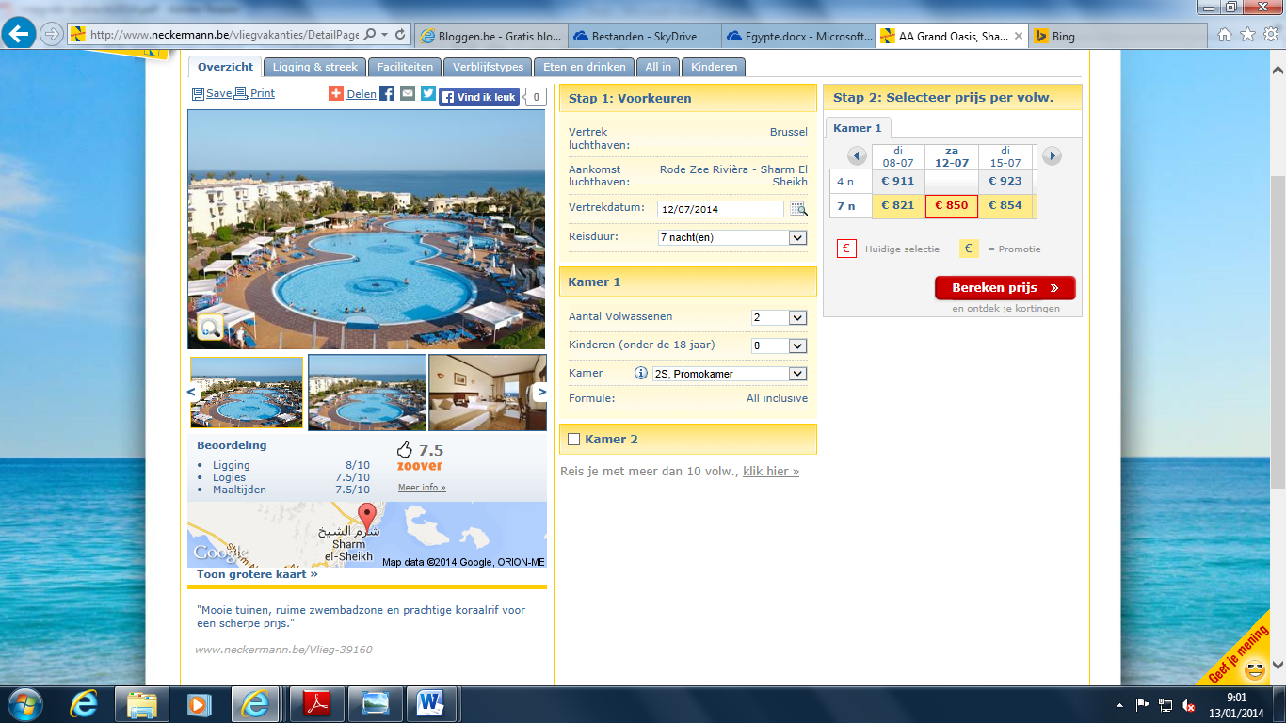
Neckermann http://www.neckermann.be/vliegvakanties/DetailPage.aspx?fh_eds=%c3%9f&fh_sort_by=pr_commercialpriority_0&fh_secondid=nvb_nvli_39160a_s14&fh_lister_pos=0&fh_location=%2f%2fpackages%2fnl_BE%2fpr_earlybookable%3e%7b0%7d%2fpk_active%3d1%2fpk_siteswitch%3e%7bnvb%7d%2fpk_country%3e%7biso_eg%7d%2fpk_region%3e%7bgeo_39981%7d%2fpr_month%3e%7b201407%7d&fh_refview=lister&rc=algemeen&a=0&em=0
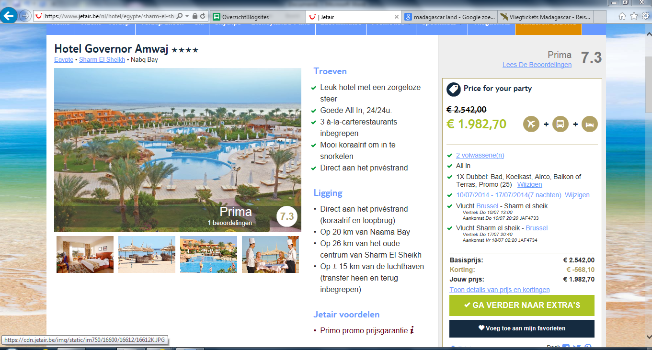
Jetair
https://www.jetair.be/nl/hotel/egypte/sharm-el-sheikh/hotel-governor-amwaj-16612
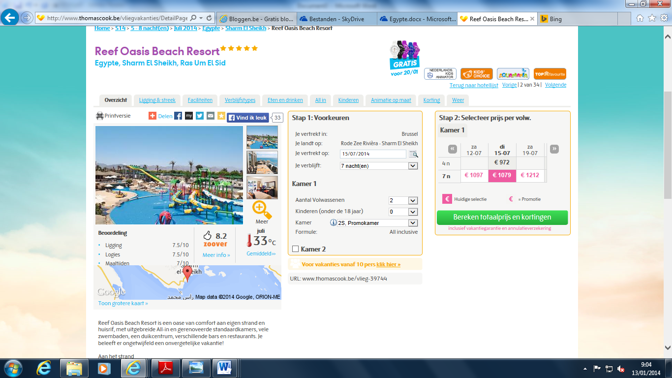
Thomas Cook http://www.thomascook.be/vliegvakanties/DetailPage.aspx?fh_eds=%c3%9f&fh_sort_by=pr_commercialpriority_0&fh_secondid=sns_sfli_39744a_s14&fh_lister_pos=1&fh_location=%2f%2fpackages%2fnl_BE%2fpr_earlybookable%3e%7b0%7d%2fpk_active%3d1%2fpk_season%3e%7bs14%7d%2fpr_duration%3e%7b0508%7d%2fpr_month%3e%7b201407%7d%2fpk_country%3e%7biso_eg%7d%2fpk_region%3e%7bgeo_39981%7d&fh_refview=lister&rc=vroegboek&a=0&em=0

