Samaritan Village Report Els Dalle – November 2013
During my stay in September, October and a few days of November, I tried to help improve the live of the kids at Samaritan Village. Thanks to the budget that I gathered with the fundraising, I could realise some things/changes. After all, I also have several ideas and advises. These comments are additions to all efforts that are made with lots of love by the staff. Please find, herewith, the overview.
Domain | Actual situation | Actions | What | To be continued by
Hygiene | Handwashing before and after meals & after use of toilet is hardly existing (or not) | Installing of a “hand washer” and soap (01). | Realisation | Staff
 |  | Training kids on using this before and after meals and after use of toilet. | Advise | Staff
 | No toiletpaper available at kids toilets | Purchase of toilet paper. | Realisation + to be continued | Staff
 |  | Training kids on using toilet paper. | Advise | Staff
 | Toddlers start using the potty but “spill” a lot and are not wiped clean after the use of it. Often the use of the potty is too late (wet pants) after which, pants are just changed without washing/wiping clean | Help toddlers who learn to use the potty to use this properly. | Advise | Staff
 |  | wash and change trousers (when wet) of toddlers who learn to use the potty. | Advise | Staff
 | Living room is cleaned thoroughly up to 2x per day but is dirty after a little while, because of dirt on the shoes of kids/adults entering from the garden. | Acquisition of shoe shelves (02) so that the kids shoes can be left on the shelves outdoor and living room is kept clean. | Realisation | Staff
 |  | Polish the shoe shelves (all material is provided). | Advise | Staff
 |  | Train kids on using these shelves and enter the living room barefoot. | Advise | Staff
 | Underwear is used from the age of 8 | Underwear should be available from the very beginning | Advise | Staff
Clothes | Lots of clothes are available and stuck in wardrobes or in spare beds. There is no overview of available clothes. | Put extra shelves in the wardrobes so that clothes can be arranged neatly (per size a.o.). Wood is available. | Advise | Staff
Toys & personal things | When volunteers want to play with the kids, toys/games are not available. There seems to be a lack of respect for toys. Kids often (regulary) receive toys from visitors/sponsors but are only kept for a short time. Soon things are left and found in the garden or on other places. | Provide a central place (per age category?) to store the toys. | Advise | Staff
 |  | Train kids on having respect for things of their own and of other people. | Advise | Staff
 |  | Arrange toys every evening. | Advise | Kids & Staff
 | There is no place where the (younger) children can keep some personal stuff (toys or others). | Provide a locker per kid where his/her personal stuff can be stored. With or without a lock? | Advise | Staff
 |  | Add these lockers on the wishlist for sponsors. | Advise | Staff
 |  | A personal present per kid. | Realisation
Leisure | If kids want to draw, paint, …. paper, pencils and other material should be asked for. This is available at the office. | Acquiring 2 double blackboards, colouring pencils, paint, brushes, pastels, chalk, wasco, paper (03). | Realisation | Staff
 |  | Paint and polish & Attach clips for paper (all material available) | Advise | Staff
 |  | Spend some time on regulary basis with the kids (in small groups) on using these blackboards for their creative development . | Advise | Staff?  Volunteers
 | Except of the time spent at school and at confirmation, the kids are continuously at Samaritan Village. An excursion and a party seemed to be a nice “escape” for all of them. Contact with others is available for certain ages as kids of the neighbourhood come and play at Samaritan. This is not for the eldest who get other needs when growing up. | 2-days safari camping trip to Tarangire with eldest kids and a staff member | Realisation
 |  | Excursion with pick nick to Lake Duluti with youngest kids and 3 staff members. | Realisation
 |  | Dance Party with all kids and staff (unfortunately there was no power for 2 hours) | Realisation
Food | There is a lot of food available. Unfortunately there is not much variety in the food. More variety (vegetables, fruit, chicken, meat, fish, … ) should be provided at low cost. | Cooking of chicken soup, pasta salad and spaghetti bolognaise (2x ! ) | Realisation
 |  | Purchase of extra meat, fish, yoghurt, ice cream, nuts, fruits, chocolate, biscuits, … | Realisation
 |  | Meeting with agricultural advisor of Arusha Municipal Council and Moshono Ward concerning the cultivation of more vegetables and fruits in own garden. Ongoing project, just started. Budget and cultivation plan are the next steps.  Contribution in the purchase of seeds/plants is foreseen in a special budget (Els & friends) | Initiation to be continued | Staff & Agric. Adv.
Social & physical development | Babies very often stay in their bedroom in their cot when awake. This room has hardly daylight and don’t alow the babies to get enough physical exercise. | Acquiring a play pen with (waterproof) mattress & cover for babies (04). To be used as much as possible during the whole day, inside/outside (protected from sun/water/wind) on the porch. | Realisation & Advise | Staff
 |  | Polish (material is available) | Advise | Staff
 |  | Train the other kids: the play pen is destinated only to babies (and baby toys) | Advise | Staff
General |  | Creation of book: tips and tricks for volunteers. To be completed by volunteers | Realisation & Advise | Staff
 |  | Purchase of some backpacks for school | Realisation

Other advises
General | Create a wish list for visitors/sponsors/… Ideas: a locker per kid, fresh fish and/or meat, sheets, blankets (?), beds (?), …
 | Website and facebook maintenance is very important for attracting and informing volunteers, sponsors, …
 | Delete the word “Orphanage” from the bus and other publications. The kids don’t have to be remembered each time they see the bus/get on bus … that they are orphans. They are in first instance kids, who have the bad luck to have lost their parents. If ever it should be mandatory to mention this word on “official” documents a.o., than in the smallest fonts possible.
Social Development | In view of their social development, contact with kids from own age is advised, especially for those who stay at home while waiting for their next school term (3 to 4 months!) (Catherine, Violet, … ). Activities once a week/once a month is advised.
 | Taking the kids out, in small groups, of the Samaritan Village, for “daily business” is to be advised. F.i. for shopping in town, to the airport, visiting friends, relatives of staff, …..
Education | A screening of the (some) kids concerning their learning competences and providing extra support is recommanded.  “Slow learners” and kids with other problems at school should be extra supported for homework. It is really wishful to let them repeat their class if recommanded by school (cfr Evarist, Flora, others? ). Otherwise, it will be more and more difficult each year. An extra school year is a good investment. | Els via schools of Kevin?
 | An extra teacher after school at Samaritan Village for support of the slow learners – 1 hr / day (?) – would be very helpfull | Els via Iddi, Kevin?
 | A quiet place is to be provided for the kids with concentration problems, far away from playing kids/toddlers, music, prayers, …
 | Contact with schools in Belgium to have volunteers who can share their expertise about education, development, … (orthopedagogie, psychologie, teachers, … ) | Els
 | Kids should be aware of values as respect (for people, nature, clothes, shoes, food, …. ). Therefor they need specific education, which they do miss now. Structure and discipline should contribute to a smooth lifestyle. In a family, this is part of daily life/growing up. How in an orphanage? Should there be someone special to teach the children (and the staff so that they can take over after a while)?
 | Train the trainer: share expertise with and provide information to the staff regarding education. As well for Samaritan Village as for schools (teachers)
 | Is it wishful to let the children sleep with the clothes they wear during the day instead of pijamas?
Prayers | Now, the kids are supposed to pray many times a day, and early in the morning. Time for prayers would better be decreased. Kids do need a minimum of hours to sleep and should be informed about religion, it should not be imposed.
Kitchen | The use/design of the kitchen could be much more efficient. To be revised by expert (January) | Jan ?
Bedrooms | Provide solid and clean sheets and blankets (wish list) | Wish list
 | Provide a solid bed per kid (not close to the floor – cfr John) | Wish list

01  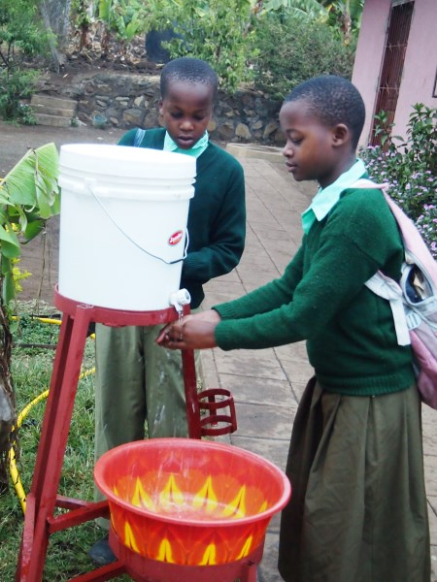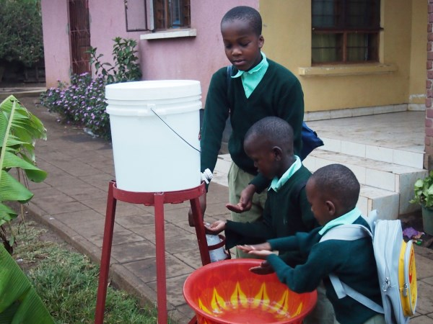 | 02 & 03  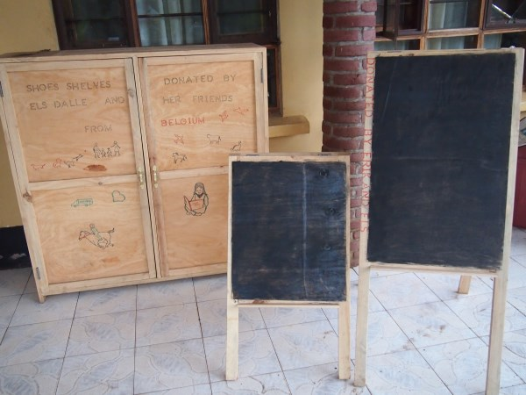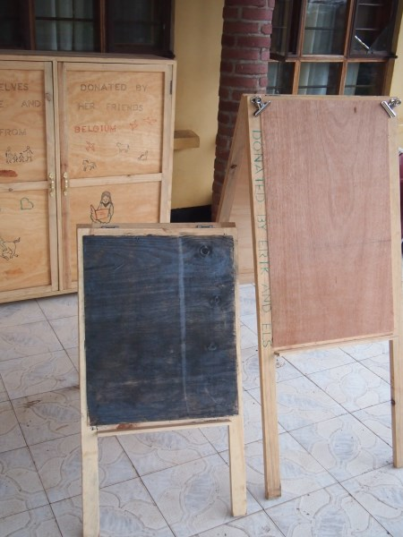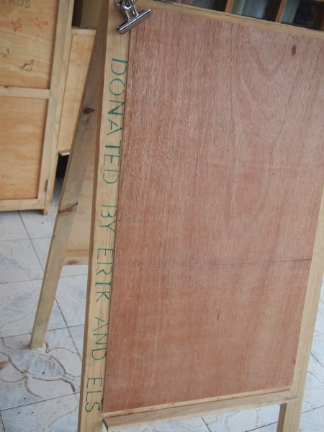
04  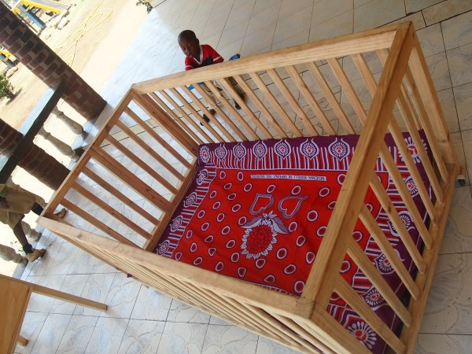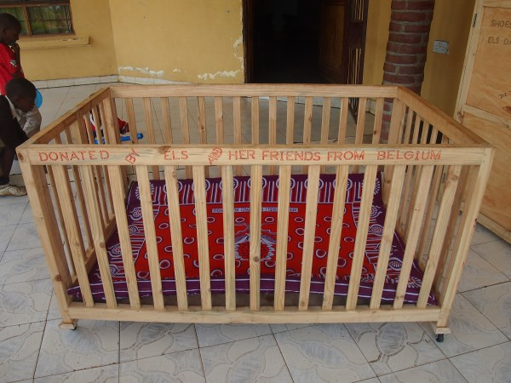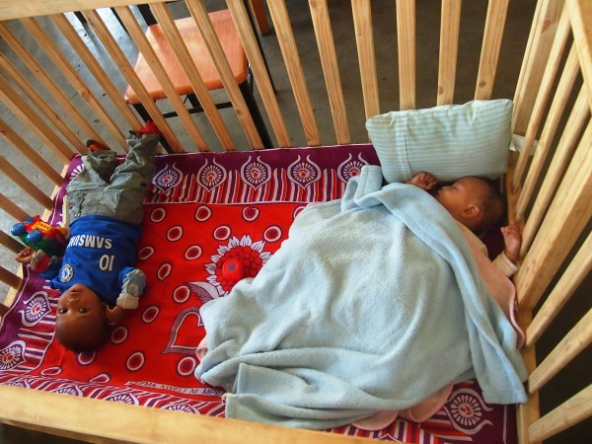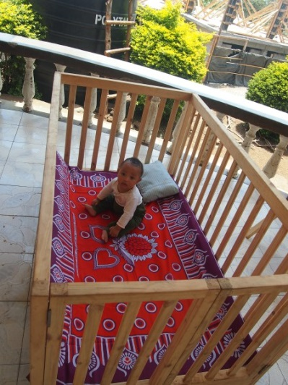 |  | 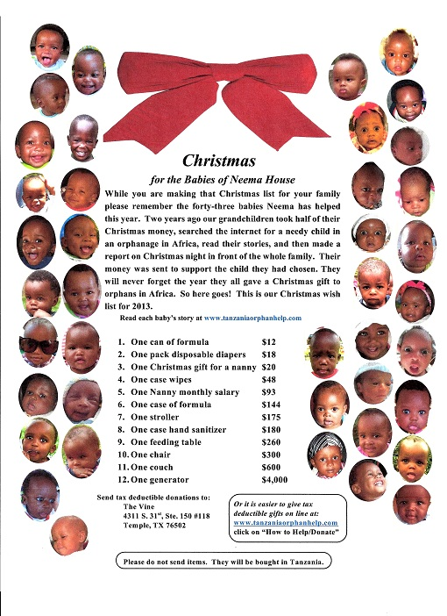
Example of sharing a “wish list”:

Mail received on november, 12:

Many of you have asked about items needed for Neema Baby Home. Below is a list of things, if it is too small to read, download the attachment. It's bigger. A neat Christmas gift idea would be to send a card stating that an item is being bought for Neema Baby Home in Africa in their honor. Thank you for caring for them.

This can also be distributed through the website/facebook page/…

