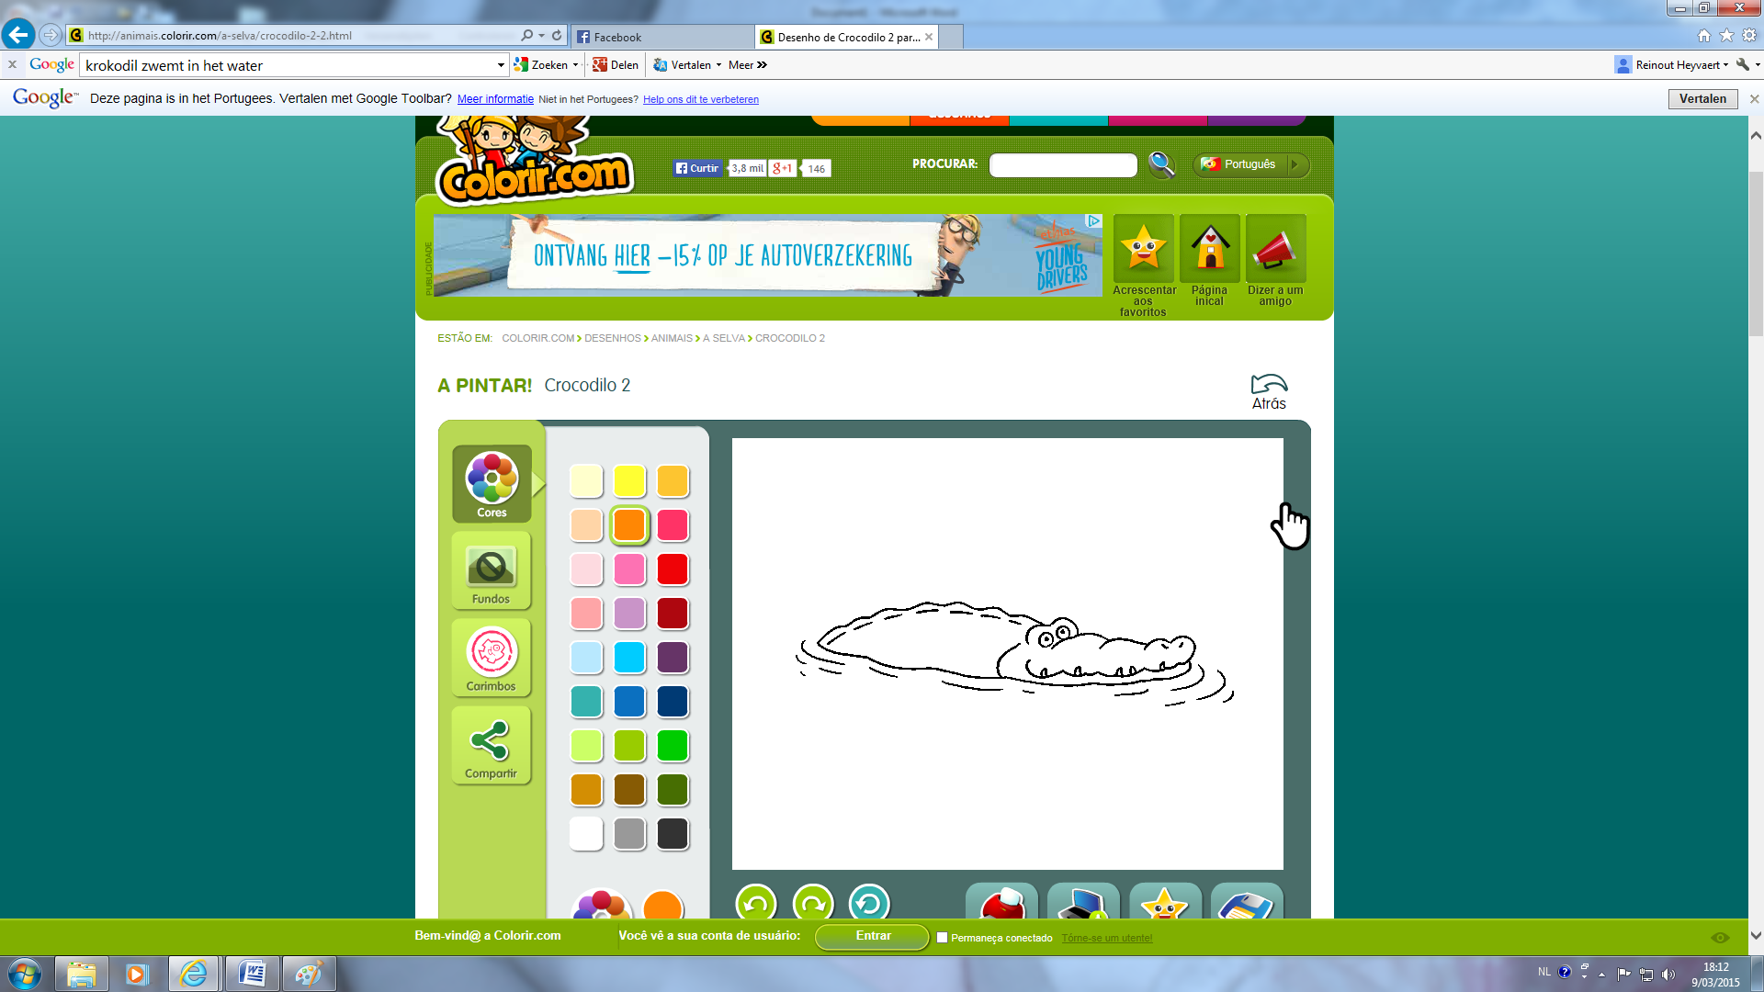[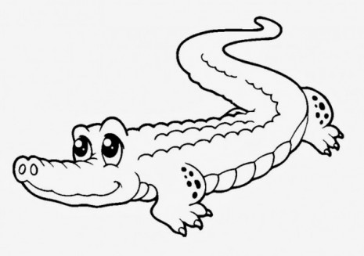](http://pintarimagenes.org/wp-content/uploads/2014/06/COCODRILO.jpg)

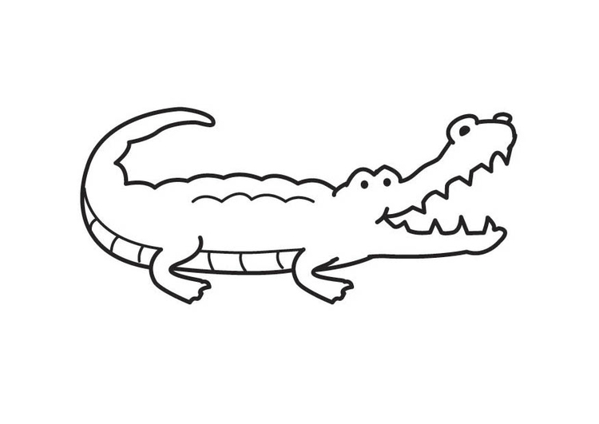[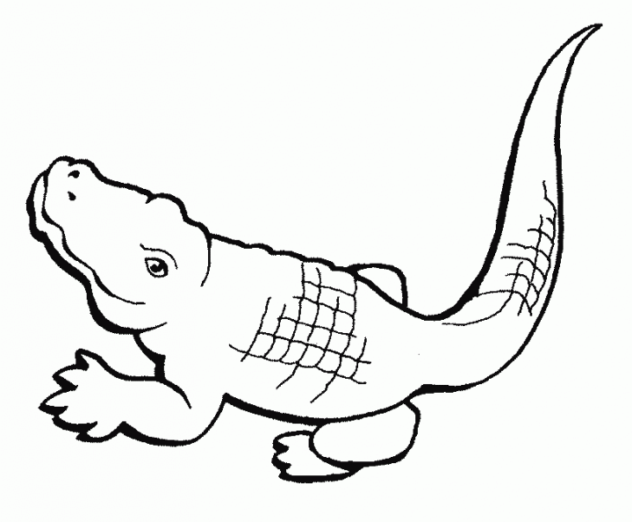](http://pintarimagenes.org/wp-content/uploads/2014/10/20121202215605-76b06fa9-me.gif)