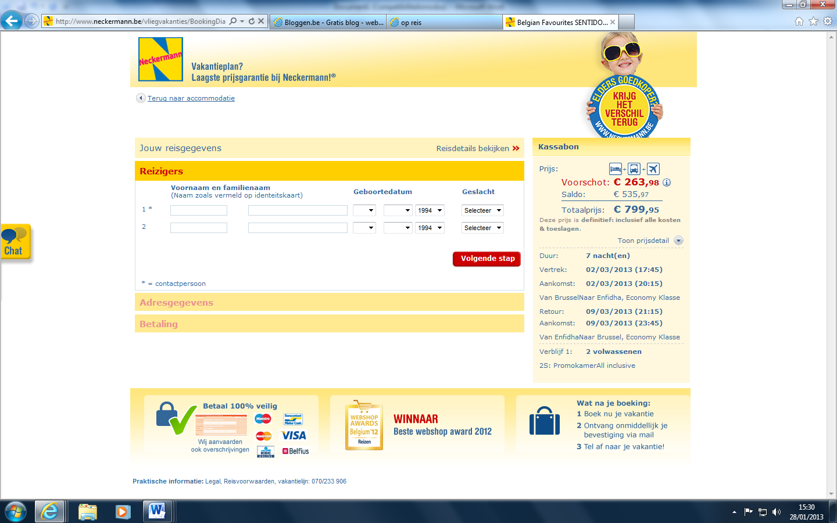

[http://www.neckermann.be/vliegvakanties/ListerEBPage.aspx?fh_location=//packages/nl_BE/pr_earlybookable%3E{0}/pk_active%3C2/pk_siteswitch%3E{nvb}/pk_hotelonly=0/pk_theme_c3%3E{eb_wave1}/pr_defaultduration=7&fh_sort_by=pr_reduction&fh_view=lister&fh_eds=%DF?scip=TCM-EBZ13_W2&s_cid=adw_nm_07_nl_vliegvakanties_country_kroatie#s=fh_location%253D%252F%252Fpackages%252Fnl_BE%252Fpr_earlybookable%253E%257B0%257D%252Fpk_active%253D1%252Fpk_siteswitch%253E%257Bnvb%257D%252Fpk_hotelonly%253D0%252Fpk_theme_c3%253E%257Beb_wave1%257D%252Fpr_defaultduration%253D7%252Fpk_vacationchannel%253E%257Bflight%257D%2526fh_sort_by%253Dpr_defaultprice%2526fh_view%253Dlister%2526a%253D0%2526em%253D0](http://www.neckermann.be/vliegvakanties/ListerEBPage.aspx?fh_location=//packages/nl_BE/pr_earlybookable%3E%7b0%7d/pk_active%3C2/pk_siteswitch%3E%7bnvb%7d/pk_hotelonly=0/pk_theme_c3%3E%7beb_wave1%7d/pr_defaultduration=7&fh_sort_by=pr_reduction&fh_view=lister&fh_eds=%DF?scip=TCM-EBZ13_W2&s_cid=adw_nm_07_nl_vliegvakanties_country_kroatie#s=fh_location%253D%252F%252Fpackages%252Fnl_BE%252Fpr_earlybookable%253E%257B0%257D%252Fpk_active%253D1%252Fpk_siteswitch%253E%257Bnvb%257D%252Fpk_hotelonly%253D0%252Fpk_theme_c3%253E%257Beb_wave1%257D%252Fpr_defaultduration%253D7%252Fpk_vacationchannel%2)

* Tunesië, Enfidha (Monastir), Hammamet

