[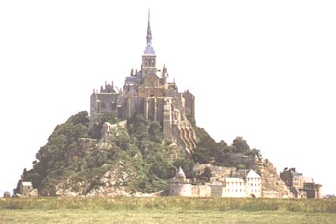](http://translate.googleusercontent.com/translate_c?hl=nl&sl=fr&u=http://www.asteria.fr/cadre.htm&prev=/search%3Fq%3Dmont%2Bsaint%2Bmichel%26hl%3Dnl%26rlz%3D1R2GGLS_nlBE404%26prmd%3Dim&rurl=translate.google.be&usg=ALkJrhhdwnRD22yiVr9Y57mr50IFlBstGA)