[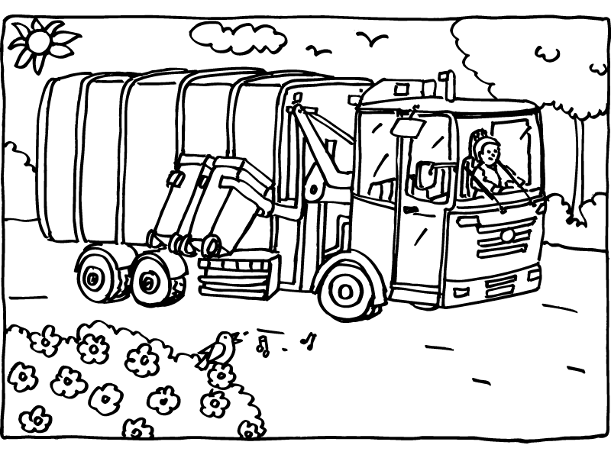](http://www.google.be/url?sa=i&rct=j&q=&esrc=s&frm=1&source=images&cd=&cad=rja&docid=eilS22AnJlRvgM&tbnid=QMuyKgmjVsqsiM:&ved=0CAUQjRw&url=http://www.meerlanden.nl/scholen_kleurplaat_nl.html&ei=8lp-Us6tCYLG0QXKtYHgDw&bvm=bv.56146854,d.d2k&psig=AFQjCNGt4n0bwEdF4MUqeUMYtlRo_DZP4A&ust=1384098922099425)

