[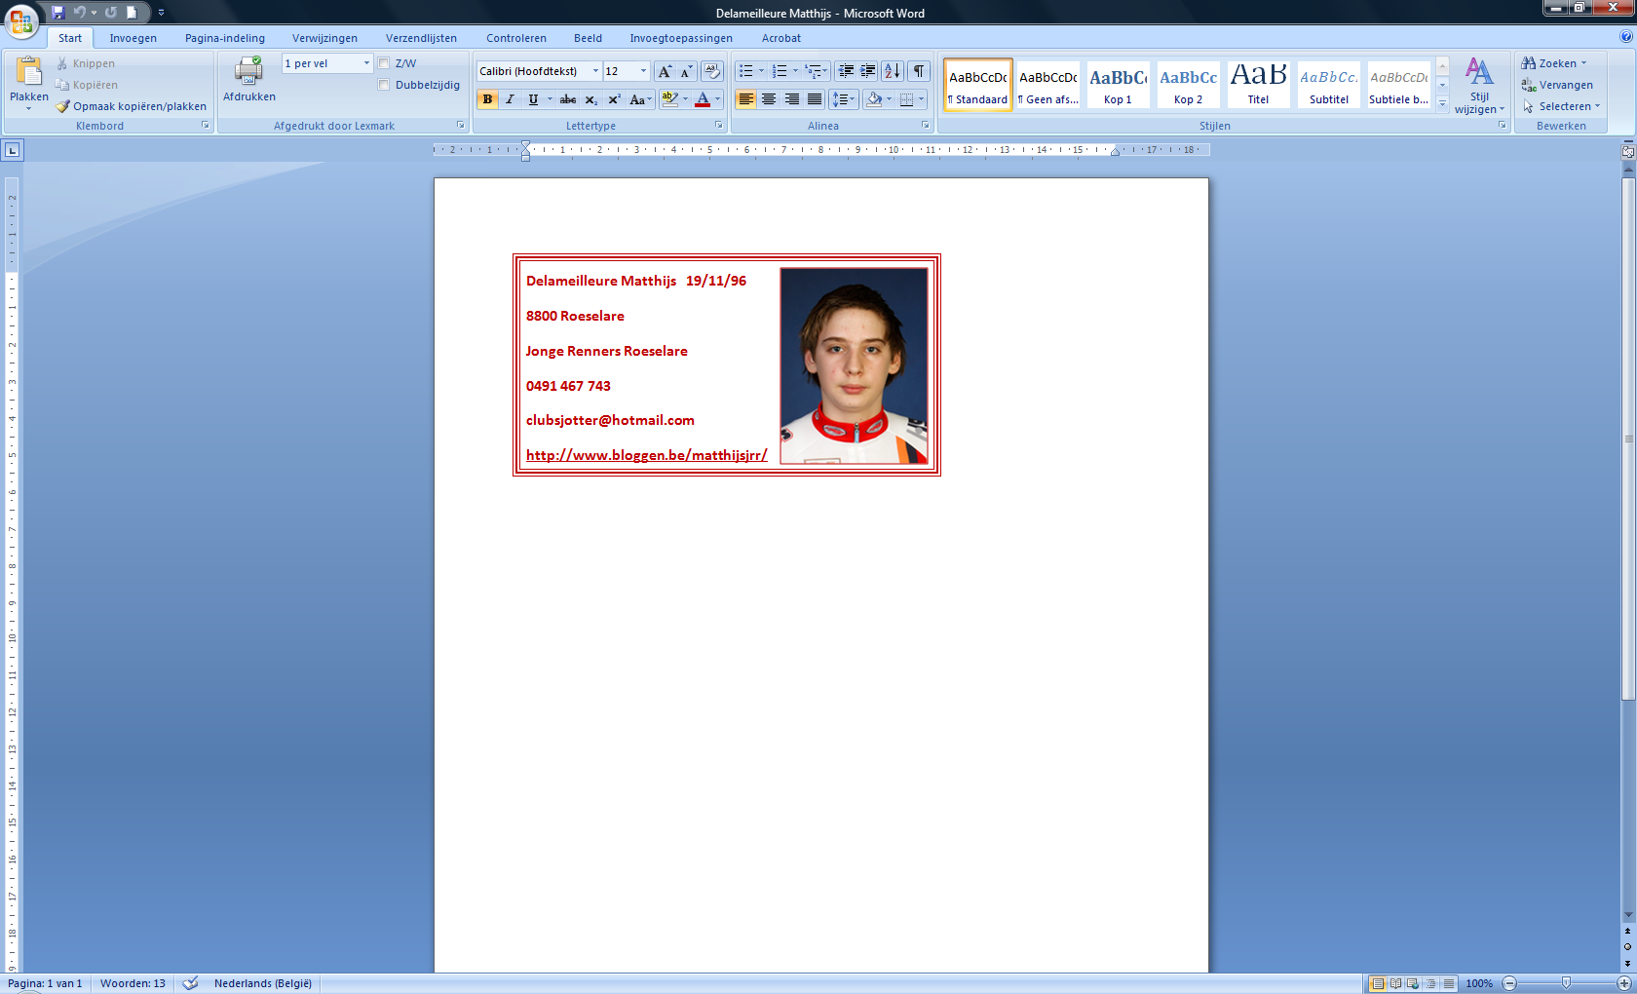](matthijs%20school/Nieuwe%20map)