[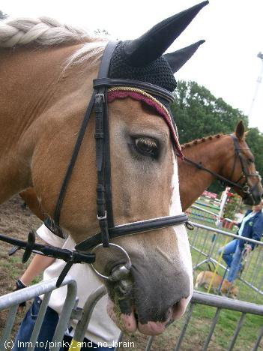](http://www.facebook.com/photo.php?pid=1426&id=100001484520647) [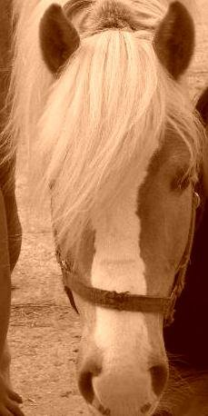](http://www.facebook.com/photo.php?pid=1426&id=100001484520647)

[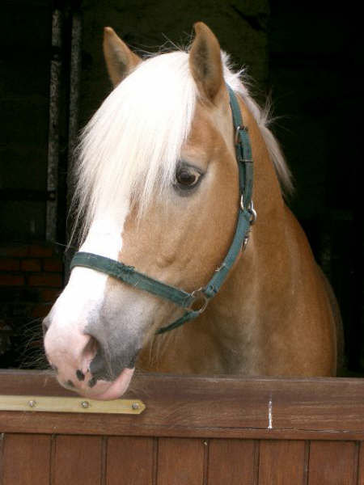](http://www.facebook.com/photo.php?pid=1426&id=100001484520647)