Sublime Light on the Turin Shroud
The true origin of a controversial medieval relic
Ludo NOENS

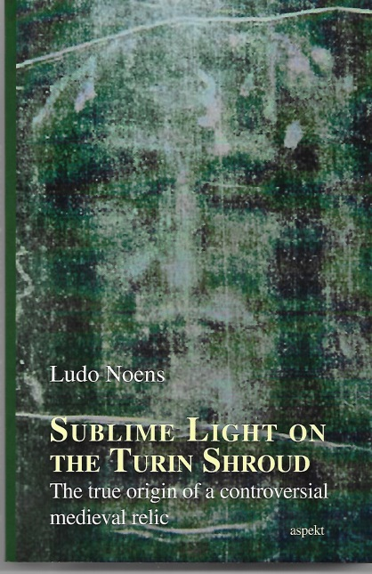
In April 1988, the Vatican authorities provided a small sample of the Turin Shroud for radiocarbon dating of the alleged burial cloth of Jesus Christ. In October of the same year, coordinator Michael S. Tite presented the conclusion of the university labs of Oxford, Zurich and Tucson (Arizona) to the entire world press: the miraculous imprint of Jesus’ resurrected body on the shroud dated to 1260-1390 CE…

‘A miraculous phenomenon requires a miraculous explanation,’ argued Régine Pernoud. This French medieval historian examined at length the mysterious case of Joan of Arc.
With Pernoud’s statement in mind, Ludo Noens has examined the case of the Turin Shroud: a preternatural phenomenon needs a preternatural explanation.

In this book the author develops a ground breaking new theory on the origin of the Turin Shroud. After a first chapter describing the historical background of the Shroud, the reader is introduced to the exceptional mental and physical properties of Jesus, his transfiguration on Mount Tabor and his death and resurrection from the tomb.
A link is made with modern Near-Death Experiences and peculiar physical light phenomena, such as ‘human batteries’.
In the final chapters, the author provides evidence that the Turin Shroud was ‘fabricated’ in the first half of 14th century, at the height of the Hesychast controversy. He argues that in the context of this Orthodox Light Mystique, ‘enlightened’ monks from Mount Athos may have been able to repeat Christ’s Metamorphosis on Mount Tabor, and leave a physical imprint of their body on a linen fabric…

ISBN-10: 9463385134 ISBN-13: 978-9463385138
Aspekt Publishers, 2019, 240 pages (incl. references + index)
https://www.amazon.com/Sublime-light-Turin-Shroud-controversial/dp/9463385134
https://www.amazon.co.uk/Sublime-Light-Turin-Shroud-contraversial/dp/9463385134
Video on YouTube: https://www.youtube.com/watch?v=M-F_p3n7scc

Ludo Noens
Belgian/Flemish author and free-lance journalist, born and living in Brussels. Focuses in his historical non-fiction on the paranormal idiosyncrasies of mystical figures of the Christian tradition.
ludonoens@yucom.be

