|  |  |  |
| --- | --- | --- |
| **Thomas Cook** | **Transeurope** | **Nordic** |
| Hotel + activiteiten: €1246/per. 🡪€2492 (zonder vlucht)  Vlucht (Cheaptickets): €691,18 | Vlucht + hotel: €2435,70 (zonder activiteiten)  + activiteiten: ongeveer €1040 | Hotel + vlucht + hotel: €2000/per. 🡪 €4000 |
| Totaal: €2492 + €691,18 = €3183,18 | Totaal: €2435,70 + €1040 = €3475,70 | Totaal: €4000 |
| Goedkoopste en duurste: Thomas Cook is het goedkoopst en Nordic het duurst | | |
| <http://www.thomascook.be/hotel/DetailPage.aspx?fh_eds=%C3%9F&fh_sort_by=pr_defaultprice&fh_secondid=sns_tusa_31351a_s15&fh_lister_pos=0&fh_location=%2f%2fpackages%2fnl_BE%2fpr_earlybookable%3E%7b0%7d%2fpk_active%3d1%2fpk_country%3E%7biso_is%7d%2fpr_duration%3E%7b0508%7d%2fpr_month%3E%7b201507%7d%2fpr_period%3E%7b20150720_06%7d%2fpr_holidayperiods%3E%7bzomer2015%7d&fh_refview=lister&rc=reizen&a=2&em=0&nonavigation=true&RoomOccupation1=31351A_2A_LO_2_0>  <https://booking.cheaptickets.be/nl/checkout/flightbooking?fbu=https%3A%2F%2Fapi.cheaptickets.be%2Fflightbooking%2Fcid-67e0c624-84e1-4744-b0f1-d9ecb314b10e%3Fcachekey%3D36eab8fa-406f-41a1-855e-5a5fccdcc3e2%26flightid%3D1%26inid%3D2%26outid%3D1#biu=https%3A%2F%2Fapi.cheaptickets.be%2Fflightbooking%2Fcid-67e0c624-84e1-4744-b0f1-d9ecb314b10e%2F65acdcd2-5989-473c-be79-310b4712c716> | <http://www.transeurope.com/nl-be/citytrips/ijsland/reykjavik/laxnes_hotel/748060352/prijsberekening.html> | <http://www.nordic.be/reizen-scandinavie/ijsland-actief-reis/#tab-id-3> |

Extra info bij Thomas Cook (wat inbegrepen en wat niet)

<http://www.thomascook.be/hotel/DetailPage.aspx?fh_eds=%C3%9F&fh_sort_by=pr_defaultprice&fh_secondid=sns_tusa_31351a_s15&fh_lister_pos=0&fh_location=%2f%2fpackages%2fnl_BE%2fpr_earlybookable%3E%7b0%7d%2fpk_active%3d1%2fpk_country%3E%7biso_is%7d%2fpr_duration%3E%7b0508%7d%2fpr_month%3E%7b201507%7d%2fpr_period%3E%7b20150720_06%7d%2fpr_holidayperiods%3E%7bzomer2015%7d&fh_refview=lister&rc=reizen&a=2&em=0&nonavigation=true&RoomOccupation1=31351A_2A_LO_2_0>

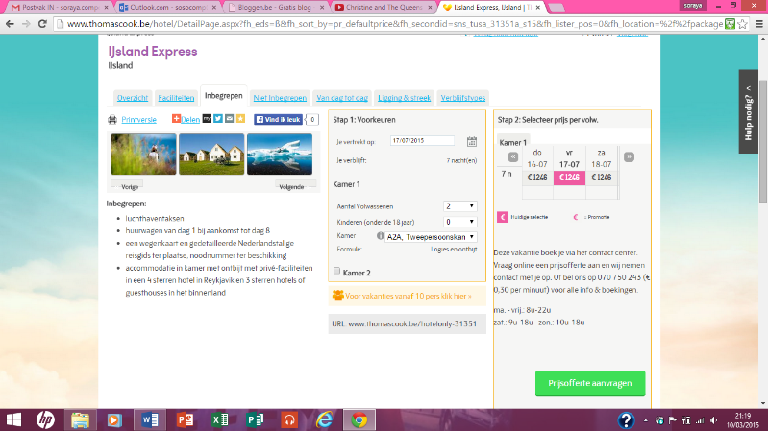

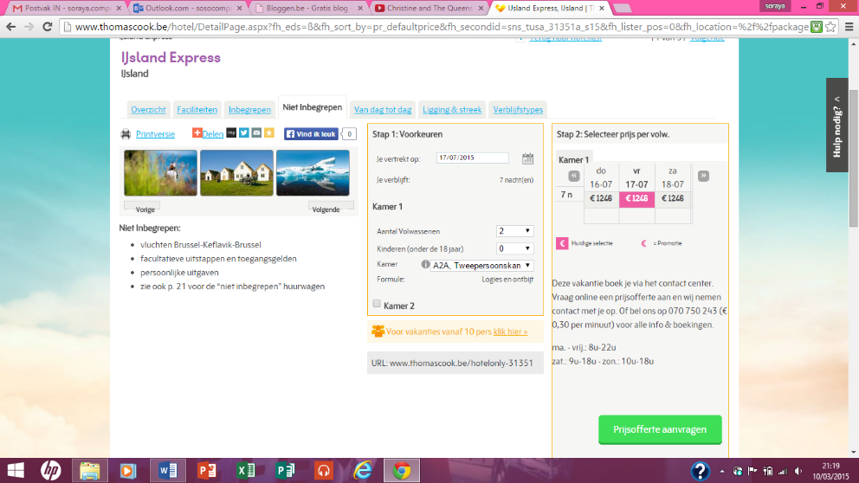<http://www.thomascook.be/hotel/DetailPage.aspx?fh_eds=%C3%9F&fh_sort_by=pr_defaultprice&fh_secondid=sns_tusa_31351a_s15&fh_lister_pos=0&fh_location=%2f%2fpackages%2fnl_BE%2fpr_earlybookable%3E%7b0%7d%2fpk_active%3d1%2fpk_country%3E%7biso_is%7d%2fpr_duration%3E%7b0508%7d%2fpr_month%3E%7b201507%7d%2fpr_period%3E%7b20150720_06%7d%2fpr_holidayperiods%3E%7bzomer2015%7d&fh_refview=lister&rc=reizen&a=2&em=0&nonavigation=true&RoomOccupation1=31351A_2A_LO_2_0>