[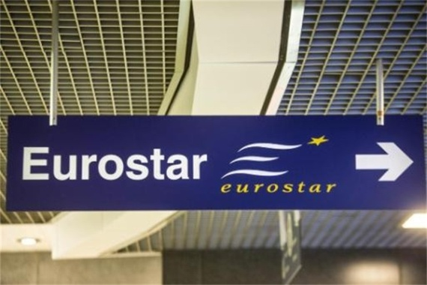](http://www.google.be/url?sa=i&rct=j&q=eurostar&source=images&cd=&cad=rja&docid=IZNR5K2Fq8h3OM&tbnid=_fEt_ueJ4wvVjM:&ved=0CAUQjRw&url=http://www.hbvl.be/nieuws/economie/belga/extern-aantal-reizigers-eurostar-blijft-stabiel-ondanks-olympische-spelen.aspx&ei=H_sgUajTGsaq4ASdhIHQDg&bvm=bv.42553238,d.bGE&psig=AFQjCNHkHXAPyEkISfD8P9hAybijB-LoAg&ust=1361202294171731)

Vertrek met Eurostar uit Calais

[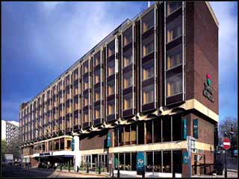](http://www.google.be/url?sa=i&rct=j&q=travelodge+kings+cross+royal+scot&source=images&cd=&cad=rja&docid=CfLVSGkSKbidEM&tbnid=cBtWJ0aY3Ky9CM:&ved=0CAUQjRw&url=http://www.dilos.com/hotel/543/UK-England-GREATER-LONDON-London-Travelodge-London-Kings-Cross-Royal-Scot-Hotel&ei=kPsgUeEG7IviBIuogYAB&bvm=bv.42553238,d.bGE&psig=AFQjCNHH46MmWzoeU8W3fw0YWsWpXQSDbA&ust=1361202440281694)

Hotel Travelodge Kings Cross Royal Scot

[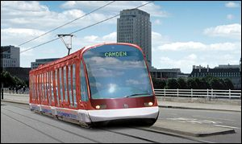](http://www.google.be/url?sa=i&rct=j&q=tram+london&source=images&cd=&cad=rja&docid=rtqgu10vDEteBM&tbnid=igcA1LT_uraFmM:&ved=0CAUQjRw&url=http://news.bbc.co.uk/2/hi/uk_news/1496073.stm&ei=C_0gUeO7CYeM4gTEl4DgCQ&bvm=bv.42553238,d.bGE&psig=AFQjCNFWjhy3bb9nS8oGPMsOX6UGeP1hLw&ust=1361202814491919)[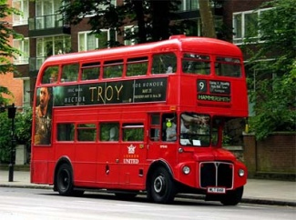](http://www.google.be/url?sa=i&rct=j&q=bus+london&source=images&cd=&cad=rja&docid=9bra04sGviIbTM&tbnid=2B5UOw_mn8EdAM:&ved=0CAUQjRw&url=http://www.nowpublic.com/world/london-bus-workers-strike-0&ei=0vwgUcfTEMnm4QTX6YH4DQ&bvm=bv.42553238,d.bGE&psig=AFQjCNHUzQl_FjGnO_HMryo0Urgol3oGLA&ust=1361202725739013)[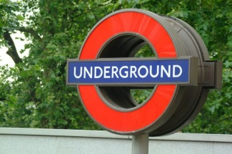](http://www.google.be/url?sa=i&rct=j&q=metro+londen&source=images&cd=&cad=rja&docid=sMMtkGkgfrWLxM&tbnid=6tQ1vaKZUx4v7M:&ved=0CAUQjRw&url=http://www.treinreiziger.nl/internationaal/bestemmingen/groot-britanie/metro_londen-141945&ei=CPwgUaKdAe754QS_-YGIAQ&bvm=bv.42553238,d.bGE&psig=AFQjCNHJv0g5DuorT19guSDsfee6dV2GEw&ust=1361202546498571)

Verplaatsing binnen Londen met metro, bus, tram ...  
( London Travelcard )

[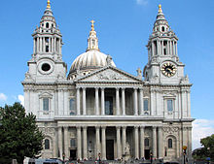](http://www.google.be/url?sa=i&rct=j&q=st+paul's+cathedral&source=images&cd=&cad=rja&docid=h0kJ73xTBxn07M&tbnid=3Z_OATJqdB1U6M:&ved=0CAUQjRw&url=http://en.wikipedia.org/wiki/St_Paul's_Cathedral&ei=ci0iUaeeCoTIhAeQtoCgAg&bvm=bv.42553238,d.bGE&psig=AFQjCNHSptH1HWPdo2E_FyovJ3iQKEF6Rg&ust=1361280744266374)

Activiteiten (wat ik zeker wil doen):  
* Madam Tussaud  
* St Paul’s Cathedral  
* Tower Bridge  
* Tower of London  
* London Zoo  
* Musical: Charlie and the Chocolate Factory  
* Buckingham Place

[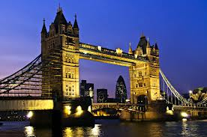](http://www.google.be/url?sa=i&rct=j&q=tower+bridge&source=images&cd=&cad=rja&docid=3pLl4zNBlfmcyM&tbnid=8SwAsMV6Ei0nyM:&ved=0CAUQjRw&url=http://outandaboutinthecity.com/2012/11/02/weekly-photo-challenge-geometry/tower-bridge-in-london-at-night/&ei=lC0iUZCeB4-HhQftuYDADw&bvm=bv.42553238,d.bGE&psig=AFQjCNGnr6J1debs-ndgbwXFYoFelJN7ng&ust=1361280777972784)

[](http://www.google.be/url?sa=i&rct=j&q=london+zoo+logo&source=images&cd=&cad=rja&docid=Pm_l5eu2S9V66M&tbnid=Cqsb84LoF7SFBM:&ved=0CAUQjRw&url=http://www.barraclough-associates.com/work/zsl-london-zoo/&ei=DC4iUYu_AYeFhQfUqoDoCA&bvm=bv.42553238,d.bGE&psig=AFQjCNH3NQ78cTQRhI7zIWJFH61B5K2vaw&ust=1361280899767976)

[](http://www.google.be/url?sa=i&rct=j&q=musical+charlie+and+the+chocolate+factory+&source=images&cd=&cad=rja&docid=6RKUXoKm5UIbqM&tbnid=YfT5X1-tq6ptrM:&ved=0CAUQjRw&url=http://www.ticketmaster.co.uk/Charlie-and-the-Chocolate-Factory-tickets/artist/844247&ei=YS4iUYbEFIWIhQf-5YBo&bvm=bv.42553238,d.bGE&psig=AFQjCNHIK6SSBuQ2f0OvQ5j-5ysQQJbAeQ&ust=1361280940362032)

[](http://www.google.be/url?sa=i&rct=j&q=eurostar&source=images&cd=&cad=rja&docid=IZNR5K2Fq8h3OM&tbnid=_fEt_ueJ4wvVjM:&ved=0CAUQjRw&url=http://www.hbvl.be/nieuws/economie/belga/extern-aantal-reizigers-eurostar-blijft-stabiel-ondanks-olympische-spelen.aspx&ei=H_sgUajTGsaq4ASdhIHQDg&bvm=bv.42553238,d.bGE&psig=AFQjCNHkHXAPyEkISfD8P9hAybijB-LoAg&ust=1361202294171731)

Vertrek met Eurostar vanuit Londen naar Calais