j

|  |
| --- |
| **KFC IZEGEM – VC WINGENE**  **ZONDAG 27/11/2011 14:30 u** |



|  |  |
| --- | --- |
| http://extranet.e-kickoff.com/project/publiek/clublogo/00935.jpg**KFC IZEGEM** | http://extranet.e-kickoff.com/project/publiek/clublogo/05216.jpg **VC WINGENE** |
|  |  |
| **SPELERS** | **SPELERS** |
|  |  |
| 22 STEFAAN VERGOTE | 21 STEVEN DEVOS |
| 2 FREDERIQUE OLLIVIER | 2 ANDY COLPAERT |
| 3 BRECHT VERVAECK | 4 NICK AZOU |
| 6 STIJN DE DEYGERE | 5 NASREDINE HARITI |
| 20 AURELIEN VERZELE | 6 JONAS BOUCHE |
| 5 GLENN LABIE | 7 BJORN VANDAELE |
| 21 ARNE DUTRY | 8 GIOVANNI FEDEROW |
| 14 JOACHIM VERCOUTER | 9 BRIAN VANHOLM |
| 10 TOM COGHE | 10 ANGELO PARAVIZZINI |
| 19 DIETER WITTESAELE | 14 DIMITRI BILLIET |
| 7 BOUALEM MERRIR | 15 BANSENGA-FUTA NTAMBWE |
|  |  |
| **WISSELSPELERS** | **WISSELSPELERS** |
|  |  |
| 4 NICHOLAS VANDILLE | 11 SIMON GLORIEUX |
| 18 JELLE POPELIER | 16 JEROEN BOUWENS |
| 9 HADJ SEMARA | 19 MATHIAS WULLAERT |
| 12 MAXIM OLIVIER | 1 JEROEN TEMPELAERE |
|  |  |
| **TRAINER** | **TRAINER** |
|  |  |
| **Peter Devos** | **Eddy Verbeeck** |

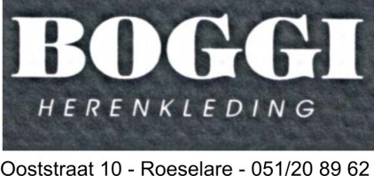

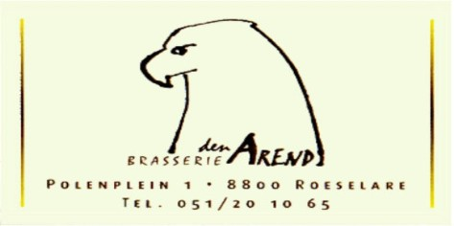







|  |
| --- |
| **Scheidsrechter : VAN DRIESSCHE BRAM**  **Assistent-Scheidsrechters : VERCRUYSSE JEAN-PIERRE**  **DEVRIESE BRECHT** |

|  |
| --- |
| **WEDSTRIJDBAL GESCHONKEN DOOR :**  **STUDAX KFC IZEGEM** |



|  |
| --- |
| **Volgende wedstrijd :**  **SK MALDEGEM - KFC IZEGEM**  **ZATERDAG 03/12/2011 20.00 u** |



|  |
| --- |
| **KFC IZEGEM - K.SV.TEMSE**  **25/08/2010 18:30 u** |