**SAMBA 8 DAYS / 7 NIGHTS**

**SOUTH EAST**

**DAY 1.- QUITO – GALAPAGOS: BALTRA – STA. CRUZ: CHARLES DARWIN STATION**

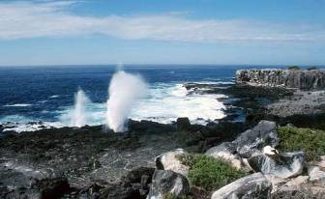

This day you will travel to one of the most amazing places of the world, The Galapagos Islands. These groups of 13 major islands and dozens of smaller islets and rocks, all the result of volcanic activity, certainly appear to be out of this world. For nature lovers, the perfection is even greater, birds and more birds, playful sea lions, exotic plant life, volcanoes and haunting land seascape.

Early in the morning you have to be in the airport to catch your Galapagos flight. At your arrival you will have to pay the Galapagos National Park entrance fee (US$ 100 cash per person). Outside, the guide of Samba will be waiting for you to transfer you to the pier where your boat will be ready to start with your cruise. On board the guide will explain you about the rules that you have to follow in Galapagos according the National Park and will give you some safety lessons. Lunch and in the afternoon you will visit Santa Cruz is the second largest island of the Archipelago and it is the home of the Charles Darwin Research Station and Galapagos National Park headquarters. Here you will learn first hand of the conservation and research efforts in the islands seeing the tortoise hatchlings and breeding programs which are saving several races of tortoises from extinction. Return to Pto Ayora and then to the boat to diner and overnight.

**(L,D)**

**DAY 2.- FLOREANA: PTA. CORMORANT – CHAMPION ROCK – POST OFFICE BAY / LA BARONESA LOOKOUT**

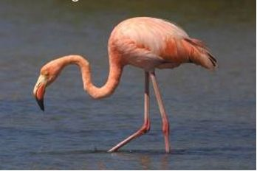

After breakfast we will enjoy of Floreana Island, to visit Pta. Cormorant, where you will find a nice lagoon full of pink flamingos and a beautiful beach where you will see some rays close to the beach. Close to mid day, we navigate to reach one of the islets that surround Floreana, Champion islet. Right here we can do a panga ride around it to observe the last members of the Floreana mockingbird, as well as enjoying the fantastic landscape of this small islet. Snorkeling here is one of the best in Galapagos, myriads of exotic fish, sharks, turtles, and the ever present playful sea lions.

Lunch and in the afternoon you will visit Post Office Bay that has left a large legacy of pirates, whalers, scientific expeditions, etc. After disembarking on the beach, we will take a very short hike to pay a visit to one of the most traditional places in Galapagos: the mail barrel, where we will maintain the tradition that started in the dawn of the 18th century. Then with our panga we’ll cross thru the sea lion colony to land at a small beach and climb to the look out point of the baroness a small tuff cone where we will listen to the obscure mysterious story of Floreana. From this point we can see as far as Enderby, Champion, Punta Cormorant, Post Office Bay and the highlands of Floreana. Return to the boat.

**(B,L,D)**

**DAY 3.- ESPAÑOLA: PTA SUAREZ - GARDNER BAY – GARDNER ROCK**

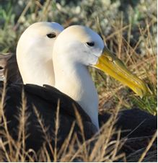

After breakfast you will visit Pta. Suarez and at afternoon Gardner Bay, both places in Española Island. Pta. Suarez is a rocky point of land that sustains one of the most impressive and varied colonies of sea birds in Galapagos. Along its southern shore, steep cliffs rise up from the sea, for a spectacular view of soaring birds and the famous blowhole. A noisy colony of Sea Lions and curious mockingbirds greet us as we land on their beach. You will meet a multitude of Blue-footed Boobies, Masked boobies and endemic Marine iguanas with unique traces of red and green soak up the heat from the sun. In Gardner Bay we find a good spot for swimming and a long brilliant white, powder-sand beach for walking. This site is favored by sea turtles for nesting, sea lions and peaceful walks. Later you will go to Gardner Islet and Osborn islets great places for snorkeling. Dinner and overnight in the boat.

**(B.L.D)**

**DAY 4.- SAN CRISTOBAL: ISLA LOBOS – KICKER ROCK AND PITT POINT**

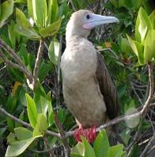

You will wake up to the barking of Galapagos sea lions, animals after which the Island was named. After a dry landing on **Isla Lobos**,we walk on over very rocky terrain. To your surprise red balloons will soon bound you, great and magnificent pirates nest on this small flat Island. Frigate birds with their magenta and green iridescent feathers decorate the saltbushes. The island is also the nesting ground of blue-footed boobies. Don’t miss the chance of swimming with sea lions; a few sea creatures are as playful as these marine mammals.

Before lunch we navigate by a dramatic tuff cone formation, **Kicker Rock**. The eroded structure has vertical walls of over 450 feet and has a great numbers of sea birds nesting and resting on it. We will circumnavigate the rock to admire its magnitude, soon after that we will jump in the water to swim with Galapagos sharks, sea turtles, and eagle rays and drop offs full of colorful fish and invertebrates.

On **Punta Pitt** we do a wet landing late in the afternoon to climb a tuff cone and enjoy the sunset. This point is closest to mainland South America. Nazca boobies, red-footed boobies, frigate birds and storm petrel nest in the area. The ochre color beach is perfect for a relaxing plunge after the walk.

**(B,L,D)**

**DAY 5.- STA FE – SOUTH PLAZAS**

The bay looks as if artist ornamented it. **Barrington Bay** is one of the most picturesque inlets of all visitor sites of the Galapagos. The white sand on the seabed reflects the light to turn the calm waters turquoise. A small forest of gigantic prickly pear cactus grows on a peninsula that keeps the bay sheltered. All the before mentioned are suitable conditions for a large sea lion colony. Santa Fe is an ancient extinct volcano and it has been isolated from other island long enough to have an endemic land dragon. Paler in color than its relatives, the Barrington terrestrial iguana has a primitive morphology. Galapagos Hawks, mocking birds, finches and endemic rice rats make company to yellowish monster. The snorkeling won’t disappoint you.

A two-hour navigation northwill take us to **South Plaza**. The dry landing takes you to a brilliant combination of life and colors. Land iguanas wondering through bright red carpet weed, Swallow tailed gulls nesting around the overhang tops and red-billed tropicbirds and shearwaters flying with dancing displays. Mind the pirates of the sky; they will strike if you drop your guard. 13 acres of beauty Hectare is one of the best spots in the archipelago to see land iguanas and swallow-tailed gulls, both indigenous to the Galapagos. There are iguana nests scattered all over the hill. The sheer cliffs of the southern shore are a perfect bird habitat, making it an unparalleled bird observatory for especially swallow-tailed gulls, Audubon shearwaters, and red-billed tropicbirds.

 If we have enough time and good weather we will swim or snorkel in **Punta Carrion**. A great way to end an active day!

**(B,L,D)**

**DAY 6.- SANTIAGO – BARTHOLOMEW**

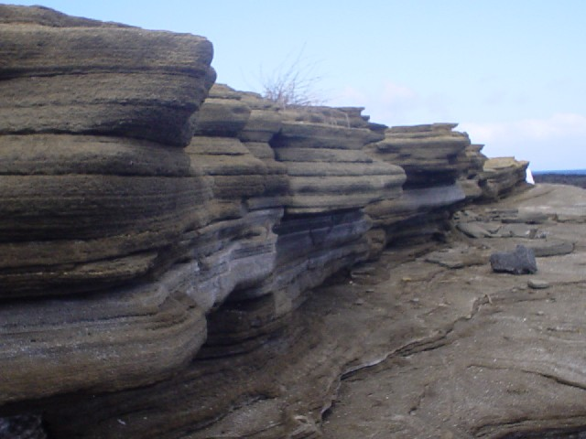

The genesis of the islands is easy to acknowledge at **Sullivan Bay**. The coiled shiny structures of the pahoe-hoe lava appear as if they were formed yesterday. Located on the east shores of James Island these 131 years old lava flow has intact driblet cones. Older cinder cones were flooded by the rivers of lava and are a great example of aging igneous rocks. The contrast of colors and shapes of the basalt, and the distinction of rust and shine of its surface will take you back you of Mars, if you’ve been there before.

**Bartholomew Island** offers an explosive volcanic landscape. Get ready to climb above 270 feet to admire the dramatic spatter cones and the view of Pinnacle Rock that everyone wants. Later, take a walk on magical golden beaches where sea turtle nest (December to March). Don’t forget to make time to swim near penguins, sharks and lava tubes.

**(B,L,D)**

**DAY 7.- RABIDA – SANTIAGO: JAMES BAY**

**James Bay**,also known as **Puerto Egas**, has magical shorelines that combine tuff cone, lava flows and organic sand. A rocky coast with a very gentle slope is used by a great number of shore birds and reptiles. Oystercatchers, whimbrels, sanderlings, turnstones, tattlers and other waders are mixed with marine iguanas and bright painted crabs to feed by the rich littoral zone. As grand finally, large lava tunnels, that are partially collapsed, are the houses of the Galapagos fur sea lions. The snorkel can be one of the best in the archipelago. Sea turtles feeding, parrot fishes, damsel fishes, white tipped reef sharks and many more…

Galapagos offers a diversity of geological formations without boundaries. The island of **Rábida** has lavas rich in iron and after millions of years of exposure to air they have turned red. The rusted volcanic material has eroded to form a beautiful crimson sand beach, lovely for a walk. The protected shore provides excellent conditions for a Galapagos sea lions nursery and brown pelicans use the nearby saltbushes as a resting and nesting area. Hawks and mocking birds are common visitors of the lowlands. Furthermore, you will find that snorkeling of the beach can be very exiting as sharks, rays and many colorful fish are often visible.

**(B,L,D)**

**DAY 8.- NORTH SEYMOUR – BALTRA AIRPORT**

The visit to **North Seymour** is the best way of saying goodbye to the Galapagos. Following a dry landing at sunrise we will walk amongst the largest blue-footed booby colony of the Islands. If breeding you will enjoy their dancing and singing to find a mate. Not far from the dancers we have great and magnificent frigate birds nesting. The males inflate their pouches to attract the ladies that fly above them. Swallow tailed gulls and tropicbirds decorate the large basaltic walls of the island.

We will be back on board for breakfast at 8:00 and we have to be ready to check out at 9:00. It is always a good idea to do most of your packing the previous night so you can have a pleasant last early morning visit and a relaxed breakfast.

**(B,)**