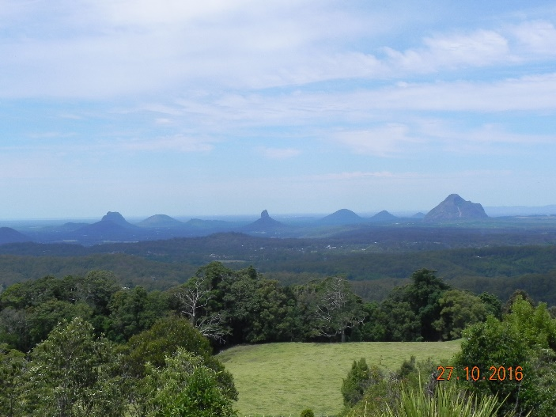 Glashouse mountains

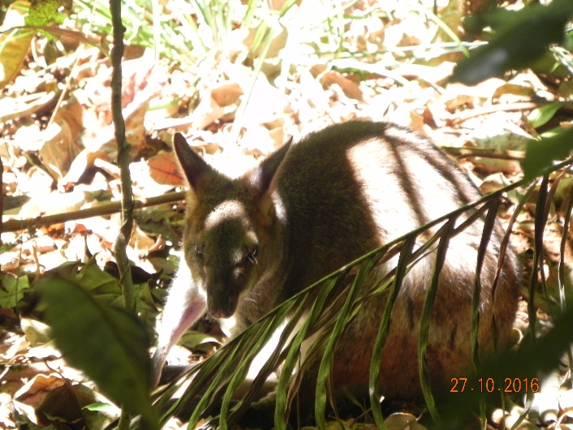 “Rost Wallaby” rainforest Glashouse Mountains

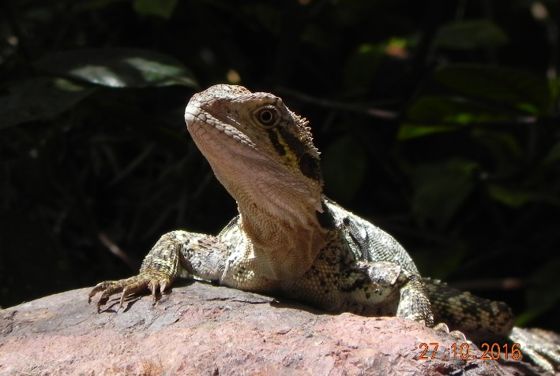

Restaurantbezoeker “glashouse mountains”

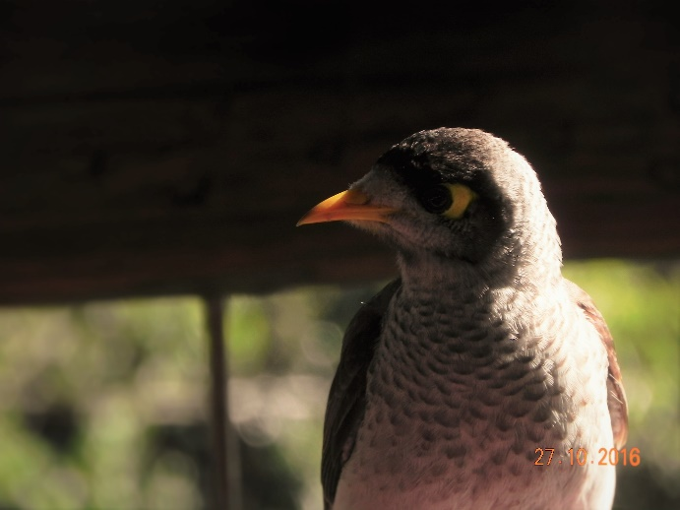kruimeldief glashouse mountains