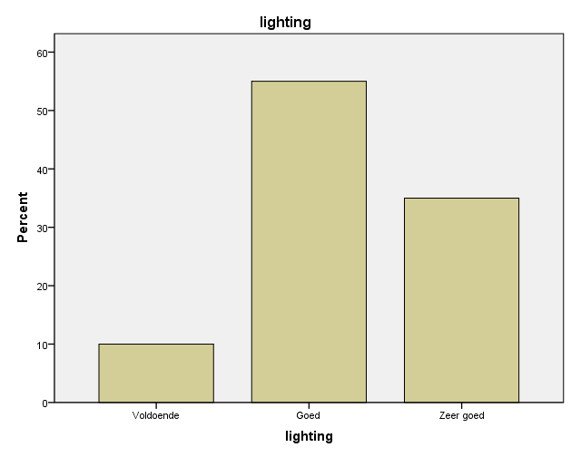

Statistics
recommendation
N | Valid | 20
N | Missing | 10
Mean |  | 8.90

