Gifted?
"They didn't actually tell me I was stupid, like, at school," he said, neatly wrenching the top of the kitchen tap off with a special tool he took from a neat box on the floor. "They just set me to gardening for my last year. I got the message. I was never much good at reading and writing. When 1 was a ganger on the railway (seven men under me), a lot of them couldn't read or write, you know. So the trick was if you came across a word you couldn't pronounce you'd just say 'wheelbarrow' and the chances were that nobody'd notice. Ganger's job was to foresee trouble and act upon it. Railways would be in a better state if the same principle had applied higher up.
''l've got this letter here : do you know it took me nearly ten hours hard labor to get those scraps of writing together. Writing words down has never come easy to me. My second name is Christopher, and would you believe it, I was over 30 before I could manage to spell it. Then one day I saw the word, broken up into parts, Christoph-er, and after that I had no trouble.
"I think it would be a good thing if the children that can't get on with the three Rs as they used to call them could be let stop, and given practical subjects. We never had anything about electricity, or plastering, or plumbing, or bricklaying at school. I can turn my hand to any of them now, thanks to what I learned at work. And I picked up a few skills in the army. Then there's driving; for seven years I was on the road, 800 miles a week, two new sets of tires a year.
When I get irritated with somebody who's a fool with their driving, I think perhaps he's one of them that's gifted with words. We're all," he said, restoring the extractor-fan with a skillful touch of his finger, "of us gifted in different ways" .
New Society, Vol. 35, W 699._

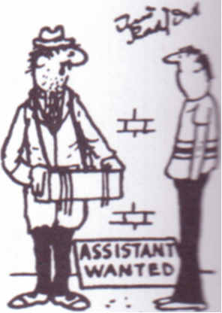"How many ‘A’ levels have you got?”

