Promoter Howest: Jan Detand Promoter Floradak: Marcel Eykens
Student: Decraecker Brecht
2010-2011
Green roof for each roof slope

Authors | Decraecker Brecht and Detand Jan
Study | Industrieel ontwerpen

Abstract

The mission spectrum of this thesis consists of following parts: Develop a green roof that can be placed on any sloped roof; Research the capacity of a sloped roof, if necessary reduce the weight of the green roof, Optimize the drainage of each roof; Reduce the cost so that the current price of a tiled roof is approximated; Develop a sustainable product.

Content
1 Floradak 4
1.1 Company selection 4
1.2 The Company 4
1.3 Acknowledgements sent to the company 4
2 School en Supervisor 4
2.1 Acknowledgements sent to the school and my supervisor 4
3 History of the green roof 4
3.1 Rice fields 4
3.2 The gardens of Babylon 4
4 Existing roofing systems 5
4.1 Tiled roof construction 5
4.2 Weight of a tiled roof 5
4.3 Stress calculations on an existing roof system 6
5 Green roof systems 6
5.1 What is a green roof? 6
5.2 Position of green roofs on the market. 7
5.3 Advantages of a green roof 7
5.4 The structure of existing green roof systems on a sloping roof. 8
5.4 Intensive and extensive green roofs 8
5.5 Vegetation of extensive green roofs 8
5.5.1 Sedum 8
5.5.2 Flowers, herbs and grasses 9
6 Testing on a square meter 9
6.1 Structure 9
6.1.1 Test 1| After 5 minutes of irrigation 10
6.1.2 Test 2| After 10 minutes of irrigation 10
6.2 Conclusion of the test results 10
7 The design 10
7.1 The start of the design 10
7.2 The LiDS wheel 11
7.3 The choice of materials and production 11
7.4 The overlap 12
7.5 Placement 12
7.7 A possible result 13
8 Conclusion 13
9 Sources 13

Floradak

Company selection

The choice of a green roof has a strong advance in recent years. Green roofs offer a wide range of benefits. Each roof has a specific shape, slope and strength. To offer a green solution to existing roofs, Floradak is the best company to help develop a green roof that can be placed on each roof.

The Company

Floradak is the best company for developing new adapted roofs, because this company is already 15 years pioneer in the field of green roofs. Floradak is the market leader in Belgium in the field of green roofs. Their roofs are also being placed by professional roofers.
EYKENS, M., FLORADAK. Groendak, internet, 2010-10-12, (http://www.floradak.be).

Acknowledgements sent to the company

As a student I am very glad that I got the chance to work with the people of Floradak, to develop a product that in many areas benefits both people and the environment. Cooperation with the people of Floradak was always very smooth. After every conversation, there was appropriate feedback from people with experience. I tried to convert this feedback into a sloping green roof that can be used for any roof.

School en Supervisor

Acknowledgements sent to the school and my supervisor

Despite the unusual path that I've made in the Hogeschool West - Vlaanderen, my supervisor Mr. Detand guided me well. For every question I got, the necessary feedback followed. He also has contributed to make my thesis became what it is now. For this I want to thank him. The “Hogeschool West – Vlaanderen” was of high quality. Again, all teachers, a heartfelt thank you.

History of the green roof

Rice fields

To fully understand green roofs, one must go back to the beginning: Rice Fields. On this ancient principle, all green roofs are based. A piece of land, walled in by low walls of mud for growing rice. The fields are, where necessary in a hilly landscape, terraced landscaped. Because rice grows in water, the water is very important. The rice fields are under water continuously until the rice is ripe and can be harvested. Another advantage of the flooding is weed control. There are different systems. Thus there are rice fields that depend on rainwater. Others are irrigated. The rice fields that depend on rainwater, collect rainwater over the entire surface. The excess water will flow through small slots in the top terraces into the next. In this way, a terrace never overflows. And thus the water level is constantly maintained the same.
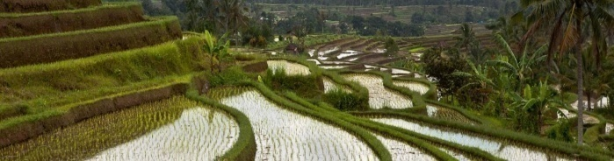
Figure 1

The gardens of Babylon

There was in the year 2500 BC. already talk of green roofs. This was actually the case in the Hanging Gardens of Babylon. Here they created gardens on the first and second floors of buildings. These gardens were one of the seven world wonders. So it is definitely worth to place these gardens in the form of green roofs on our roofs today. This will provide a tremendous aesthetic value to our buildings.

Existing roofing systems

Tiled roof construction

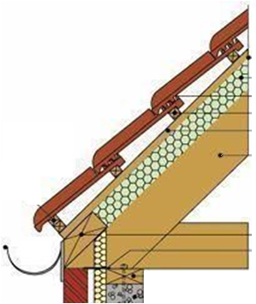
If the roofing system should be adapted to any pitched roof, One must know how most roofs are built. In this way the design can be customized.
Depending on which municipality one lives, one should take several factors in consideration. Because there are rules concerning ventilation, mounting of materials and the materials itself.
If one wants to place a roof, the contractor should clearly know how strong the roof is. This is usually discussed with the engineer or the architect.
After this, the roof placers will place the under felt on top of the trusses of the roof. Today this step is preceded by placing insulation. Here, the insulation on the roof trusses is places, so it won’t cause thermal bridges to arise. The under felt ensures that the roof, in any weather condition, guarantees a watertight roof. When it snow or when the wind blows water can seep under the tiles. After this is done, the vertical battens are places on the roof on the rafters. This allows for the attachment of the residences on the rafters.
The horizontal battens are the connection points for the tiles and keep the tiles in place. The distance should be large enough that the tiles overlap each other. That overlap is dependent on the type of pan and the way it hangs, the slope of the roof and the prevailing weather. This distance varies on average between 20cm and 25cm. This could be concluded after investigating several producers of clay tiles.
Finally the tiles are placed on these battens. And if so anchored to withstand strong gusts.
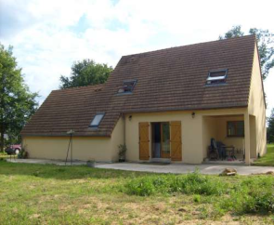
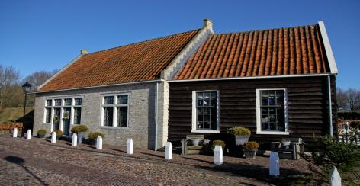
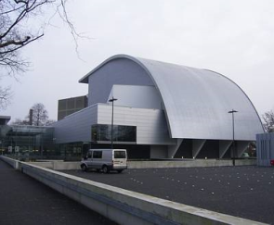
Figure 3
Figure 2

Weight of a tiled roof

The weight of existing tile is a good reference for a clear picture of the strength of roofs in general.
It was decided that: The larger the surface of the tiles, how lower the weight of these tiles is per square meter. This is due to the reduction of overlaps. Large tiles have fewer overlaps than smaller ones.
Also shown in this graph, is that an average roof weighs 44.4 kg per square meter. These roofs are designed by an architect or engineer to be able to carry more weight. A roof has to be resistant to wind, rain and snow. The safety factor that is often used is 3. It can be deduced that an average structure can bear 133.2 kilograms per square meter. Obviously this value cannot be used for any roof. This value is not the same for each roof. An engineer or an architect should be appointed.
(‘red.’), ETERNIT. Dakpannen, internet, 2010-09-05, (http://dak.eternit.be).
(‘red.’), OLIVIER. Dakpannen, internet, 2010-09-05, (http://www.olivier.be).

Stress calculations on an existing roof system

In order to obtain more certainty in the capacity of an existing roof structure, a finite element calculation is performed on an existing roof. The wooden beams that have been drawn for this test are pine beams. The roof pitch is 32 °; the squares have a section of 70x36; the battens 30x20.
Here was concluded that the maximum deflection at a weight of 60 kg, is 8mm. The maximum yield stress that occurs is 2384N/cm². This is much lower than the yield stress of the used wood: 8000N/cm².
The minimum safety factor that was applied was in every design 3. The deflection was permissible. The target value of the roof will therefore be 60 kg.
Figure 5
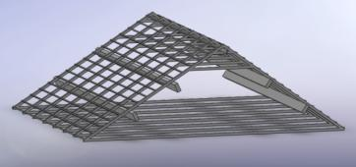
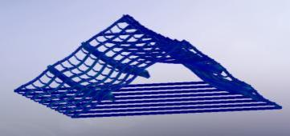

Tabel 1

Green roof systems
Figure 4

What is a green roof?

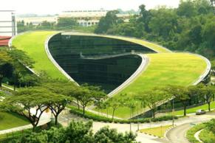
A green roof is a roof that is made up of several layers, so that the plant can grow in a correct matter. The choice of plants that can be planted on the roof is huge. One must be choosing the right plants for every roof and climate. Although a relatively unknown system, mainly in Belgium experiencing a big growth. In Antwerp there is an obligation for green roofs. If a building with a flat roof is build or renovated, a green roof has to be places on that flat roof. The success of these roofs is mainly due to the enormous benefits it offers to peple and the environment.

Position of green roofs on the market.

In the world, there is mainly in Belgium a large market for green roofs present. Green roofs are also on the rise in the Netherlands. The reason for this local market is due to our perfectly suitable climate for the roofs. It is therefore necessary for the particular product to be positioned within the Benelux.
Below is a representation of the current manufacturers:
- In Belgium
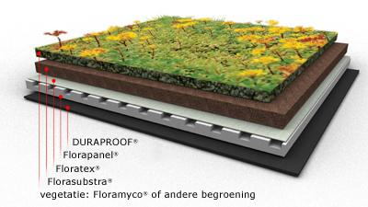

Figure 6
- In the Netherlands
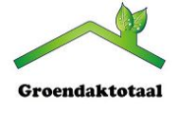
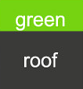
Figure 9

Figure 7
- International

Figure 8
(‘red.’), FYTO BVBA. Diensten, internet, 2010-10-19, (http://www.fyto.be).
(‘red.’), SEMPERGREEN BV. Informatie, internet, 2010-10-19, (http://www.sempergreen.be).
(‘red.’), GREEN ROOF BVBA. Onthaal, internet, 2010-10-19, (http://www.green-roof.be/nl/).
(‘red.’), GOOGLE IMAGES. Afbeeldingen, internet, 2010-08-08, (www.google.be/imgres).

Advantages of a green roof

The plants that grow on a green roof, absorb moisture. This allows the plants to survive dry periods. The water is buffered in the green roof and will be less affected by flooding. A green roof has several advantages:

- Extra insulation against heat;
- Filtering of particulate matter;
- Increase biodiversity;
- Ensures the quality of the roofing;
- Provides an ideal surface for solar panels on it for a higher return;
- Premiums of government;
- Aesthetics;
- Damping of ambient noise.

The structure of existing green roof systems on a sloping roof.

The construction of a green roof of Floradak consists of several layers. Each layer has its function and is essential for a proper functioning of the roof.
First a vapour barrier is placed to ensure that the damp from indoor will be stopped, so that no condensation can occur on the cold side of the roof. This could damage the insulation.
The insulation is placed on top of the vapour barrier and will ensure that minimal heat is released to the environment.
The waterproofing is clearly essential since it ensures that no moisture can penetrate into the house.
FLORAPANEL is placed above. The main function of this component is to ensure that water is retained so the plants over an extended period of moisture can escape from this layer. Furthermore, this layer makes sure that the roof will be protected. It also helps the insulation (sound and thermal). To dispose water without substrate to the FLORAPANNEL, there is also a textile cloth needed. In reverse, this canvas passes condensed water to the substrate.
The substrate is a mineral substrate that is extremely airy. The thickness of all the layers, depends on the vegetation. This thickness varies from 5 to 20 cm.

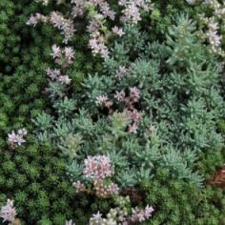
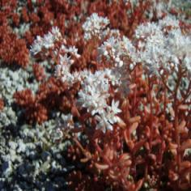
5.4 Intensive and extensive green roofs

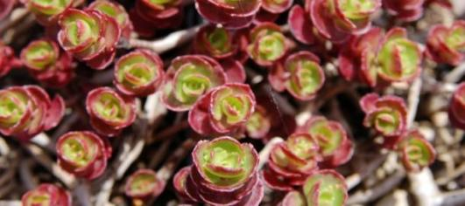
An intensive green roof requires an intensive maintenance. An example of these intensive green roofs are the roof gardens on flat rooftops. An intensive green roof has to be maintained like a regular garden. Pruning, weeding and other tasks include to the maintenance package of an intensive green roof.
An intensive green roof (roof garden) requires much more substrate for the vegetation to grow. The roof consists of several thick layers together to a thickness of 50 to 60cm. This makes the system not applicable to sloping roofs. The weight of this system would rice far beyond the capacity of existing roof.
Figure 11
Extensive green roofs, by contrast, frequently have roofs that cannot be entered, only for maintenance. An extensive green roof requires less maintenance and is significantly lighter than an intensive green roof. This system has therefore been preferred. However, it has the limitation that only a few species can grow out. The fact remains that the choice is still very broad.
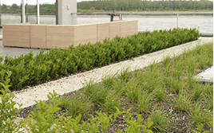
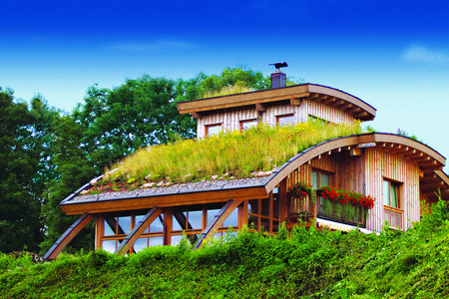

Vegetation of extensive green roofs
Figure 10

Sedum

Different plants can be placed on green roofs. A commonly used type is sedum (stonecrop). This family consists of 400 to 500 species. The species are found throughout the Northern Hemisphere. The plants are succulents that store water in their leaves. During the daytime the stomata of the leaves close allowing the evaporation to a minimum. This is an important benefit for both plants and humans. Because the plants can easily save a lot of moisture to endure extreme dry periods. The sewers will be less stressed and hereby flooding will also be reduced. The leaves of sedum break off easily and can root again in better times, and in this way reproduce vegetatively. Succulents absorb water very fast in their leaves, to endure the extremely dry periods. The plants can take on a wide range of temperatures. These plants have a need for a substrate layer thickness of 2-15cm. They are green in winter, ensuring throughout the year a beautiful green roof. Because of their requirements these plants are very easy to maintain. Only in very long periods of aridity extra water must be provided.

Flowers, herbs and grasses
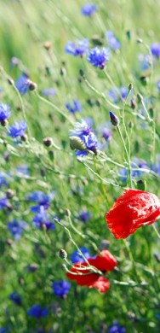
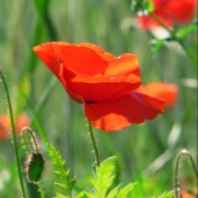

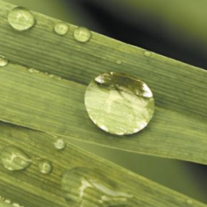

Figure 12
The plant and the roots of Flowers, herbs and grasses grow very quickly. This rapid growth of the roots is very beneficial for the cohesion of the substrate. Because the roots act as a network around the substrate, this substrate is much less likely to wash.
These plants are not winter hardy. People can only in the summer, enjoy a magnificent view of the roof. The plants wither in the winter, but the roots remain intact, allowing the plants to grow back without any problem in the spring.
A major advantage of these plants is that they are very easy to put on a roof by sowing. This provides a lower price of the roof.
The substrate thickness of these plants is between 5 and 20cm. This allows these plants to be used on any sloped roof.

Testing on a square meter

Structure

To ensure that all conducted tests are adapted to the benchmarks, a roof structure is made that can be placed under three different angles. Namely 20 °, 30 ° and 40 °. The surface of this arrangement is 1m². On top of the adjustable structure, several layers are placed that consists of:
- Plastic film terraces;
- Substrate in the terraces;
- A moisture-containing layer;
- A sedum mat.
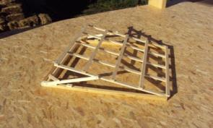
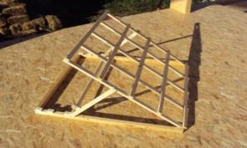

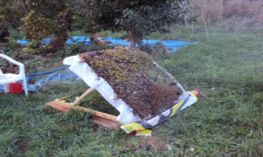
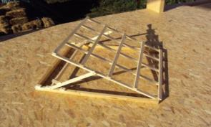

Figure 13

This all was artificially watered at a rate of 10mm/m². This amount of water corresponds to a downpour in Belgium. This rainstorm was performed two times. The first time for 5 minutes at all angles. The second time for 10 minutes at all angles.
In this way, both the weight loss of substrate, as the absorbed water can be measured. The rinsed substrate was collected in a filter.

Tabel 2

Test 1| After 5 minutes of irrigation

 | Lost substrate (gr) | Amount of absorbed water (l) | Total weight (kg)
40° | 21 | 10 | 42,2
30° | 17 | 10 | 42,2
20° | 8 | 14 | 45,2

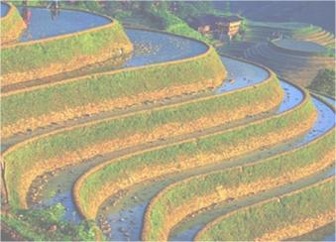
Test 2| After 10 minutes of irrigation
Tabel 3

 | Lost substrate (gr) | Amount of absorbed water (l) | Total weight (kg)
40° | 20 | 10 | 42,2
30° | 18 | 11 | 43,2
20° | 8 | 13 | 44,2

Conclusion of the test results

If the roof has stored a certain amount of water, it becomes saturated. This will not increase the weight so that the system remains below the specified weight limit.
The substrate that will be released by a larger roof will be much less. The substrate will only be released at the gutter.
If the roots of the sedum get the opportunity to adhere to the substrate, the loss of substrate will be reduced again.
To keep the loss within bounds even more, a drainpipe will be used. This will obstruct the small substrate particles and pass through the excess water.

The design

The start of the design

The design has started from an existing ecological system, namely the rice field. The buffering of water on a sloping roof is extremely difficult. A green roof needs standing water. This was generated by small terraces, just like a rice field, to create the green roof. This will also allow water and substrate to be present any time, in these small terraces.
Figure 14
In order to achieve this, the roof had to be modular to proceed. A tiled roof was fused with a rice field. The result of this Fusion was a green tile. (figure 15)
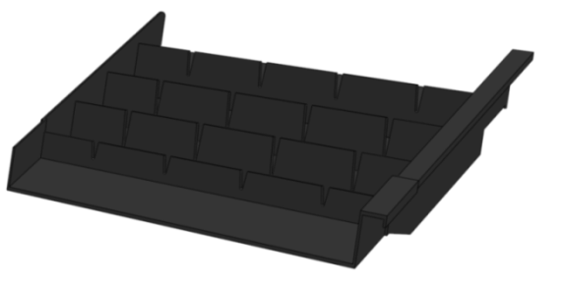
Figure 15

The LiDS wheel

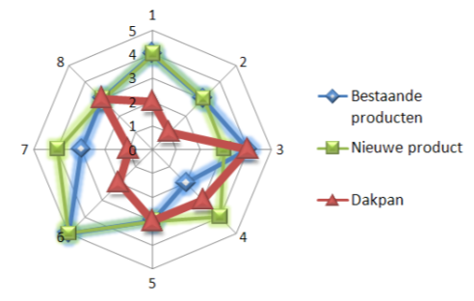
The LIDS wheel or full "Lifecycle Design Strategies" is a list of sustainable design strategies. The list consists of a few rules of thumb that may be used as support for sustainable product and has been developed by TU Delft. This is a wonderful tool to create an ecological product. By comparing existing products with the new product, could be found where the weaknesses and strengths were on the life cycle.

Tabel 4
Figure 16
Tabel 4

The choice of materials and production

Eco indicator 99 showed that PVC is a material that has a relatively low impact score. It should be noted that the recycling of this material was charged.
Furthermore, PVC is a material that can vary in hardness by using plasticizers. The more of it they add, the more flexible the final result. This is very useful for the design to make sure that the right hardness is obtained.
After several tests and investigations on vacuum forming of the PVC to the desired result appeared to fail. The wall thickness in this type of shaping plastic is in fact variable. Even after many precautions, the thickness of the wall will make major downturns in the design. The average thickness of the material is also unacceptable. A plate of 6mm PVC is required to achieve an end result of 3mm.
Finally the decision was made to produce a mould for the product. This technique has a high start-up cost. For a roof we need large quantities, allowing the price to be reduced over time.
The green tile is designed so that it ca, be produced with a two-part mould. Simplifying this mould contributes to a cheaper product.

The overlap

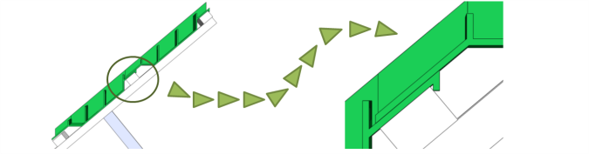
A horizontal and vertical overlap was provided. This will allow the natural flow of water to flow freely through all the terraces.
The distance between the battens can vary both horizontally and vertically. This ensures a better adjustment to any roof.

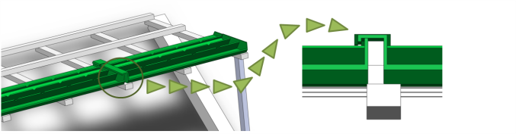

Figure 17

Placement

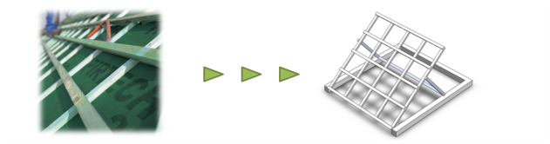
For all roofs will be started at a under felt so whatever the weather a watertight roof is ensured. Present – day, this under felt is placed on all roofs.

The placement of the green roof should always be done from bottom to top so that the overlap is guaranteed.
Figure 18
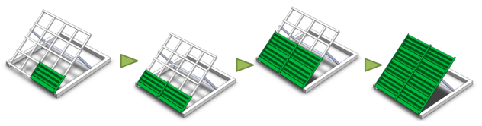

Figure 19

The substrate can be placed on the roof with a crane. Hereby people have to walk less on the tiles. This reduces the chance of damage to these elements.
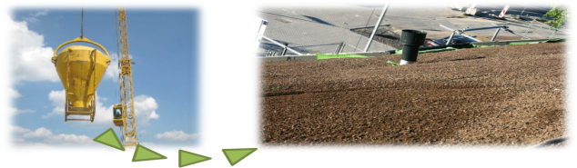

Finally the Sedum mats are put on the roof. They should be placed within 24 hours, to ensure that the plants can survive. The mats are rolled allowing the plants to receive no sunlight.
Figure 20
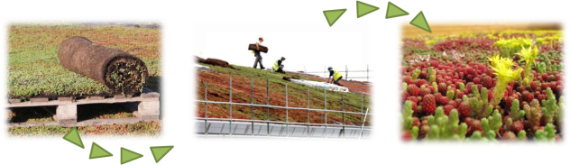
Figure 21
  - De finishing

A roof consists of more than one type of tiles. This entails taking into account the eaves, the ridge, the gutter, connection to the chimney, ventilation, etc. In the case of the tiles for each of these problems developed a separate tile.
Also for the green roof tiles, several tiles could be developed to solve these problems.
In the image below is an edge finish sown. The edge is slightly widened allowing the edge of the roof to come more into its own.
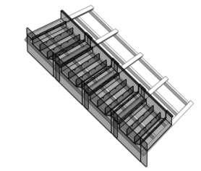
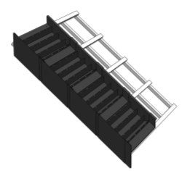
Figure 22
Figure 22

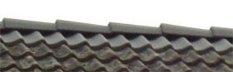
Also for the ridge a separate tile can be developed, but this is not necessary. A clay ridge can also be used since they are not in contact with the other pans. A ridge is in fact usually floating on top of the roof structure.

Figure 23
Figure 23
In the gutter a drainage tube is best placed, so that small amounts of substrate cannot provide a blockage in the drains.
The connections between the roofs, the chimney and the windows can be obtained by gluing EPDM. This material would provide the most ecologically solution.
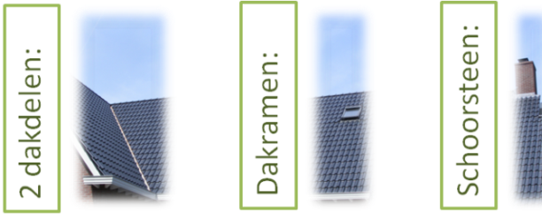
Figure 24

A possible result

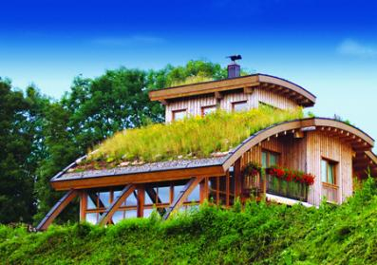

Figure 25

Conclusion
The development of the tile was for me a very pleasant experience. People should treat the environment better. This can be accomplished by very simple ways. Very small changes such as a green roof can have a major impact on the environment.
The drawbacks of existing green roof are reduced by the new green roof system. People with an existing roof can more easy exchange their old roof for an new green roof. Green roofs are the answer to many environmental problems. For example flooding. Energy could be saved thanks to the natural cooling of the green roof. Even solar panels work better thanks to green roofs.
I hope in the future, to be able to undertake similar projects. Because not only for roofs, a sustainable solutions can be found. The rest of the house could follow. Here we can also return to the past by building with straw bales.
The green trend that I experienced is becoming more common. For example: During the last two car shows, there was a remarkable green trend, like cars on electricity. The government support for this trend is very strong. I hope this will last a long time.

Sources
EYKENS, M., FLORADAK. Groendak, internet, 2010-10-12, (http://www.floradak.be).
(‘red.’), WIKIPEDIA. Rijstvelden, internet, 2010-10-02, (http://nl.wikipedia.org/w/index.php?title=Speciaal%3AZoeken&search=rijstvelden).
(‘red.’), WIKIPEDIA. Hangende tuinen van Babylon, internet, 2010-10-02, (http://nl.wikipedia.org/wiki/Hangende_tuinen_van_Babylon).
(‘red.’), FYTO BVBA. Diensten, internet, 2010-10-19, (http://www.fyto.be).
(‘red.’), SEMPERGREEN BV. Informatie, internet, 2010-10-19, (http://www.sempergreen.be).
(‘red.’), GREEN ROOF BVBA. Onthaal, internet, 2010-10-19, (http://www.green-roof.be/nl/).
(‘red.’), GOOGLE IMAGES. Afbeeldingen, internet, 2010-08-08, (www.google.be/imgres).
(‘red.’), ETERNIT. Dakpannen, internet, 2010-09-05, (http://dak.eternit.be).
(‘red.’), OLIVIER. Dakpannen, internet, 2010-09-05, (http://www.olivier.be).
(‘red.’), WIKIPEDIA. Sedum, internet, 2010-10-18, (http://species.wikimedia.org/wiki/Sedum).

