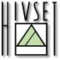

HIVSET
Herentalsstraat 70 . 2300 TURNHOUT. (32) 14/ 47 13 20
Apostoliekensstraat 4 . 2300 TURNHOUT. (32) 14/ 47 13 20
www.hivset.be

INFORMATION BROCHURE

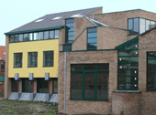 TAKING CARE

diversity & colour & quality & social contact & confidence & learning & sports & environment & creativity & respect & you 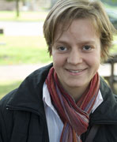 TAKING CARE

Educational project

We welcome young people who after an education in the different training programmes at our campus, will be able to become full members in society and responsible professionals in the social profit sector.
We aim to develop our students’ full potential.

We value

1. Respect, honesty, trust, motivation and discipline.
These values involve ourselves and others.
- We prepare our students to develop self-confidence.
- We teach our students social values that will result in personal attitudes. We also focus on a positive learning and working attitude.
- With the support of our staff we teach our young people to become independent learners.
- We want to stimulate team spirit by organizing a wide range of social activities within our school and together with other schools.

Our educational project reflects the spirit and the vision through which we wish to engage in active cooperation.
The school team, the students, the parents, the senior staff and the CLB, service for students with specific educational needs, all contribute to the
implementation of this vision.
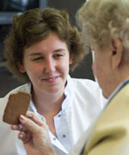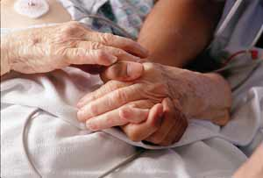

HIVSET CAMPUS – EDUCATIONAL PROGRAMMES

- OKAN
Okan is the abbreviation for Onthaalklas Anderstalige Nieuwkomers.
  - One year programme for immigrant students (minimum age: 12) whose knowledge of Dutch is not sufficient to take part in regular courses. We start from the individual needs of every student.

- SECONDARY EDUCATION
  - Vocational level
    - 14-16 years: care & food
    - 16-18 years: care
  - Technical level
    - 16-18 years: health & social sciences

- SECONDARY AFTER SECONDARY EDUCATION
  - Vocational level
    - 1 year programme:
Child care & care for elderly people & home care
  - Technical level
    - 1 year programmes:
    - Care for youth at risk & the disabled
    - Dental Assistant

- ASSOCIATE DEGREE NURSING
  - Vocational education for nursing: 3 years modular programme

- CENTRE FOR LEARNING & WORKING
  - Vocational programmes for students with special needs (-18, drop-outs ) in combination with work.

- VOCATIONAL TRAINING
  - Several programmes in adult education especially for students with a dual programme: combination of working & learning.
  - Short vocational courses for nurses and care workers
  - Two year training programme ‘Leadership in care’
  - Guidance and mentoring of on the job learning

How to find us

HIVSET-campus
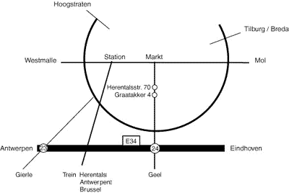

Contacts

Bob Van De Putte headmaster and rector; bob.van.de.putte@hivset.be

Coordinator international relationships:

Annemie Lauryssens: annemie.lauryssens@hivset.be

