Blinde kaart Nabije Oosten

[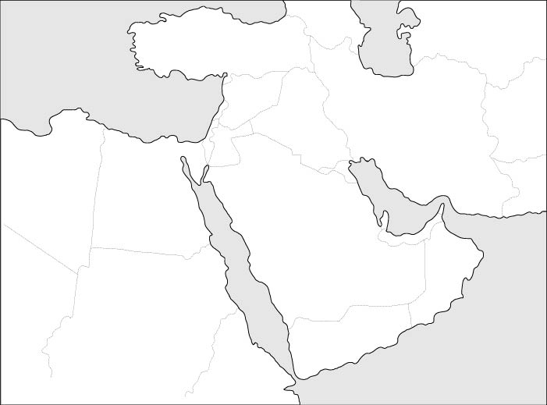](http://www.google.be/url?sa=i&rct=j&q=&esrc=s&frm=1&source=images&cd=&cad=rja&uact=8&ved=0CAcQjRw&url=http%3A%2F%2Flandkaarten.startpagina.nl%2F&ei=6IiaVJfmIIWCPfjYgLgE&bvm=bv.82001339,d.ZWU&psig=AFQjCNEKKBYz1b2H2sZQVwuLhz0_QC1uqQ&ust=1419500117215331)

[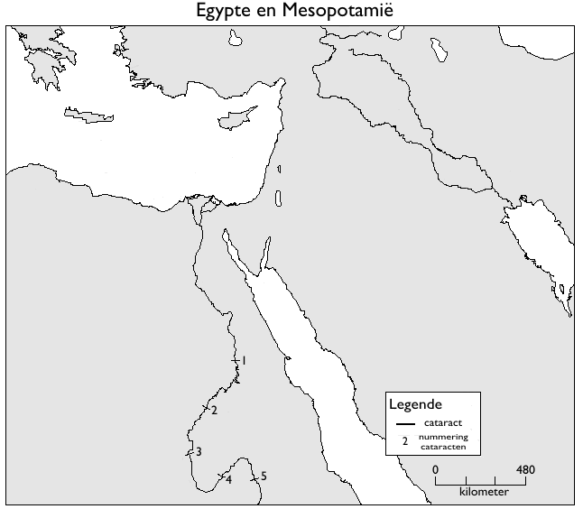](http://www.google.be/url?sa=i&rct=j&q=&esrc=s&frm=1&source=images&cd=&cad=rja&uact=8&ved=0CAcQjRw&url=http%3A%2F%2Fusers.skynet.be%2Fsoundsofscience%2Feindwerk%2Fgalerijhome.htm&ei=6ImaVJuPBM3JOfqvgZAB&bvm=bv.82001339,d.ZWU&psig=AFQjCNEKKBYz1b2H2sZQVwuLhz0_QC1uqQ&ust=1419500117215331)

[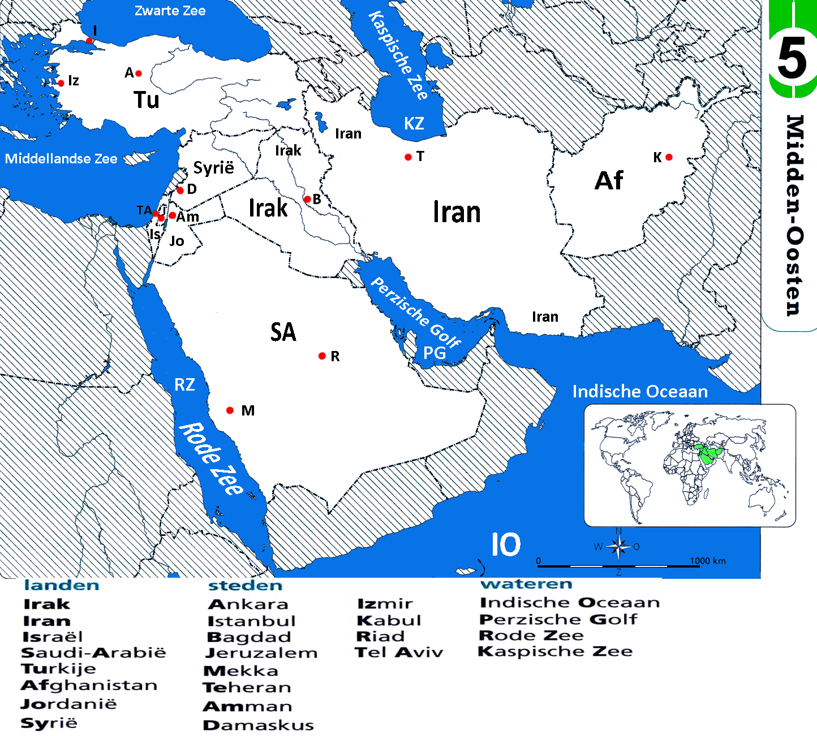](http://www.google.be/url?sa=i&rct=j&q=&esrc=s&frm=1&source=images&cd=&cad=rja&uact=8&ved=0CAcQjRw&url=http%3A%2F%2Fichthusgr8.yurls.net%2Fnl%2Fpage%2F769398&ei=MI2aVKX_FYPAPY2IgJgB&bvm=bv.82001339,d.ZWU&psig=AFQjCNFe3FBiKUSnrCxLWZ4VEf4ACw0sVA&ust=1419501185435275)

[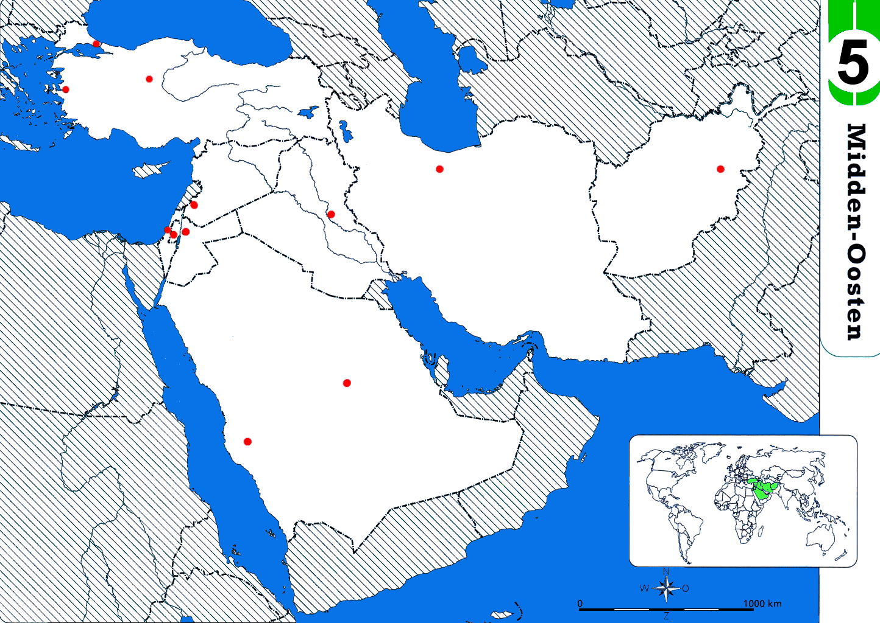](http://www.google.be/url?sa=i&rct=j&q=&esrc=s&frm=1&source=images&cd=&ved=0CAcQjRw&url=http%3A%2F%2Fichthusgr8.yurls.net%2Fnl%2Fpage%2F769398&ei=BYyaVM6AGYbBOYOtgaAN&psig=AFQjCNEHJyCZK61hDhPChT26SGNJ4Gyqiw&ust=1419500909094713)