**magic white beach cruiser te koop**

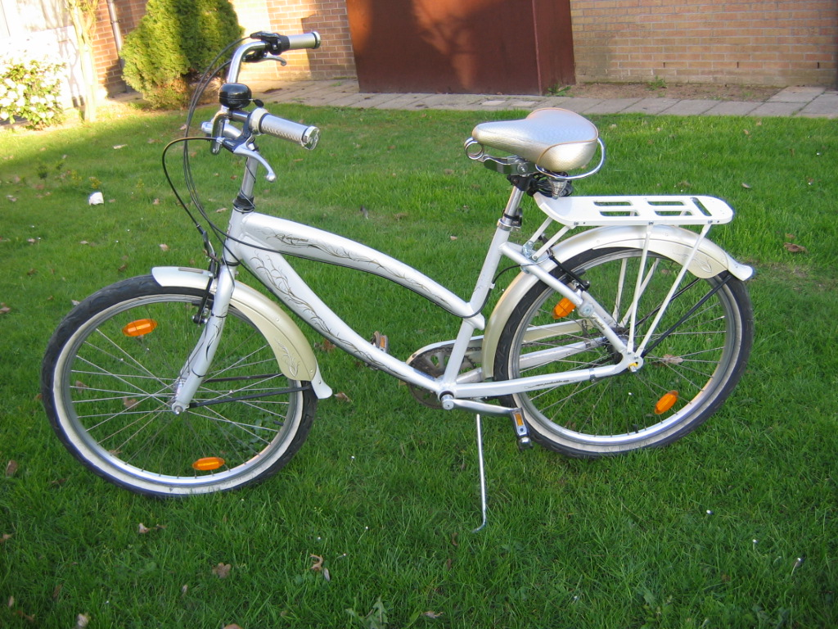

SPECIFICATIES:   
Frame: 26” Alloy, Beach Cruiser, Gents // LADIES: 47 cm   
Gearing: Shimano Nexus 3-speed   
Fork: D-Type, bended   
Rims: Rodi “Airline One”, 9x4   
Hubs: F: Shimano // R: Shimano Nexus 3-speed   
Brakes: Alloy V-Brake “TX125”   
Tires: 54-559 Kenda “Cruiser”

Vraagprijs : 350 euro

3 jaar oud

0488/26 45 06 : Annemie