EGYPTIAN MUMMIES

http://forum.christogenea.org/viewtopic.php?f=38&t=2174
http://mathildasanthropologyblog.wordpress.com/2008/07/21/mummies-and-mummy-hair-from-ancient-egypt/

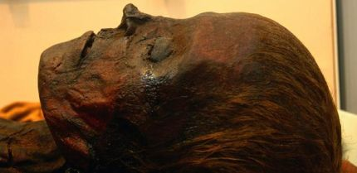
a woman from about 700 BC, and she has dead straight hair, probably hennaed
British Museum

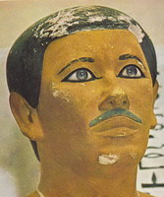 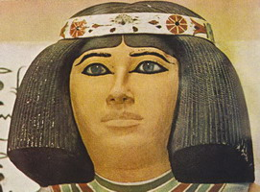 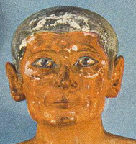 Egypt- 1 2 3

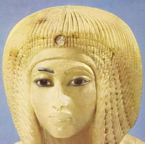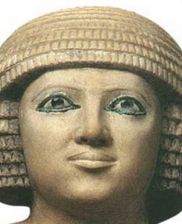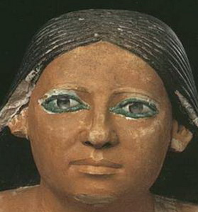
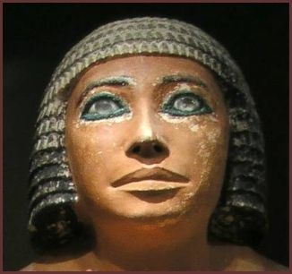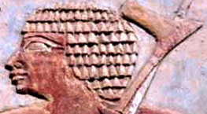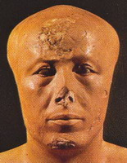
. crystal eyes soldier

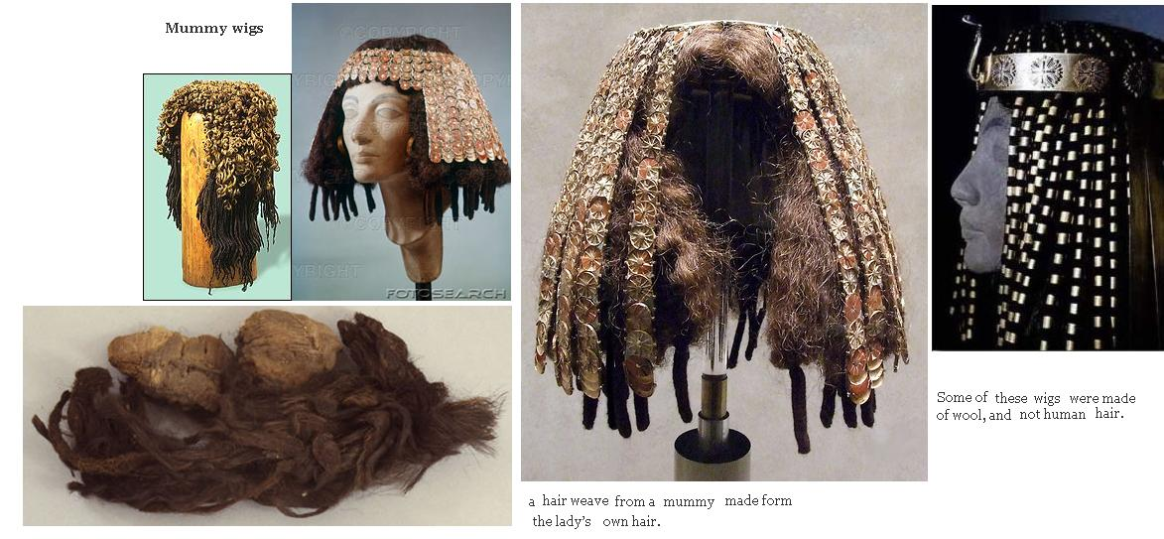

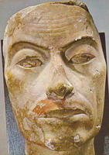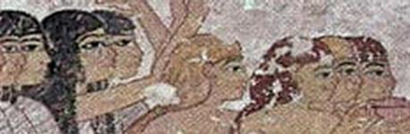

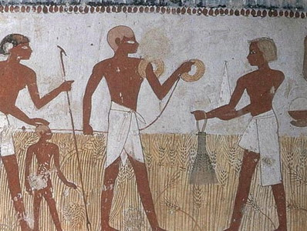

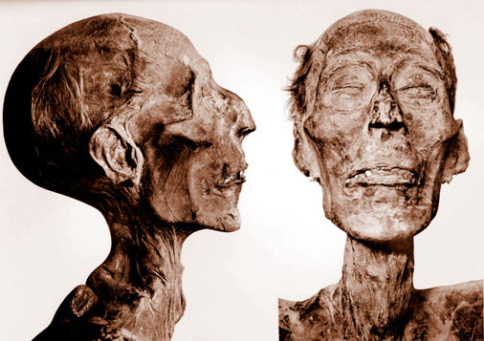

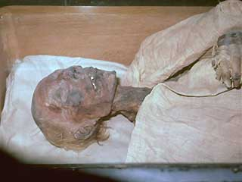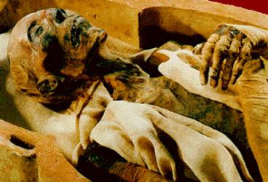
You can get a decent look at Ramses II hair here.
The L’Oreal institite plucked out one of hairs to examine the roots, and found it to be naturally auburn when he was younger (even grey hair retains pigment in the roots). It was hennaed in his old age to match the colour of his youth.
He is descibed as having cynotrichous wavy Caucasian red hair

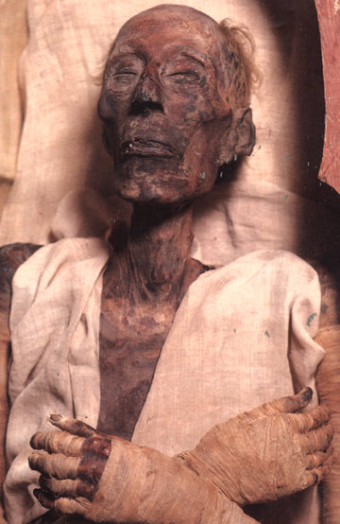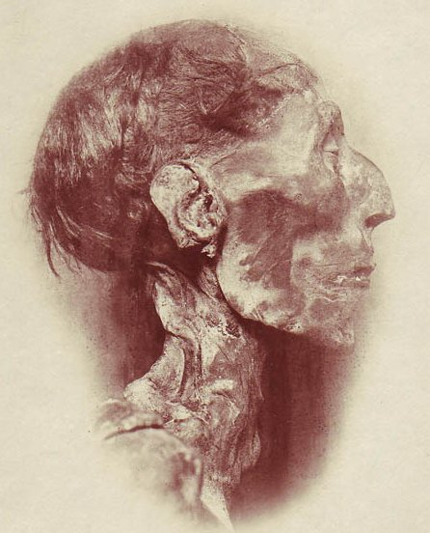

ramses-ii
Mummy of Ramses the second

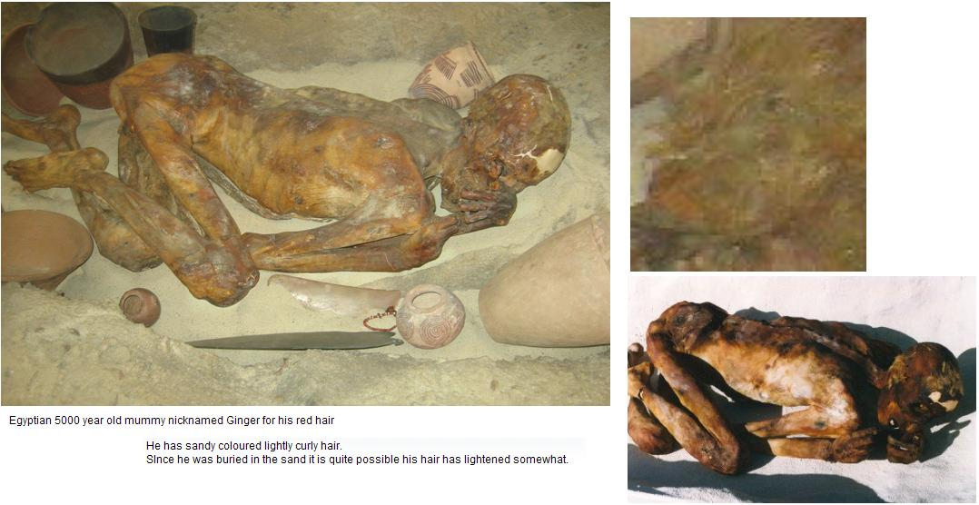

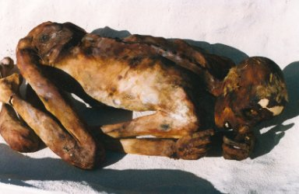

" Ginger "
Egyptian 5000 year old mummy nicknamed Ginger for his red hair

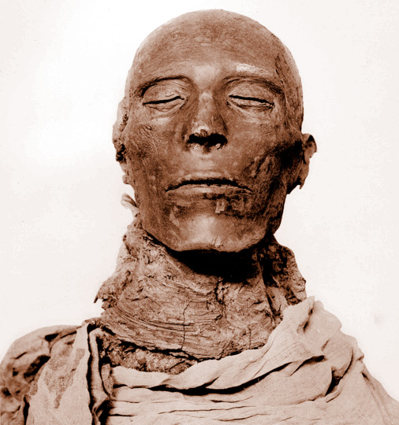

Seti-l

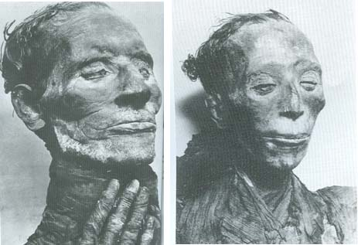
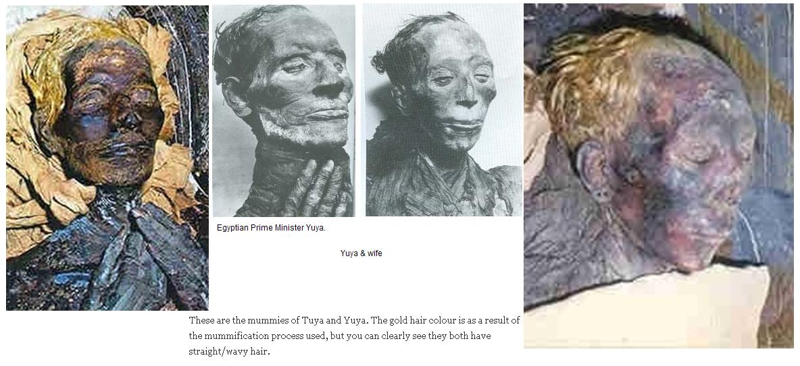

Yuya & wife
Egyptian Prime Minister Yuya. His mummy had light, blond hair.

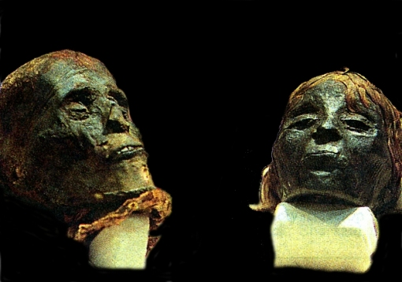

mummy hair- blond
These are two mummies from Egypt, currently in Australia. The red colour is thought to be in part due to resin, but upon close examination the head with a lot of hair appears to have naturally fair or light auburn straight hair.

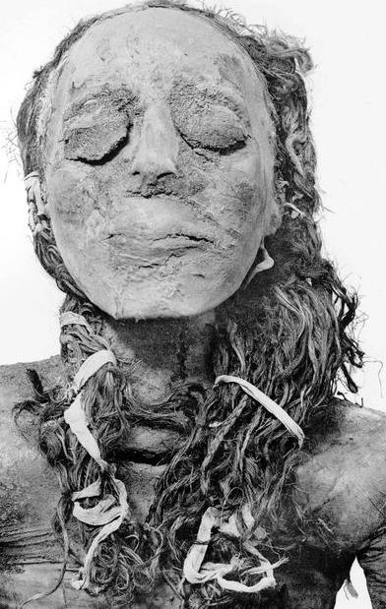
The princess Nsikhonsu, with long wavy brown hair

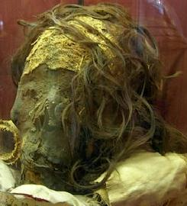This head is currently in Naples. It has long slightly wavy brown hair.
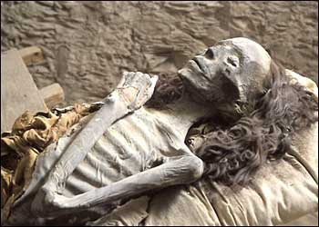
Elder lady tomb-kv35. As can be easily seen she has long slightly curly fine hair





