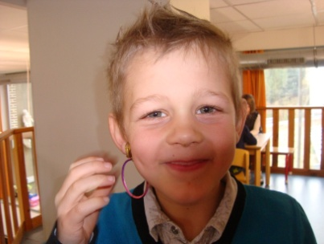[](http://www.google.be/url?sa=i&rct=j&q=&esrc=s&frm=1&source=images&cd=&cad=rja&docid=VPRoAEF33RqhmM&tbnid=AapSsOZsYHXUAM:&ved=0CAUQjRw&url=http%3A%2F%2Fwww.alfataal.nl%2Foef%2Flettersklanken%2Fsch%2Fschil00.htm&ei=LrcwUcQcpsHRBcqogMgG&bvm=bv.43148975,d.ZG4&psig=AFQjCNFoPXRhKhrOqbvDGpQBUr19DAJ5Xg&ust=1362233505355248)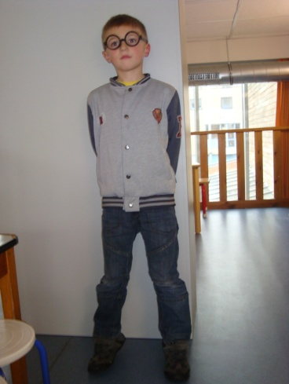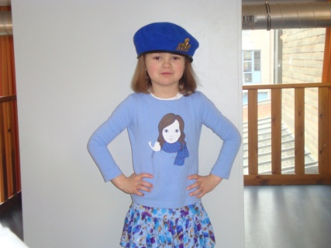[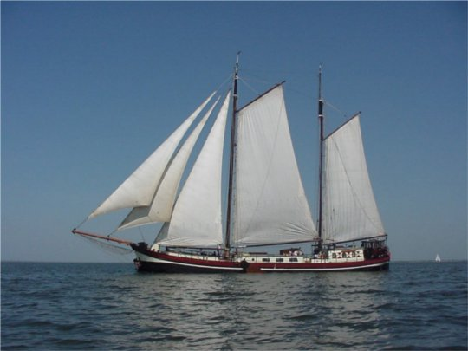](http://www.google.be/url?sa=i&rct=j&q=&esrc=s&frm=1&source=images&cd=&cad=rja&docid=VPRoAEF33RqhmM&tbnid=AapSsOZsYHXUAM:&ved=0CAUQjRw&url=http%3A%2F%2Fwww.naupar.com%2Fleisure%2Fbirthday%2F&ei=YLwwUdW-IIaQ4gT66ICQCA&bvm=bv.43148975,d.ZG4&psig=AFQjCNFoPXRhKhrOqbvDGpQBUr19DAJ5Xg&ust=1362233505355248)