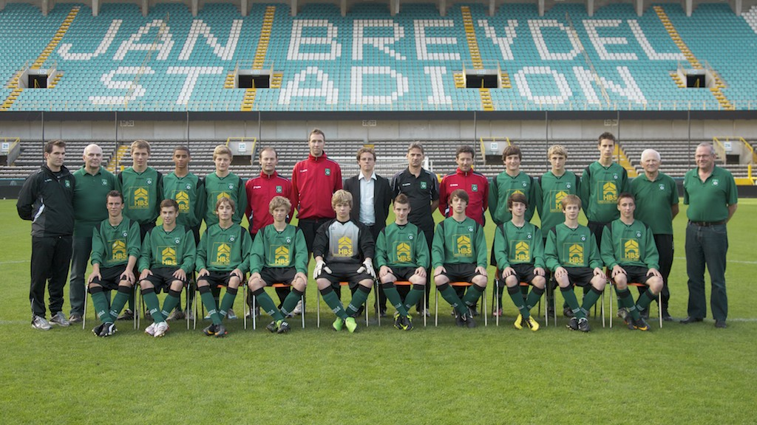

Cercle Brugge Elite U17 – Seizoen 2011 – 2012

 | ~ Juli 2011 ~
Sun | Mon | Tue | Wed | Thu | Fri | Sat
 |  |  |  |  | 1 | 2
3 | 4 | 5 | 6 | 7 | 8 | 9
10 | 11  18h30  Training | 12  18h30  Training | 13  18h30  Training | 14 | 15  18h00  Training | 16  Training  Onderlinge Partij  U15-U16-U17
17  Week 1 | 18  18h30  Training | 19  18h30  Training | 20  18h30  Training | 21 | 22  18h00  Training | 23  Oefenwedstrijd  14h00  Eernegem – Cercle
24  Week 2 | 25  18h30  Training | 26  18h30  Training  KTA !! | 27  18h30  Training | 28 | 29  18h00  Training  KTA !! | 30  Oefenwedstrijd  14h00  Cercle - Deinze
31 | Notes:

 | ~ Augustus 2011 ~
Sun | Mon | Tue | Wed | Thu | Fri | Sat
 | 1  18h30  Training | 2  18h30  Training | 3  18h30  Training | 4 | 5  18h15  Training | 6  Oefenwedstrijd  14h45  Cercle – Club
7  Week 3 | 8  18h30  Training | 9  18h30  Training | 10  Oefenwedstrijd  19h30  Bel. Ursel - Cercle | 11 | 12  18h15  Training | 13  Oefenwedstrijd  15h00  Oostende – Cercle
14  Week 4 | 15  18h30  Training | 16  18h30  Training | 17  18h30  Training | 18  10h00  Training | 19 | 20  13h30  KRC Genk – Cercle   4-1
21  Week 1 | 22  18h30  Training | 23  18h30  Training | 24  18h00  Cercle – RSCA   1-2 | 25 | 26  18h00  Training | 27  14h00  OH Leuven – Cercle  3-3
28  Week 2 | 29  18h30  Training | 30  18h30  Training | 31  14h00 – 16h00  Training | Notes:

◄ Aug 2011 | ~ September 2011 ~ |  |  |  |  | Oct 2011 ►
Sun | Mon | Tue | Wed | Thu | Fri | Sat
 |  |  |  | 1 | 2  18h00  Training | 3  14h00  Cercle – Lierse  2-1
4  Week 3  - Gills  - Mathieu  - Milan M  - Greg | 5  Training  18h30 | 6  Training  18h30 | 7  Training  14h00 | 8 | 9  18h30  Training | 10  13h30  Westerlo – Cercle  4-1
11  Week 4 | 12  Training  18h30 | 13  Training  18h30 | 14  Training  14h00 | 15 | 16  18h30  Training | 17  14h00  Cercle – Klup  2-3
18  Week 1  - Arne  - Pieter  - Milan DR  - Yaron | 19  Training  18h30 | 20  Training  18h30 | 21  Training  14h00 | 22 | 23  18h30  Training | 24  15h00  Zulte – Cercle  4-5
25  Week 2  - Gills  - Mathieu  - Milan M  - Gregory | 26  Training  18h30 | 27  Training  18h30 | 28  Training  14h00 | 29 | 30  Training  18h30 | Notes:

 | ~ Oktober 2011 ~
Sun | Mon | Tue | Wed | Thu | Fri | Sat
1
14h00
Cercle - KVK
2-0
2  Week 3 | 3  Training  18h30 | 4  Training  18h30 | 5  Training  14h00 | 6 | 7  Training  18h30 | 8  14h00  Gent -Cercle   1-4
9  Week 4 | 10  Training  18h30 | 11  Training  18h30 | 12  Training  14h00 | 13 | 14  Training  18h30 | 15  14h00  Cercle - Lokeren  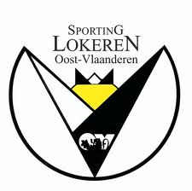 1-0
16  Week 1 | 17  Training  18h30 | 18  Training  18h30 | 19  GEEN Training | 20 | 21  Training  18h30 | 22  14h00  Cercle-Beerschot  1-0
23  Week 2 | 24  GEEN Training  Trainersvergadering | 25  Training  18h30 | 26  Training  14h00 | 27 | 28  Training  18h30 | 29  15h00  KV Mechelen - Cercle  2-2
30  Week 3 | 31  Training  18h30  - Video-analalyse | Notes:

◄ October | ~ November 2011 ~ |  |  |  |  | December ►
Sun | Mon | Tue | Wed | Thu | Fri | Sat
 |  | 1  Training U16-U17  9h45 Kunstgras  Met EIGEN vervoer !  (9h30 op Cercle) | 2  Training  14h00 | 3 | 4  Training  18h30 | 5  14h00  Cercle – Standard  1-5
6  Week 4 | 7  Training  18h30 | 8  Training  18h30 | 9  Training  14h00 | 10 | 11  Training  18h30 | 12  14h00  STVV – Cercle  2-0
13  Week 1 | 14  RECUP  Training  18h30 | 15  Training  18h30  Onderlinge partij  Vs U16 | 16  Training  14h00 | 17 | 18  Training  18h30 | 19  14h00  Cercle – Bergen  3-1
20  Week 2 | 21  Training  18h30 | 22  Training  18h30 | 23  Training  14h00 | 24 | 25  Training  18h30 | 26  14h00  Cercle – Genk  1-1
27  Week 3 | 28  Training  18h30 | 29  Training  18h30 | 30  Training  14h00 | Notes:
More Calendars: December, January, February

 | ~ December 2011 ~
Sun | Mon | Tue | Wed | Thu | Fri | Sat
 |  |  |  | 1 | 2 | 3  14h00  Rsca – Cercle  5-0
4  Week 4 | 5  Evaluatie  18h – 21h | 6  VRIJ | 7  VRIJ | 8 | 9  VRIJ | 10  VRIJ
11  Week 1 | 12  Winterstop | 13  Winterstop | 14  Winterstop | 15 | 16  Winterstop | 17  VRIJ
18  Week 2 | 19  Winterstop | 20  Winterstop | 21  Winterstop | 22 | 23  18h30  Training  U15/U16/U17 | 24  VRIJ
25  Week 3 | 26  GEEN training | 27  18h30  Training | 28  GEEN  Training | 29 | 30  18h30  Training | 31  VRIJ

 | ~ Januari 2012 ~
Sun | Mon | Tue | Wed | Thu | Fri | Sat
1 | 2  18h30  Training  (Tr. David) | 3  18h30  Training  (Tr. David) | 4  14h00  Training  (Tr. David) | 5 | 6  18h30  Training | 7  9h30  Training  - Onderlinge partij U16
8  W1 | 9  18h30  Training | 10  18h30  Training | 11  14h00  Training | 12 | 13  18h30  Training | 14  14h00  Cercle – OHL  3-1
15  W2 | 16  18h30  Training | 17  18h30  Training | 18  14h00  Training | 19 | 20  18h30  Training | 21  12h00  Lierse – Cercle  AFGELAST => training KTA
22  W3 | 23  18h30  Video-analyse +  Uitlopen | 24  18h30  Training | 25  14h00  Training | 26 | 27  18h30  Training | 28  14h00  Cercle – Westerlo  2-2
29  W4 | 30  18h30  Training | 31  18h30  Training | Notes:

 | ~ Februari 2012 ~
Sun | Mon | Tue | Wed | Thu | Fri | Sat
 |  |  | 1  14h00  Training | 2 | 3  GEEN training | 4  14h00  Klup – Cercle  AFGELAST
5  WEEK 1 | 6  18h30  GEEN Training | 7  18h30  Training | 8  13h00 - 14h30  Training  (Tr David) | 9 | 10  18h00  Training  (Tr Gertjan & Tr Bart) | 11  14h00  Cercle – Zulte  AFGELAST
12  WEEK 2 | 13  18h30  Training | 14  18h30  Training | 15  14h00  Training | 16 | 17  18h30  Training  (Tr David) | 18  14h00 (Tr David)  KV Kortrijk – Cercle  AFGELAST
19  WEEK 3 | 20  18h30  Training  (Tr David) | 21  18h30  Training  (Tr David) | 22  18h00  Wedstrijd  Cercle – Nat. U17  (Tr David) | 23 | 24  18h30  Training  (Tr David) | 25  14h00  Cercle – Gent  2-4
26  WEEK 4 | 27  18h30  Training | 28  18h30  Training | 29  14h00  Training | Notes:

 | ~ Maart 2012 ~
Sun | Mon | Tue | Wed | Thu | Fri | Sat
 |  |  |  | 1 | 2  18h30  Training | 3  14h30  Lokeren – Cercle  2-1
4 | 5  18h30  Training | 6  18h30  Training | 7  14h00  Training | 8 | 9  18h30  Training | 10  14h00  Beerschot – Cercle  2-2
11 | 12  18h30  Training | 13  18h30  Training | 14  14h00  Training | 15 | 16  18h30  Training | 17  14h00  Cercle – Mechelen  2-0
18 | 19  18h30  Training | 20  18h30  Training | 21  !! GEEN Training !! | 22 | 23  18h30  Training | 24  GEEN Wedstrijd  Galabal  
25 | 26  Geen Training  (Algemene Verg.) | 27  18h30  Training | 28  14h00  Training | 29  18h30 (start 19h00)  Training | 30 | 31  14h00  Cercle – STVV  1-0

 | ~ April 2012 ~
Sun | Mon | Tue | Wed | Thu | Fri | Sat
1 | 2  GEEN Training  Evaluaties | 3  18h30  Training | 4  18h00  Cercle – Zulte  2-3 | 5 | 6  18h30  Training  Evaluaties | 7  VRIJ
8 | 9  GEEN  Training | 10  18h30  Training | 11  18h00  Standard – Cercle  2-2 | 12 | 13  18h30  Training | 14  14h00  Bergen – Cercle  1-0
15 | 16  18h30  Training | 17  18h30  Training | 18  GEEN  Training | 19 | 20  18h30  Training | 21  12h00  Lierse – Cercle  3-0
22 | 23  18h30  Training | 24  18h30  Training | 25  GEEN  Training | 26 | 27  18h30  Training | 28  14h00  Club – Cercle  2-2
29 | 30 | Notes:

U17: Beurtrol => Materiaal & kleedkamer (W1 => W4)
Week 1
- Arne
- Pieter
- Milan D
- Yaron
Week 2
- Mathieu
- Milan M
- Gregory
Week 3
- Kwame
- Joren
- Jilke
- Kyle
Week 4
- Stef
- Maxim
- Jasper
- Aaron


Cercle Brugge U17 Seizoen 2011-2012
(Weekplanning => Wedstrijd + 4 trainingen)
Maandag
- “Hersteltraining” => Omvang van de training primeert op de intensiteit ! => Inlopen (joggings)
- Actief herstellen & recupereren => Afvoeren afvalstoffen / Relaxatie spieren / Optimaliseren basisconditie
- Uithouding => EDT (= Extensieve duurtraining)
- Tempo waarbij je nog net kan praten
- HF => 140 – 160
- Duur: blokken 10 à 12 minuten
- Preventietraining
- Stabilisatie
- Proprioceptie
- Kracht (=> Algemene kracht)
- Buik
- Rug
- Benen
- Armen & schouders
- Techniektraining
- “Huiswerk”
Dinsdag
- “Prikkel-training” binnen Thema

- Inloop: => Extensieve Duur (HF 140-160) – Voetbalschoenen (of joggings)

- Atelier
- 1. Loopladder (coördinatie)
- 2. Haagjes (frequentie)
- 3. Combi (Wendbaarheid – Plyometrie – Snelheid)
- 4. Dynamische Stretching

- Prikkeltraining ifv Thema

- Duurtraining: Wedstrijdconditie onderhouden (HF 160-180)
- Verhogen Anaerobe drempel ° Verbeteren zuurstoftransport
- Trainen melkzuurverwijdering
- Prikkelen snelle spiervezels
OF
- Intervaltraining: Prestatieverbetering => Verbeteren snelheid- en krachtuithoudingsvermogen, verbeteren explosief vermogen (HF 170-190)
- Startsnelheid
- Versnellingsvermogen

- Cooling Down: Uitloop + Statische Stretching

Woensdag
- Inlopen => Recuperatie van prikkeltraining dag voordien !!
- Individueel programma + Circuittraining + Onderlinge partij

Vrijdag
- Wedstrijdvoorbereiding
- Duur: 1h10
- Opwarming
- Inloop => 5’
- Dynamische opwarming + coördinatie (snelvoetenwerk) => 5’
- Dynamische stretching
- Pasvorm/Wedstrijdvorm => 10’
- Pasvorm/Wedstrijdvorm => 10’
- Sprintwerk : “kort & competitief” => 10’
- Per 2
- 5-12m
- Variaties: signaal-posities-looplijn-lengte
- Wedstrijdvorm => kort (2 à 3 minuten) & kleine ruimtes => 10’
- Cooling Down (Standaardsituaties) => 10’

