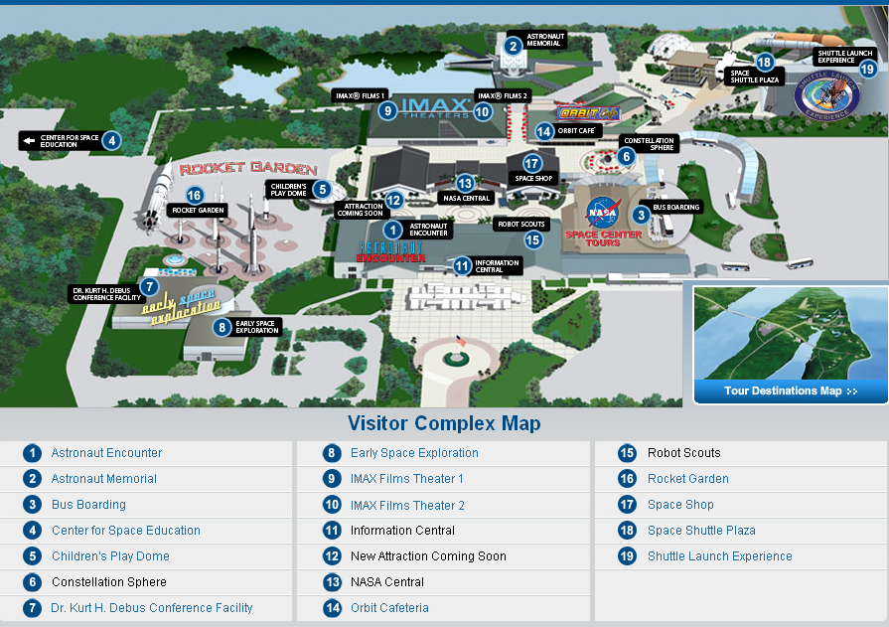
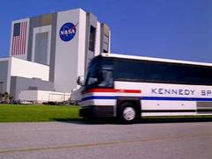
Kennedy Space Center Tour
Included with admission, this unique tour takes you to the International Space Station Center, LC 39 Observation Gantry, and the Apollo/Saturn V Center. The tour bus departs every 15 minutes from the Visitor Complex.
Kennedy Space Center and Cape Canaveral are working space launch facilities. Tours may be altered or closed due to operational requirements. Tickets are non-refundable and non-transferable. Prices subject to change and do not include tax.
Price: Included with General Admission

International Space Station Center
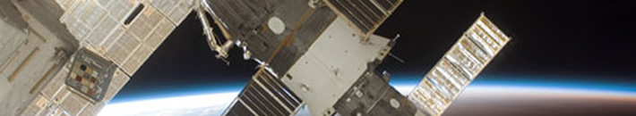

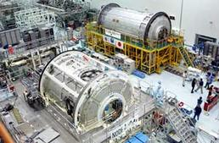
Now it's your turn to climb aboard the International Space Station. The International Space Station is "the dream that seemed impossible" – the most ambitious space program since the Apollo moon landings.
This fascinating attraction gives you an up-close glimpse inside the actual facility where NASA prepares the real components of the International Space Station – the largest, most complex structure ever to be placed into orbit. In an elevated observation room, you’ll see the actual processing bay where each Space Station component is checked out, processed and readied for its trip into orbit.
After the observation room, you can enter a full-scale mock-up of the Habitation Module and see how Space Station crew members live, sleep and work.
Price: Included with General Admission

KSC Tour: LC 39 Observation Gantry


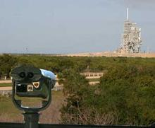
The 60-foot-tall Launch Complex (LC) 39 Observation Gantry provides a breathtaking 360-degree view of the two giant Shuttle Launch Pads, 39A and 39B. In addition to the bird’s-eye view of our launch pad structures, the panorama also includes the Launch Control Center, the well-traveled crawlerway and the massive Vehicle Assembly Building. KSC tours of the LC 39 Observation Gantry also include behind-the-scenes briefings on what it takes to launch and land every NASA Space Shuttle.
Price: Included with General Admission

Apollo / Saturn V Center
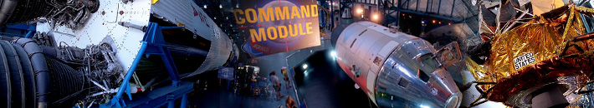

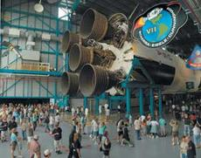
Millions of people held their breath while a single man stepped onto the moon’s surface – a journey that began just a short distance from where the Apollo/Saturn V Center stands today. For those who remember, the event remains in their minds just as those footprints remain in the lunar soil.
Here, in a spacious facility featuring a real Saturn V rocket, the Apollo program returns spectacularly to life. The Apollo/Saturn V Center is a tribute to the Apollo astronauts and the machines that got them there – and brought them home safely.
Price: Included with General Admission

Celebrate the 40th Anniversary of Man's First Steps on the Moon
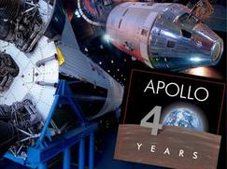
Apollo astronauts Buzz Aldrin, Walter Cunningham, Edgar Mitchell, Al Worden, Charlie Duke; and Apollo support crew Jerry Carr, Vance Brand and Bruce McCandless, celebrated the 40th Anniversary of Apollo and marked the opening of a new exhibit at the Apollo/Saturn V Center. The new exhibit showcases rarely seen treasures from the Apollo moon missions.
The Apollo artifacts in the new exhibit include a rare collection of spacesuits and other gear used by the Apollo moonwalkers to explore the lunar surface.

