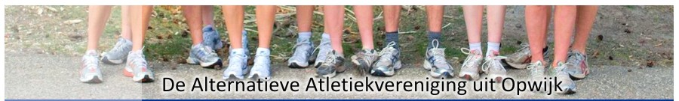

**UURROOSTER VOLKSCROSS 2012**

|  |  |  |  |
| --- | --- | --- | --- |
| **12u30** | **KIDS-SNOEPRUN** |  |  |
|  |  |  |  |
| **13u00** | BEN Vr (2005-2004-2003) | 887m | 1 kleine ronde |
| **13u05** | BEN M (2005-2004-2003) | 887m | 1 kleine ronde |
| **13u10** | PUP VR (2002-2001) | 1.528m | 1 grote ronde |
| **13u18** | PUP M (2002-2001) | 1.528m | 1 grote ronde |
| **13u25** | MIN Vr (2000-1999) | 1.774m | 2 kleine ronden |
| **13u33** | MIN Vr (2000-1999) | 1.774m | 2 kleine ronden |
| **13u40** | CAD Vr | 2.415m | 1 kleine + 1 grote ronde |
| **13u52** | CAD M | 3.056m | 2 grote ronden |
| **14u04** | SCH Vr | 3.056m | 2 grote ronden |
| **14u18** | SCH M | 3.943m | 1 kleine + 2 grote ronden |
| **14u32** | Korte cross Ma | 3.056m | 2 grote ronden |
| **14u45** | JUN Vr | 4.584m | 3 grote ronden |
| **14u45** | SEN Vr | 4.584m | 3 grote ronden |
| **14u45** | MAS Vr | 4.584m | 3 grote ronden |
| **15u05** | SEN M | 8.527m | 1 kleine + 5 grote ronden |
| **15u35** | JUN M | 6.112m | 4 grote ronden |
| **15u35** | MAS M | 6.112m | 4 grote ronden |



