VWF PARCOURS 2011
Parcours HUMBEEK 4 juli Criterium (rondje 800m)
http://www.google.be/maps?saddr=Saslaan&daddr=Seringenlaan+to:Azalealaan+to:Steenstraat+to:Saslaan&hl=nl&sll=50.977696,4.391795&sspn=0.005012,0.009624&geocode=FWneCQMdTANDAA%3BFXDiCQMdaARDAA%3BFTTdCQMdzhFDAA%3BFfbZCQMdGA5DAA%3BFWLeCQMdXQNDAA&mra=mi&mrsp=4&sz=17&t=h&z=17
Parcours Bavegem 3 juli BENELUX-kampioenschap
http://www.google.be/maps?saddr=Sint-Antoniusstraat,+9520+Sint-Lievens-Houtem&daddr=Meulestraat+to:Letterhoutemdorp+to:Vlierstraat+to:Bussegem+to:Lindestraat+to:Sint-Antoniusstraat&hl=nl&ll=50.937121,3.877873&spn=0.020067,0.038495&sll=50.941934,3.869376&sspn=0.010032,0.019248&geocode=FUJVCQMdePk6ACnr2yQrKaDDRzElANVnxDgGOQ%3BFawrCQMd_w07AA%3BFXoVCQMdMDo7AA%3BFWUlCQMdhnA7AA%3BFUdTCQMdFmc7AA%3BFU5kCQMdMjg7AA%3BFXFVCQMdm_k6AA&mra=dme&mrsp=6&sz=16&dirflg=w&z=15
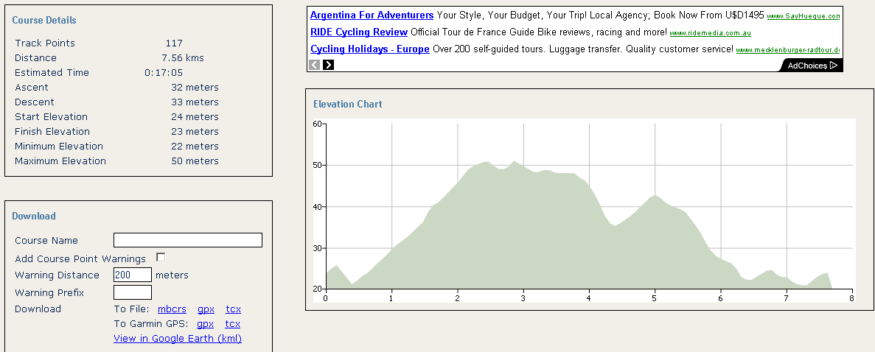
Parcours Dilbeek 2 juli
http://maps.google.be/maps?saddr=Kattebroekstraat+44,+1700+Dilbeek&daddr=Sint-Ambrosiuslaan+to:d'Arconatistraat+to:Stationsstraat+to:Robert+Dansaertlaan+to:Elegemstraat,+Dilbeek,+Vlaams+Gewest+to:Kattebroekstraat&hl=nl&ll=50.857435,4.256558&spn=0.020101,0.038495&sll=50.8568,4.255975&sspn=0.020101,0.038495&geocode=FdP2BwMdpRpBACnN47OFLMHDRzEYx-oAgcNIQg%3BFW7mBwMd1BRBAA%3BFQPgBwMdafJAAA%3BFeYiCAMdIMdAAA%3BFcQmCAMd4utAAA%3BFc4KCAMdrRRBACmLY98PKcHDRzHWkDD6oJwzWg%3BFQj3BwMd8BpBAA&mra=dme&mrsp=6&sz=15&dirflg=w&z=15
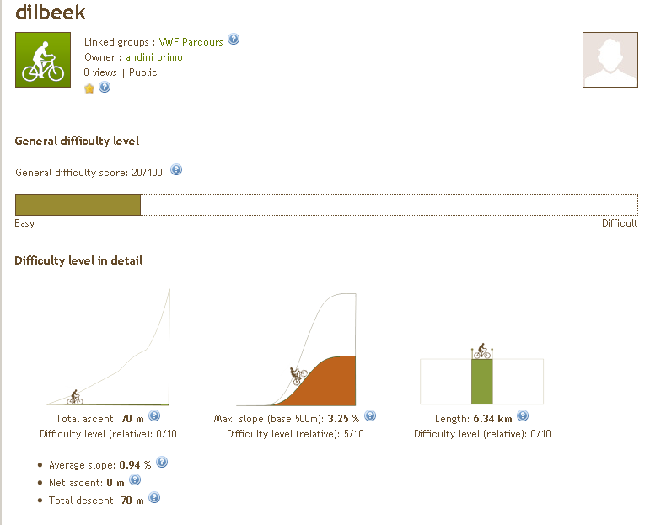
Parcours Hemelveerdegem 29 juni
http://www.google.be/maps?saddr=Triepstraat&daddr=Haltbaan+to:Kwaadstraat+to:Wassegemstraat+to:Populierenstraat+to:Watermolenstraat+to:Galgestraat+to:Gentsestenweg%2FN42+to:Triepstraat&hl=nl&ll=50.797689,3.854055&spn=0.040254,0.07699&sll=50.800131,3.864269&sspn=0.040252,0.07699&geocode=FSc_BwMdueo6AA%3BFfgrBwMdY7w6AA%3BFeMrBwMdOmg6AA%3BFUH_BgMdmpA6AA%3BFV4aBwMdkJ46AA%3BFcj7BgMdYsI6AA%3BFRQKBwMdaxg7AA%3BFeM4BwMdExY7AA%3BFQA_BwMdDus6AA&mra=mi&mrsp=8&sz=14&z=14
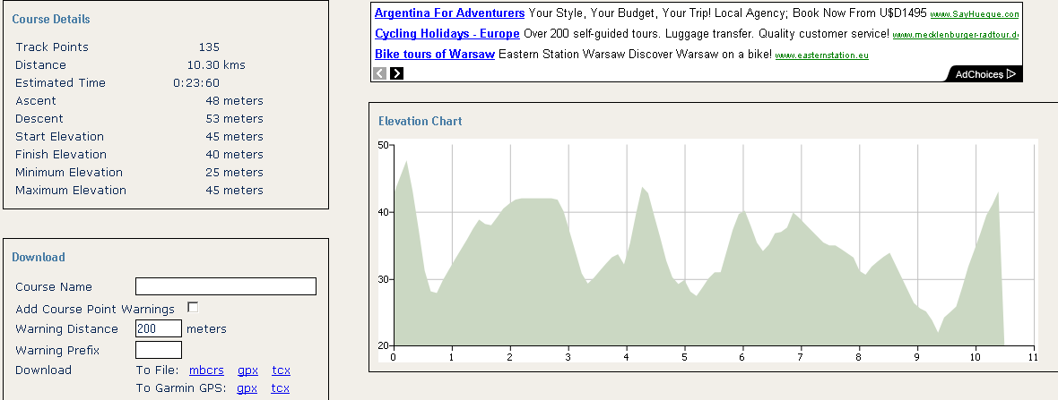
Parcours Gooik 26 juni
http://maps.google.be/maps?f=d&source=s_d&saddr=Dorpsstraat&daddr=Stuivenbergstraat+to:Drie+Egyptenbaan+to:Kindekensstraat+to:Lindestraat+to:Dorpsstraat&geocode=FR4UBwMdLtQ-AA%3BFQgqBwMdntw-AA%3BFWpABwMdKFg-AA%3BFdgWBwMdgVg-AA%3BFU0YBwMdOpI-AA%3BFe4TBwMd5NM-AA&hl=nl&mra=mi&mrsp=5&sz=16&dirflg=w&sll=50.79575,4.110239&sspn=0.009806,0.019248&ie=UTF8&ll=50.799995,4.103007&spn=0.01961,0.038495&z=15
Parcours Elversele 25 juni
http://maps.google.be/maps?f=d&source=s_d&saddr=Legen+Heirweg,+9140+Temse&daddr=Burggravestraat+to:Bergstraat+to:Hofstraat+to:Hofstraat+to:Gentstraat+to:Legen+Heirweg&geocode=FWzvCwMdnVc_ACl197mE_I3DRzGQPXQnaSHmuw%3BFRP8CwMdUE4_AA%3BFW8cDAMde28_AA%3BFZY5DAMduYc_AA%3BFVsHDAMd3qU_AA%3BFbDwCwMdPJM_AA%3BFXDvCwMd91c_AA&hl=nl&mra=mi&mrsp=6&sz=15&sll=51.118098,4.167037&sspn=0.019477,0.038495&ie=UTF8&ll=51.121358,4.164934&spn=0.038951,0.07699&t=h&z=14
Parcours Huizingen 20 juni
http://www.google.be/maps?f=d&source=s_d&saddr=Henry+Torleylaan&daddr=Oudstrijdersstraat+to:J.+van+Laetstraat+to:Molenstraat+to:Watermolenstraat+to:Watermolenstraat+to:Lotsesteenweg+to:Menisberg+to:Henry+Torleylaan&hl=nl&geocode=FZFWBgMd8jpBAA%3BFS5jBgMdwhhBAA%3BFQ5uBgMdEhdBAA%3BFd6PBgMd0ShBAA%3BFW9vBgMdkT1BAA%3BFbpiBgMd0UtBAA%3BFatzBgMdAWtBAA%3BFUNVBgMdrUtBAA%3BFUlWBgMdRDtBAA&mra=mi&mrsp=8&sz=16&dirflg=w&sll=50.748947,4.282587&sspn=0.009816,0.019248&ie=UTF8&ll=50.754106,4.279475&spn=0.01963,0.038495&t=h&z=15
Parcours Buggenhout 19 juni
http://www.google.be/maps?f=d&source=s_d&saddr=Vierhuizen+15,+9255+Buggenhout&daddr=Bovendonkstraat+to:Bovendonkstraat+to:Stenenstraat+to:Meir+to:Hauwerstraat+to:Vierhuizen&hl=nl&geocode=FaFoCgMdQARAACkbKUzPhJTDRzHJh3kikE3Hog%3BFeBYCgMd5ApAAA%3BFQg2CgMdFAtAAA%3BFQwyCgMdAe4_AA%3BFZ80CgMdnLs_AA%3BFfh1CgMdoNM_AA%3BFVdpCgMdUQNAAA&mra=dme&mrsp=4&sz=15&dirflg=w&sll=51.000064,4.187722&sspn=0.019526,0.038495&ie=UTF8&ll=51.007328,4.189568&spn=0.039047,0.07699&t=h&z=14
Parcours Zele 18 juni
http://www.google.be/maps?f=d&source=s_d&saddr=Wijnveld,+9240+Zele&daddr=Hoekstraat+to:Donkerputstraat+to:Donkerputstraat+to:Durmen+to:Wijnveld&hl=nl&geocode=FTt1CwMdNak9AClxS9zInZrDRzFFRcfEpQKbDA%3BFVOfCwMdjqo9AA%3BFW2gCwMdENY9AA%3BFVODCwMdxuU9AA%3BFRZyCwMdDLs9AA%3BFTZ1CwMdL6k9AA&mra=mi&mrsp=5&sz=15&sll=51.085626,4.052539&sspn=0.01949,0.038495&ie=UTF8&ll=51.089346,4.049706&spn=0.019489,0.038495&z=15
Parcours Erembodegem Criterium 17 juni
http://www.google.be/maps?f=d&source=s_d&saddr=Kaai&daddr=Onbekende+weg+to:Zwalmkouter+to:Zwalmkouter+to:Dokter+Carlierlaan+to:Gaston+de+Schepperstraat+to:Erembodegem-Dorp+to:Kaai&hl=nl&geocode=FQL7CAMdc-s9AA%3BFeL4CAMdJOQ9AA%3BFevzCAMd3eM9AA%3BFUneCAMd9uk9AA%3BFTjlCAMdafU9AA%3BFTLyCAMdy_A9AA%3BFa76CAMdKvI9AA%3BFdb6CAMdpOs9AA&mra=dme&mrsp=7&sz=17&dirflg=w&sll=50.91891,4.060822&sspn=0.004802,0.009645&ie=UTF8&ll=50.916292,4.058719&spn=0.009605,0.01929&z=16
Parcours Nieuwkerken-Waas TTC-ronde 16 juni
http://www.google.be/maps?f=d&source=s_d&saddr=Nieuwkerkenstraat+37,+9100+Sint-Niklaas&daddr=Vrasenestraat%2FN451+to:Kolkstraat+to:Ekelstraat+to:Buitenstraat+to:Kriekelaarstraat+to:Nieuwkerkenstraat+to:Nieuwkerkenstraat&hl=nl&geocode=Fb4fDQMdSsI_ACnbHsGD9ovDRzENKV0Nl_Pg3Q%3BFW0zDQMdr9E_AA%3BFXdPDQMdkds_AA%3BFeZKDQMd4Jk_AA%3BFYpcDQMdvak_AA%3BFddODQMdfxhAAA%3BFeoaDQMdnMU_AA%3BFYAfDQMd4MI_AA&mra=mi&mrsp=7&sz=15&sll=51.197741,4.188066&sspn=0.019443,0.038495&ie=UTF8&ll=51.198897,4.184289&spn=0.019443,0.038495&z=15
Parcours Merchtem-Peisegem 13 juni
http://www.google.be/maps?f=d&source=s_d&saddr=Sint+Huybrechtstraat&daddr=Kouter+to:Gasthuisstraat+to:Galgestraat+to:Dries+to:Sint+Huybrechtstraat&hl=nl&geocode=FRTwCQMdf3NAAA%3BFVLsCQMdnoBAAA%3BFaCtCQMd0pJAAA%3BFYjUCQMdMFhAAA%3BFSLgCQMdokBAAA%3BFfvvCQMd8nJAAA&mra=dme&mrsp=5&sz=15&dirflg=w&sll=50.974724,4.217591&sspn=0.019186,0.038581&ie=UTF8&t=h&z=15
Parcours Affligem 12 juni
http://www.google.be/maps?f=d&source=s_d&saddr=Kerkstraat,+1790+Affligem&daddr=Zwarteberg+to:Balleistraat+to:Balleistraat+to:Bremtstraat+to:Bellestraat%2FN208+to:Kerkstraat&hl=nl&geocode=FTDUCAMdRqk-ACmB45642r3DRzHOL1EWg3y0yg%3BFbzHCAMdW5U-AA%3BFSiuCAMdtnY-AA%3BFUqbCAMdyIo-AA%3BFQGTCAMdmqw-AA%3BFaujCAMdv7A-AA%3BFffTCAMdbak-AA&mra=mi&mrsp=6&sz=16&dirflg=w&sll=50.90739,4.110324&sspn=0.009607,0.01929&ie=UTF8&ll=50.902302,4.105282&spn=0.019216,0.038581&z=15
Parcours Breendonk 11 juni
http://www.google.be/maps?f=d&source=s_d&saddr=Veurtstraat&daddr=Groenstraat,+2870+Puurs,+Antwerpen,+Vlaams+Gewest+to:Zavelstraat+to:Veurtstraat&hl=nl&geocode=FfmpCgMdHPBBAA%3BFWPuCgMdmNZBACl1Vm78N-zDRzHLspVZAYS-Jw%3BFQzgCgMdCatBAA%3BFbypCgMdaO9BAA&mra=dme&mrsp=0&sz=15&dirflg=w&sll=51.032111,4.31973&sspn=0.019162,0.038581&ie=UTF8&ll=51.040827,4.314837&spn=0.019158,0.038581&z=15

