VWF PARCOURS 2011
Parcours Gooik 26 juni
http://maps.google.be/maps?f=d&source=s_d&saddr=Dorpsstraat&daddr=Stuivenbergstraat+to:Drie+Egyptenbaan+to:Kindekensstraat+to:Lindestraat+to:Dorpsstraat&geocode=FR4UBwMdLtQ-AA%3BFQgqBwMdntw-AA%3BFWpABwMdKFg-AA%3BFdgWBwMdgVg-AA%3BFU0YBwMdOpI-AA%3BFe4TBwMd5NM-AA&hl=nl&mra=mi&mrsp=5&sz=16&dirflg=w&sll=50.79575,4.110239&sspn=0.009806,0.019248&ie=UTF8&ll=50.799995,4.103007&spn=0.01961,0.038495&z=15
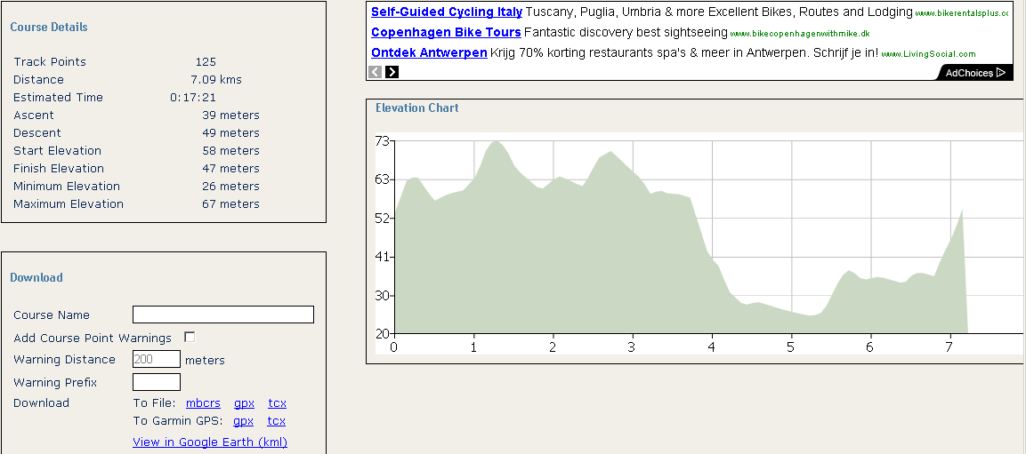
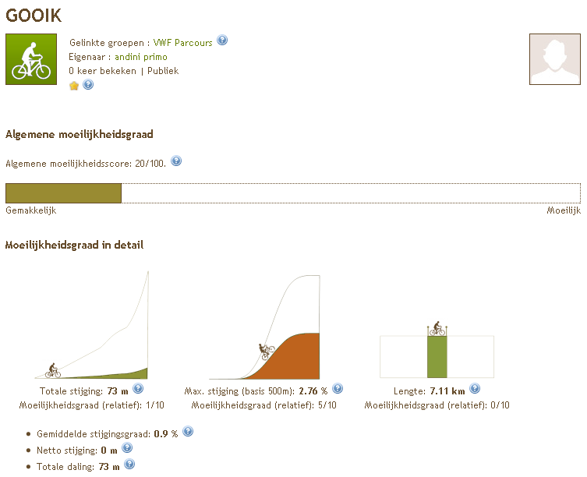

Parcours Elversele 25 juni
http://maps.google.be/maps?f=d&source=s_d&saddr=Legen+Heirweg,+9140+Temse&daddr=Burggravestraat+to:Bergstraat+to:Hofstraat+to:Hofstraat+to:Gentstraat+to:Legen+Heirweg&geocode=FWzvCwMdnVc_ACl197mE_I3DRzGQPXQnaSHmuw%3BFRP8CwMdUE4_AA%3BFW8cDAMde28_AA%3BFZY5DAMduYc_AA%3BFVsHDAMd3qU_AA%3BFbDwCwMdPJM_AA%3BFXDvCwMd91c_AA&hl=nl&mra=mi&mrsp=6&sz=15&sll=51.118098,4.167037&sspn=0.019477,0.038495&ie=UTF8&ll=51.121358,4.164934&spn=0.038951,0.07699&t=h&z=14
