**De app Cycloo is de koerskapitein van de Vlaamse recreant**

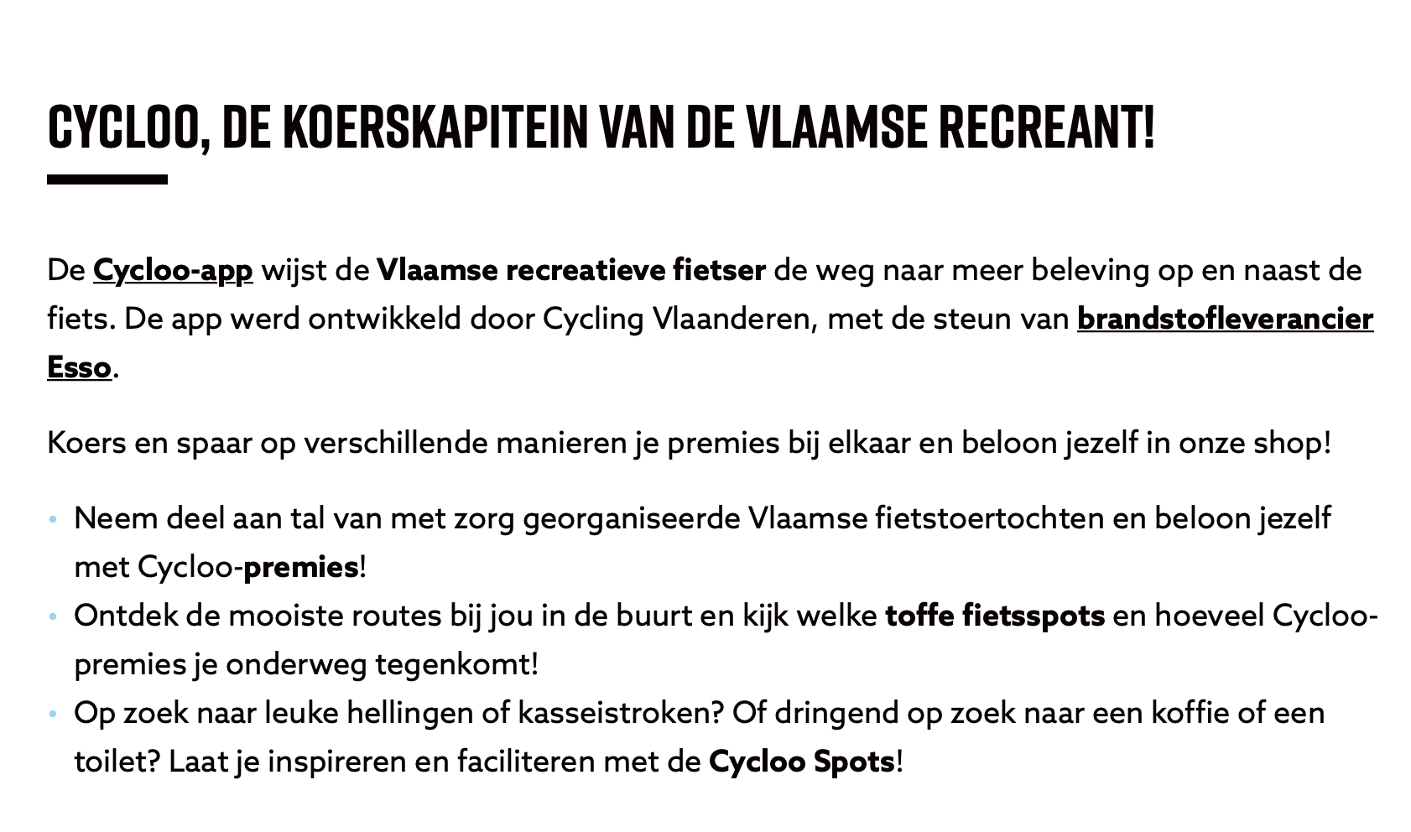

**Download hem – Iphone toestel? Via de app store / andere smartphone met android? Via Google Play.**

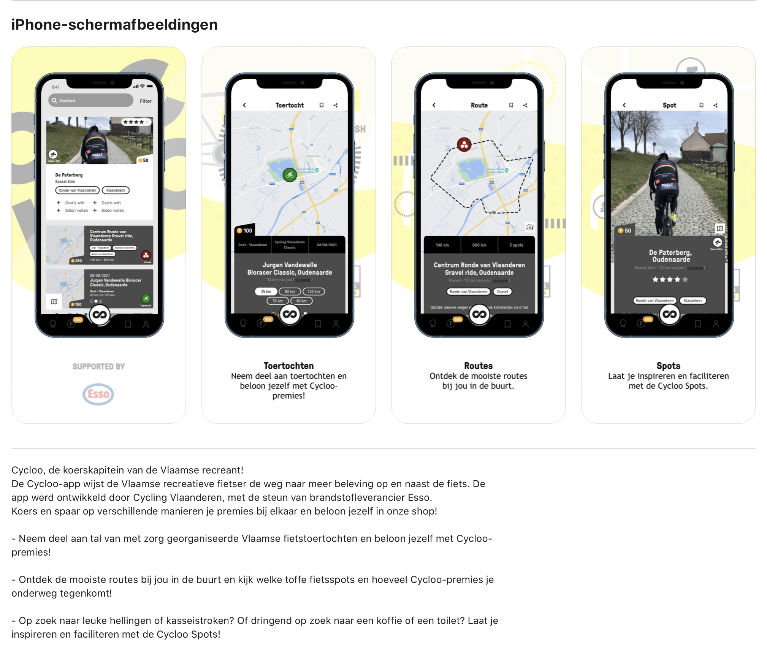

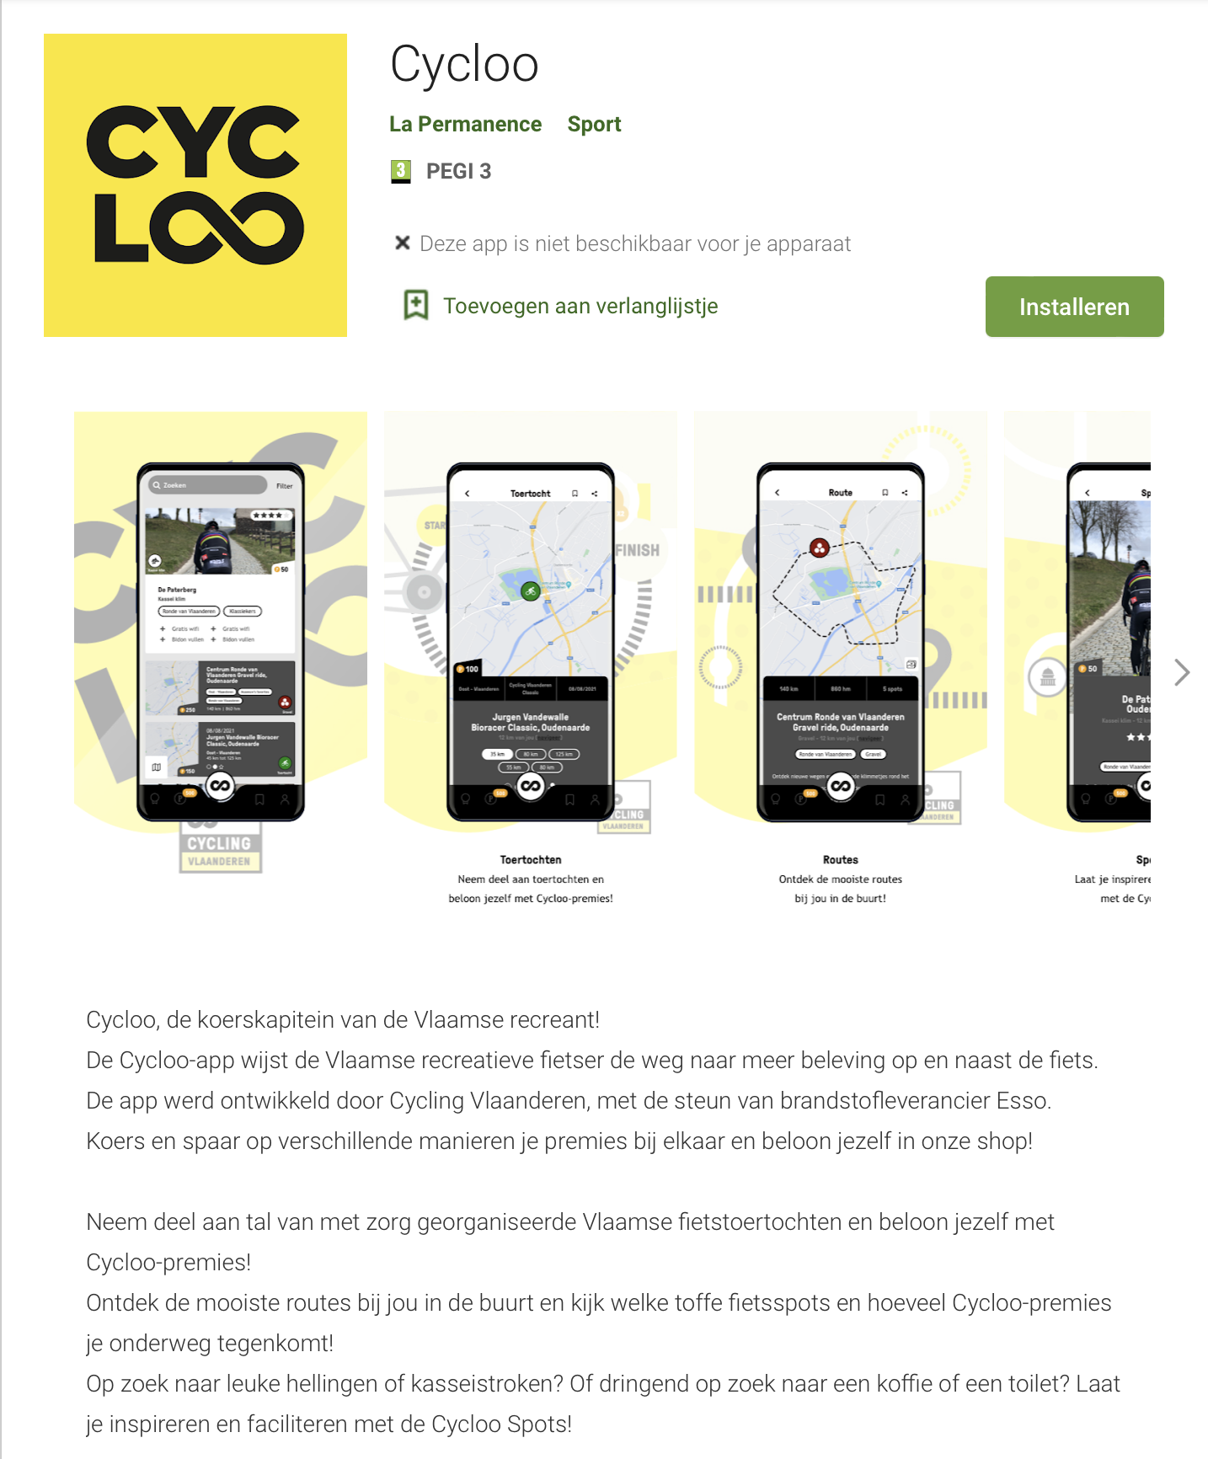

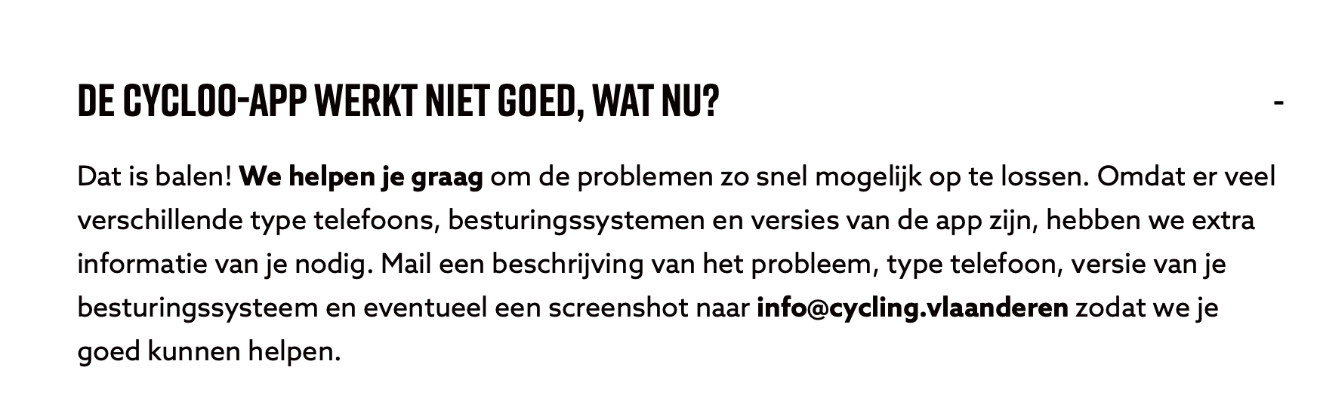

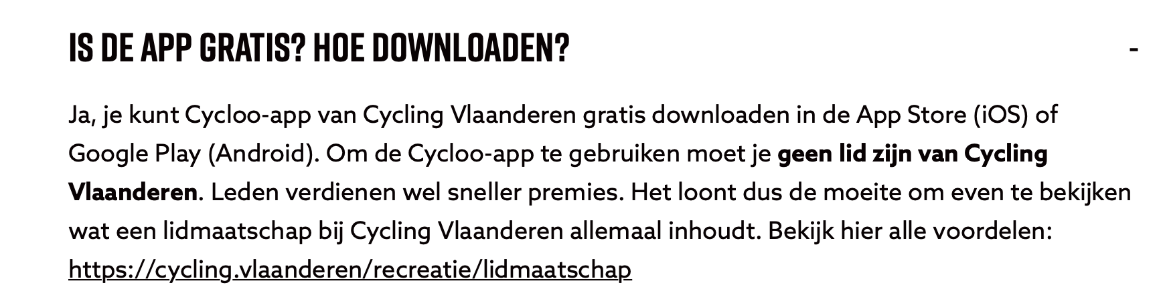

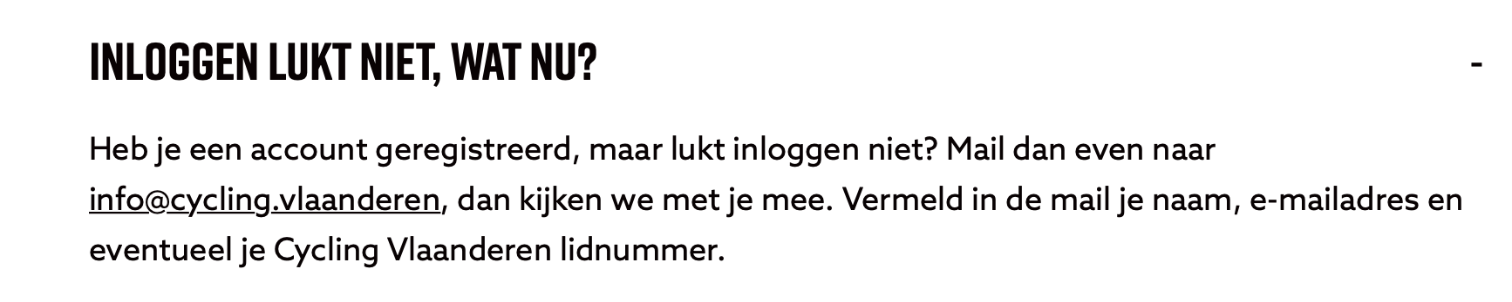

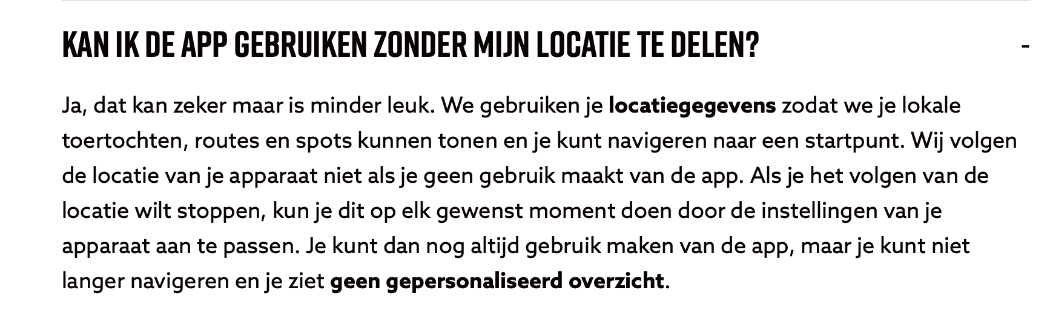

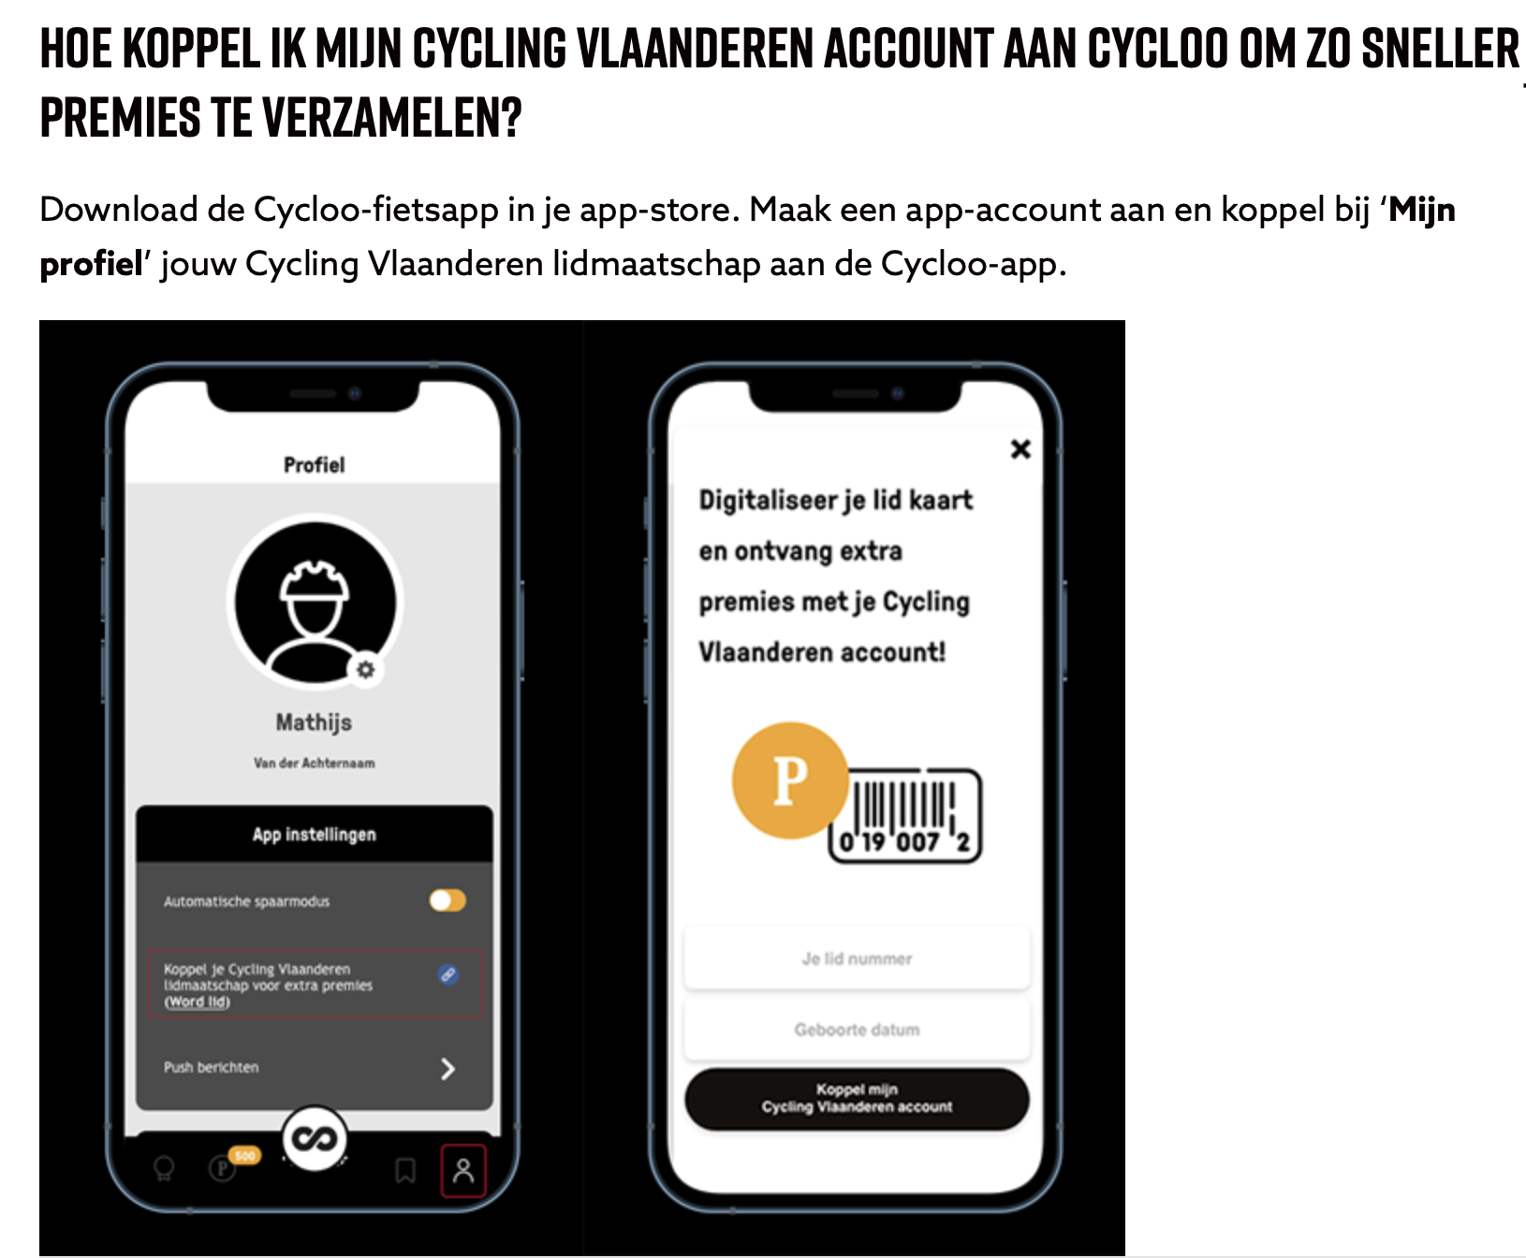

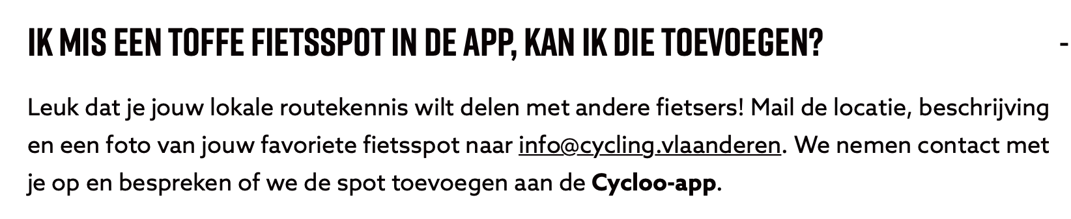

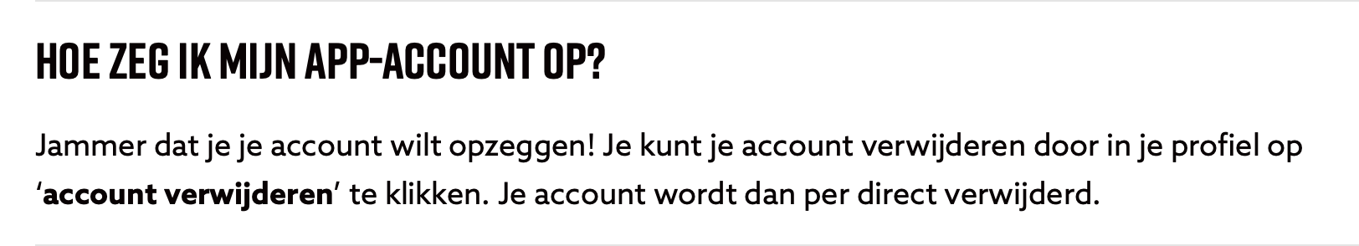

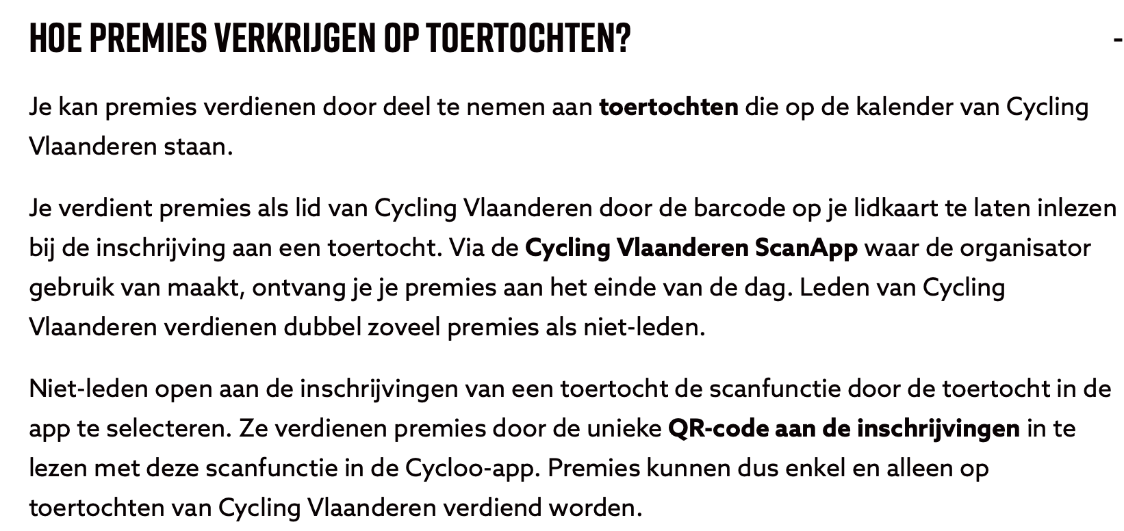

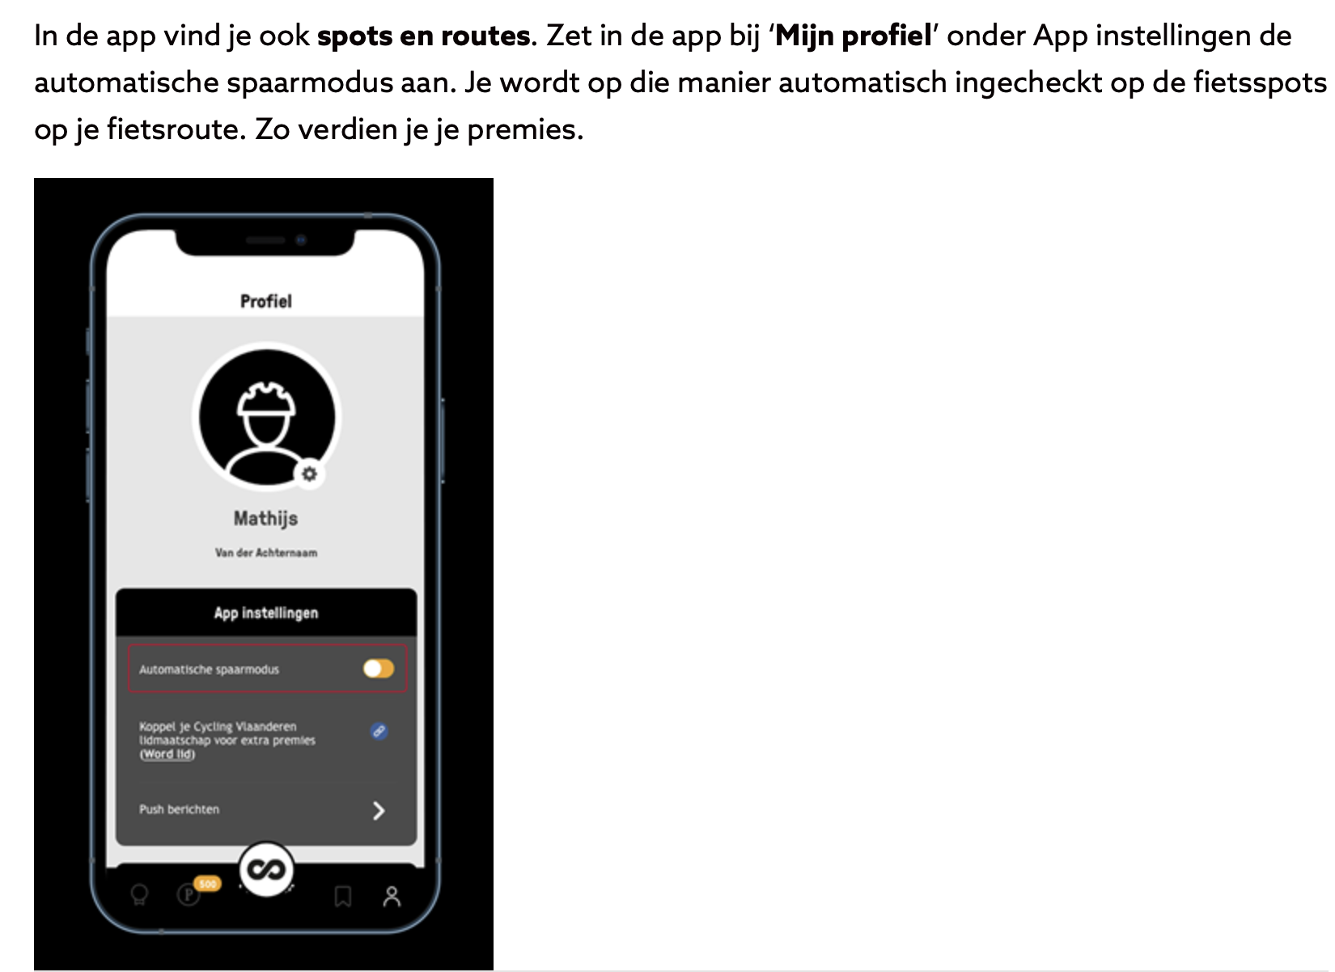

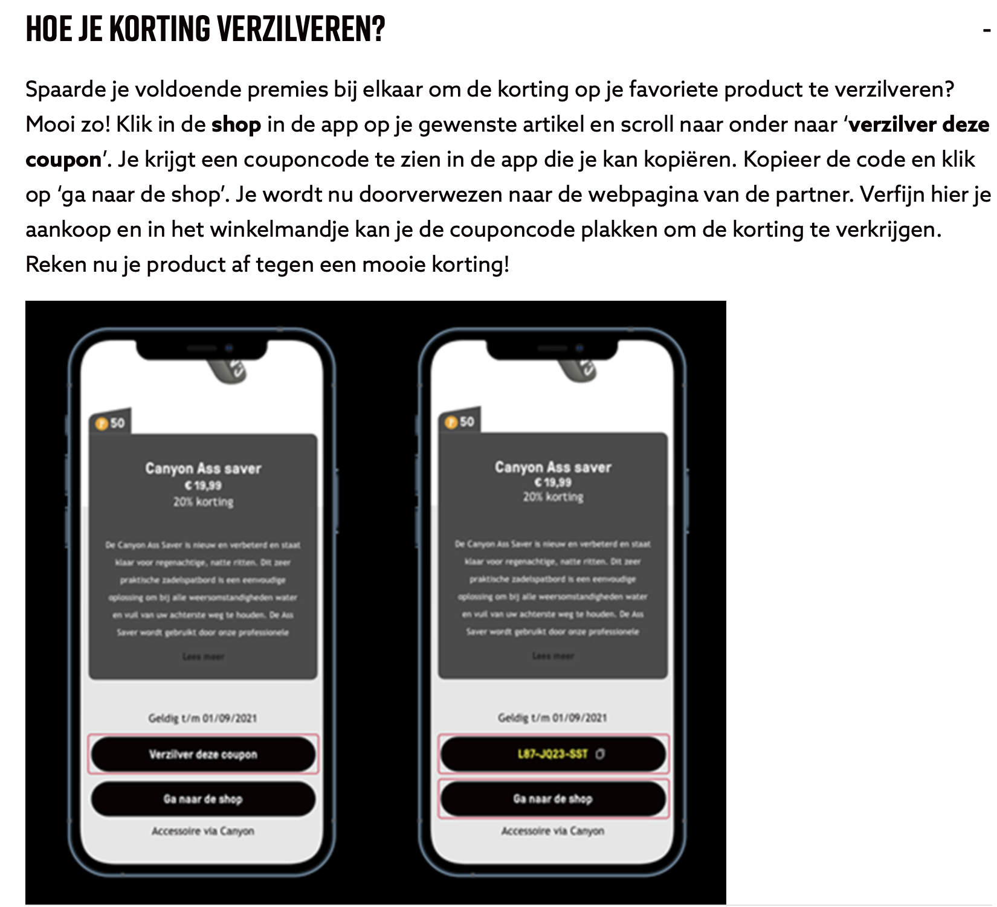

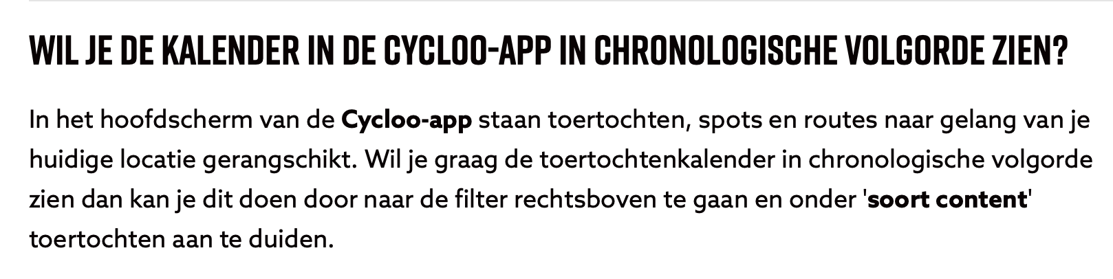

**Mvg, Yvo Rens**