Vixen av Quantos
Part 1.
Story from the first time we meet Edith Zielinski and Heinz Borgards.

Me and Gerd Sørensen, who are the owner of Vixen, were contacted by Edith at the HAS 2013 (Danish Siegerschau). She asked if she can buy Vixen and if she can see here, but Vixen was at the time sick of eating a Maiscorn howl. So she did not come for the show place before Sunday. We said no they cannot buy Vixen, and then she asked if they could lend Vixen to show here in Germany together with Fred v. Rumbachtal up to BSZS 2014. I said to Edith that I must talk to Gerd about that because she would not send her away. After a while we agreed that Edith and Heinz could lend Vixen but there was said many times that we should not pay anything for it. That was all ok for Edith and Heinz, we talked then when she should go for Germany, and we wanted her to be healthy before she goes down there so we kept her with us until January 2014. Because they could not come for the Christmas show in Denmark 2013 26.12.13 with here. We decided to deliver her in New Year show in Holland 2014 04.01.14. Where we also did say many times that this is not about the money, is all for your benefit for Fred. For this we have witness in our handler Morten Snedker Jensen.
In the meantime me and Gerd were in Germany with Edith and Heinz for breeding Vixen`s half-sister Gipsygården`s Diddi with Fred. Fred would not mate her. But that’s another story. Then we asked if Edith and Heinz were interested in breeding Vixen and that they could do that as payment for everything, but then Vixen must have IPO1 and Körung before BSZS 2014, which she did not have. Then they could have one litter with Vixen.
We also made x-ray and DNA with Vixen this trip in Germany.
When we delivered Vixen at New Year show, they said that they could not make IPO1. and Körung with Vixen because they did not have a helper in their Ortsgruppe. And that we must pay for the IPO1. and Körung for Vixen. But then I said I take her home and make it in Denmark when BSZS Is over. So that has always been the meaning when they said that they could not make IPO1.
The only thing we said that Edith and Heinz had to do to lend Vixen was that they have to come to HAS 2014. And that they agreed with, they should show Fred and some other dogs also. Everything else was up to them. And I think that they did a very good job with Vixen, so when I 3 months before BSZS get offered to change the place for Vixen I turned them down. I also said no to every offer of selling her.
The only one who would have had an income (who would profit) of Vixen stay in Germany have to be Edith and Heinz, I believe Fred`s carrier was on the way down before they started to show Vixen In Germany. But after she come to Edith and Heinz his carrier started with a new wind and he get his VA at BSZS in Nurnberg 2014. I don’t think Fred would have got this title without Vixen, but that we never know. I only know she was a big part of it.
Vixen av Quantos
Part 2.
Story from the first time we meet Edith Zielinski and Heinz Borgards.

When we come to BSZS in Nurnberg 2014, we were both (me and Gerd) very nervous and we did not know how it would end with Vixen in the ring Sunday. But we decided to relax and have some good days in Nurnberg with good friends and enjoy all the good GSD that’s there and don’t care how Vixen did in the ring, it was all out of or hands anyway. When Friday come and we were going for the Stand in the ring, we had a lot of waiting. Plenty of people come and take pictures with Vixen. So when the stand was finished we wanted to make a picture with the 3 sisters (Vixen, Vikki and Vantaa v Quantos) at the Ring. We just think how often a small breeder does from Norway/Denmark the chance to take a picture of so many from the same litter at BSZS. But when I said to Heinz Bogards that I want to take this picture, he get really mad and turn around and walk away. To this there where many witness. I then follow him and said loudly to him that this is my female and I really want to take this picture now, I would not get this chance once more in my life. (At least I don’t think so.) Then Heinz turned around and get really mad, but I take my Vixen and go to where the other two were waiting and we take the picture. THAT WAS WHEN THE HELL STARTED… BECAUSE OF ONE PICTURE!!!
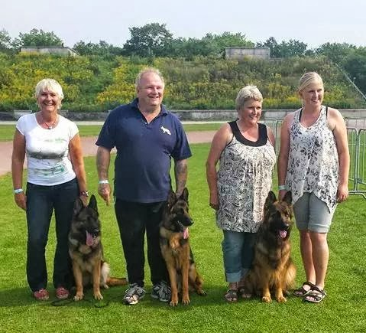

We have not seen Vixen since that..

