NGANDONG MENSEN
The Ngandong hominin skulls are eleven skull caps, remains of human ancestors found in 1931 near the Solo River in Java, Indonesia. They are a part of the human ancestry puzzle because the morphology of the skulls appears to fit both Homo erectus or an archaic form of Homo sapiens.

Dating the Ngandong Hominins

The first dates on the skulls put them at 100,000 years before the present, while Homo sapiens aren't known in this part of the world until about 40,000 years ago and Homo erectus is thought to have died out well before 100,000 years ago. Some researchers believe the skulls represent a small colony of Homo erectus that survived long after the rest had died off.
Recent dates seem to suggest that the skulls are actually between 27,000 and 50,000 years old, which would definitely fit the timing of archaic Homo sapiens more comfortably. However, these dates were taken on faunal remains that other researchers believe are not the same age as the hominins.

Sources

Bartstra, Gert-Jan, Santosa Soegondho, and Albert van der Wijk. 1988. Ngandong man: age and artifacts. Journal of Human Evolution 17:325-337
Grün, Rainer and Alan Thorne. 1997. Dating the Ngandong Humans. Science 276 (5318):1575-1576. (free download)
Swisher III, C. C. et al. 1997. Latest Homo erectus of Java: Potential Contemporaneity with Homo sapiens in Southeast Asia. Science 274(5294):1870-1874. (free download)
This glossary entry is part of the Dictionary of Archaeology. Any mistakes are the responsibility of Kris Hirst.

Also Known As: Solo man

Alternate Spellings: Ngangdong

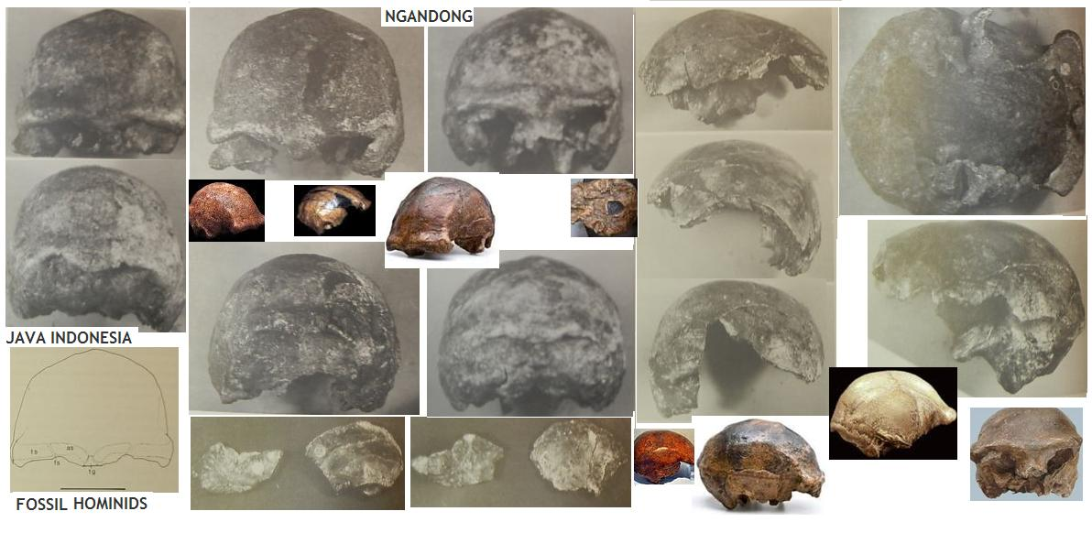
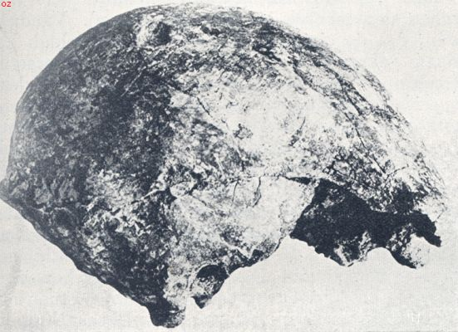 BU362507.jpg
http://www.weekbladbuiten.net/OZfoto2Dasplist.asp?x_Plaats=Ngandong&z_Plaats=LIKE%2C'%25%2C%25'
Ngandong
Indonesië
1936 De schedel van Ngandong van terzijde gezien. Men lette op de torus supra-orbitalis (wenkbbrauwboog-rechel) (Naar Oppenoorth)
http://www.weekbladbuiten.net/OZfoto2Dasplist.asp?x_Plaats=Ngandong&z_Plaats=LIKE%2C'%25%2C%25'
Nederlands indie

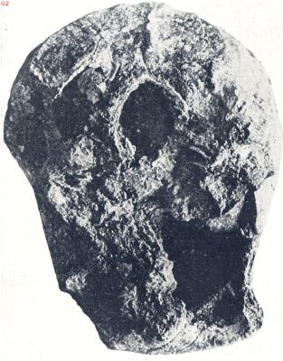

2 / 11 BU362508.jpg http://www.weekbladbuiten.net/OZfoto2Dasplist.asp?x_Plaats=Ngandong&z_Plaats=LIKE%2C'%25%2C%25' Ngandong
Indonesië 1936

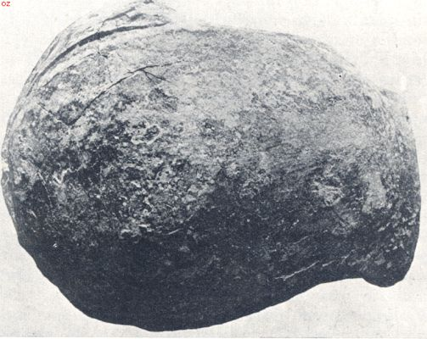

3 / 11

BU362509.jpg
http://www.weekbladbuiten.net/OZfoto2Dasplist.asp?x_Plaats=Ngandong&z_Plaats=LIKE%2C'%25%2C%25'
Ngandong
Indonesië
1936
Schedeldak van den Ngandongmensch van boven bezien. Let op de postorbitale insnoering (insn. Boven achter de oogholten) (N. Oppenoorth)

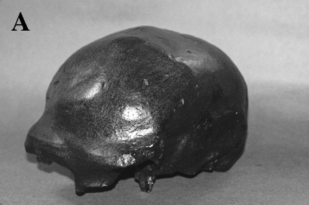

5 / 11

Ngandong
http://genome.cshlp.org/content/8/4/339.full
Fossil modern hominid skulls from Australia and Africa, compared with the H. erectus Ngangdong skull from Java. (A) Cast of Ngangdong, (
(A) R. Foley; (http://www.une.edu.au/~Arch/PalaeoIndes.html/.

- Homo Erectus

More on Ngandong Hominins

- Ngandong (Genome research)
- Ngangong (Rainer & Thorne)
- Ngangdong Fossil Hominids (A.P. Santa Luca)
Related Articles

- Homo Erectus Colonization in Europe - Pakefield Homo erectus in England
- Further Fossil Finds of Flores Man, Indonesia: Nine More of the Hobbit'...
- Peking Man - Homo erectus specimen called Peking Man
- What is a Caucasoid - Kennewick Man Part 2 - What is a Caucasoid
- Weird Skeletons in Mankind's Closet

Related Glossary Entries

- Homo
- Hominid
- Hominin

More on Human Origins

- Human Origins

http://archaeology.about.com/library/glossary/bldef_homo.htm

AUSTRALIE / ARCHAIC HOMO AFRICA
MUNGO MENS

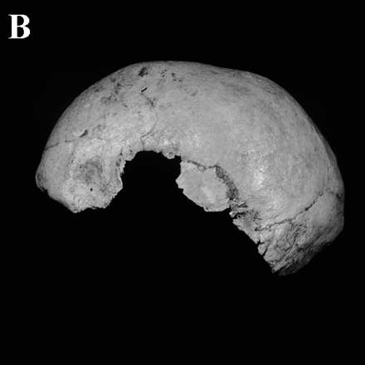

6 / 11

Lake Mungo 3
http://genome.cshlp.org/content/8/4/339.full
Fossil modern hominid skulls from Australia and Africa, compared with the H. erectus Ngangdong skull from Java. Photograph credits: (A) R. Foley; (B–E) kindly supplied by Peter Brown (University of New England, Armidale, NSW, Australia); (F,G) kindly supplied by Chris Stringer (Natural History Museum, London, UK). For further information about the fossil Australian hominids, see Peter Brown’s Web page at
http://www.une.edu.au/~Arch/PalaeoIndes.html/.
http://www.convictcreations.com/aborigines/prehistory.htm

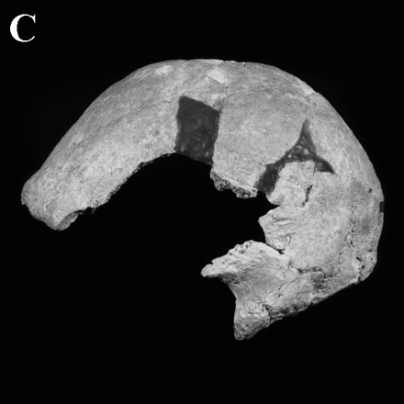 Willandra Lakes 50 (WLH-50,

Fossil modern hominid skulls from Australia and Africa, compared with the H. erectus Ngangdong skull from Java. Photograph credits: (B–E) kindly supplied by Peter Brown (University of New England, Armidale, NSW, Australia); http://www.une.edu.au/~Arch/PalaeoIndes.html/.
http://genome.cshlp.org/content/8/4/339.full

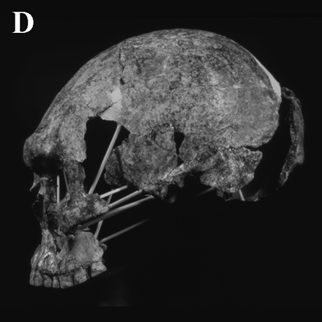

8 / 11

Kow Swamp
Fossil modern hominid skulls from Australia and Africa, compared with the H. erectus Ngangdong skull from Java. (A) Cast of Ngangdong, (B) Lake Mungo 3 (Australia); (C) Willandra Lakes 50 (WLH-50, Australia); (D) Kow Swamp (Australia): (E) Keilor (Australia); (F) Ngaloba (African transitional); (G) Omo Kibish (early modern African). Photograph credits: (A) R. Foley; (B–E) kindly supplied by Peter Brown (University of New England, Armidale, NSW, Australia); (F,G) kindly supplied by Chris Stringer (Natural History Museum, London, UK). For further information about the fossil Australian hominids, see Peter Brown’s Web page at
http://www.une.edu.au/~Arch/PalaeoIndes.html/.
http://genome.cshlp.org/content/8/4/339.full

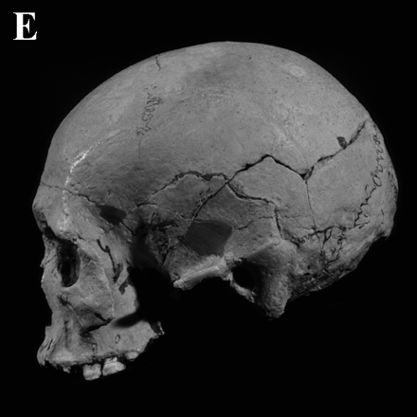

9 / 11

Keilor
Fossil modern hominid skulls from Australia and Africa, compared with the H. erectus Ngangdong skull from Java.(B–E) kindly supplied by Peter Brown (University of New England, Armidale, NSW, Australia); http://www.une.edu.au/~Arch/PalaeoIndes.html/.
http://genome.cshlp.org/content/8/4/339.full
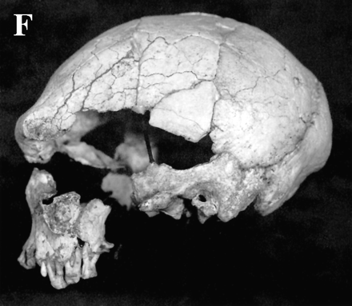

10 / 11

Ngaloba (African transitional);
Fossil modern hominid skulls from Australia and Africa, compared with the H. erectus Ngangdong skull from Java.
Ngaloba (African transitional); (F,G) kindly supplied by Chris Stringer (Natural History Museum, London, UK). For further information about the fossil Australian hominids, see Peter Brown’s Web page at
http://www.une.edu.au/~Arch/PalaeoIndes.html/.
http://genome.cshlp.org/content/8/4/339.full

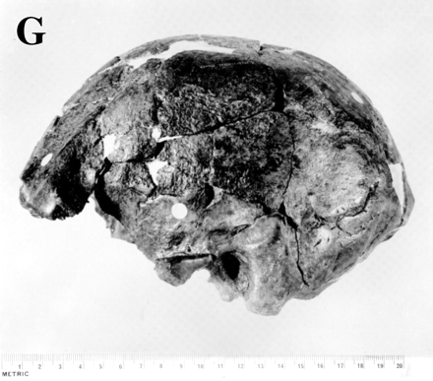

11 / 11

(G) Omo Kibish (early modern African).
Fossil modern hominid skulls from Australia and Africa, compared with the H. erectus Ngangdong skull from Java.
Omo Kibish (early modern African). Photograph credits: (A) R. Foley; (F,G) kindly supplied by Chris Stringer (Natural History Museum, London, UK). For further information about the fossil Australian hominids, see Peter Brown’s Web page at
http://www.une.edu.au/~Arch/PalaeoIndes.html/.
http://genome.cshlp.org/content/8/4/339.full

