FAQ

..\..\..\..\Astronomy

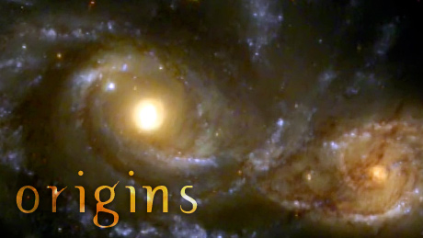

Has the universe always existed? How did it become a place that could harbor life? What was the birth of our planet like? Are we alone, or are there alien worlds waiting to be discovered?
More

http://www.pbs.org/wgbh/nova/space/origins-series-overview.html

Related Links

Life's Little Essential
Everybody knows that water is necessary for life, at least as we know it. But just why exactly?

A Conversation With Neil Tyson
Hear from the host of “Origins” on hot discoveries in origins research, his advice for budding scientists, and more.
- 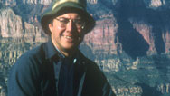

How Did Life Begin?
Harvard's Andrew Knoll discusses the deeply mysterious jump long ago from non-living to living.

Does Mars Have Life?
NASA's Christopher McKay thinks the Red Planet once had living things and maybe, just maybe, still does.
- 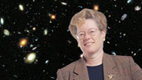

Who Needs Galaxies?
Astronomer Sandra Faber explains how galaxies brew the ingredients for life.
- 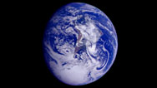

Are We Alone in the Universe?
How common is intelligent life in the cosmos? Neil deGrasse Tyson and Peter Ward take opposite sides of the debate.
- 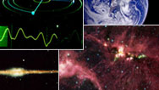

The Drake Equation
Try your hand at calculating how many intelligent, communicating civilizations might be in our galaxy.
- 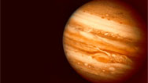

Decoding Cosmic Spectra
Play astronomer and analyze the spectral fingerprints of a planet, star, galaxy, and nebula.
- 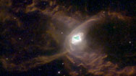

History of the Universe
Explore, in brief, the evolution of the universe—from the Big Bang to the distant future.
- 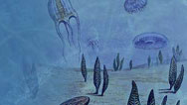

A Brief History of Life
An overview of the history of life on Earth, from the earliest bacteria to the first modern humans
- 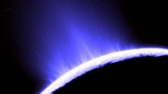

Will We Ever Find ET?
What are the odds that smart aliens exist in the universe?
- 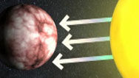

Detecting Life Beyond Earth
In this video and quiz, see how scientists sniff out signs of life on distant planets, then try it yourself.
- 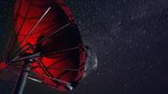

SETI: The Search for ET
Astronomers have their radio telescopes tuned to receive signals from alien worlds. But is anybody out there?
- 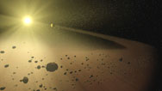

Origins of the Solar System
The shock wave from a supernova may have triggered the formation of our sun and planets five billion years ago.

Revealing the Origins of Life
How did molecules first make the leap from non-living to living? An English chemist may have solved part of the mystery.

Ouderdom universum ?
An Ancient Universe: How Astronomers Know the Vast Scale of Cosmic Time
http://education.aas.org/publications/AncientUniverseWeb.pdf

IS ONS UNIVERSUM UNIEK? Mogelijk is ons universum slechts een van de vele universums in een multiversum.
Er bestaan oneindig veel universums, elk met hun eigen realiteit, hun eigen tijd, hun eigen toestand. Zij zouden op hun beurt onderdeel kunnen zijn van een omniversum.
Volgens sommige kwantumtheoretici en kosmologen wordt bij iedere observatie van een gebeurtenis in de kwantumwereld elke mogelijk uitkomst verwerkelijkt in een nieuw parallel universum. Samen vormen ze een multiversum.
Tegenwoordig zijn de meeste wetenschappers het eens over de noodzaak van een multiversum om te komen tot een allesomvattend beeld van het universum.
Hoeveel parallelle universums er zijn, weet alleen Boeddha.

WAAROM VERSCHILT TIJD VAN DE ANDERE DIMENSIES?
Na duizenden jaren prakkiseren weten wetenschappers dat tijd een dimensie is. Samen met de ruimtedimensies lengte, breedte en diepte vormt ze een van de elf vermoedelijke dimensies. De andere zeven dimensies zijn niet door mensen waar te nemen omdat ze opgerold zouden zitten in de kleinste deeltjes materie.
De dimensies tijd en ruimte zijn onlosmakelijk met elkaar verbonden.
Het begrip dat daarvoor gebruikt wordt is tijdruimte of ruimte-tijd.
Wiskundig is dat allemaal erg zinvol, maar de vraag is waarom we überhaupt een ‘nu’ waarnemen.En waarom tijd zich lijkt te bewegen zoals wij dat aanvoelen.

HOE ONTSTAAN PLANETEN?
Het is nog steeds niet duidelijk hoe stukken stof, ijs en gaswolken samenklitten tot planeten, zonder dat ze door de zon in stukken worden gereten. Hopelijk kan de planetenvorming rond andere sterren de volgende decennia opheldering brengen. Volgens de meest gangbare theorie ontstaan planeten uit protoplanetaire schijven (proplyds in vakjargon) via blootstelling aan een extreme hoeveelheid ultraviolette straling van naburige sterren.
Het grootste deel van een dergelijke schijf klontert in het centrum samen tot een ster. Het overige gas en stof vormt zich langzaam tot planeto챦den die later uitgroeien tot planeten. Massieve zonnevlammen zouden de jonge planeten ver genoeg van de vraatzuchtige zon houden.

http://www.corante.com/loom/archives/2005/07/01/it_never_hurts_to_ask.php http://www.sciencemag.org/sciext/125th/
THE QUESTIONS
The Top 25
Essays by our news staff on 25 big questions facing science over the next quarter-century.
> | What Is the Universe Made Of?
> | What is the Biological Basis of Consciousness?
> | Why Do Humans Have So Few Genes?
> | To What Extent Are Genetic Variation and Personal Health Linked?
> | Can the Laws of Physics Be Unified?
> | How Much Can Human Life Span Be Extended?
> | What Controls Organ Regeneration?
> | How Can a Skin Cell Become a Nerve Cell?
> | How Does a Single Somatic Cell Become a Whole Plant?
> | How Does Earth's Interior Work?
> | Are We Alone in the Universe?
> | How and Where Did Life on Earth Arise?
> | What Determines Species Diversity?
> | What Genetic Changes Made Us Uniquely Human?
> | How Are Memories Stored and Retrieved?
> | How Did Cooperative Behavior Evolve?
> | How Will Big Pictures Emerge from a Sea of Biological Data?
> | How Far Can We Push Chemical Self-Assembly?
> | What Are the Limits of Conventional Computing?
> | Can We Selectively Shut Off Immune Responses?
> | Do Deeper Principles Underlie Quantum Uncertainty and Nonlocality?
> | Is an Effective HIV Vaccine Feasible?
> | How Hot Will the Greenhouse World Be?
> | What Can Replace Cheap Oil -- and When?
> | Will Malthus Continue to Be Wrong?

Frequently Asked Questions in Cosmology
Tutorial : Part 1 | Part 2 | Part 3 | Part 4 | Age | Distances | Bibliography | Relativity
- What is the evidence for the Big Bang?
- What happened during the Big Bang?
- What is this "anti-gravity"? [The cosmological constant]
- Why do we think that the expansion of the Universe is accelerating?
- What is quintessence?
- How old is the Universe?
- If the Universe is only 10 billion years old, why isn't the most distant object we can see 5 billion light years away?
- If the Universe is only 10 billion years old, how can we see objects that are now 30 billion light years away?
- Is the Universe really infinite or just really big?
- How can the Universe be infinite if it was all concentrated into a point at the Big Bang?
- How can the oldest stars in the Universe be older than the Universe?
- Can objects move away from us faster than the speed of light?
- What is the redshift?
- Are quasars really at the large distances indicated by their redshifts?
- What about objects with discordant redshifts, like Stephan's Quintet?
- Has the time dilation of distant source light curves predicted by the Big Bang been observed?
- Are galaxies really moving away from us or is space just expanding?
- Why doesn't the Solar System expand if the whole Universe is expanding?
- Is the Universe expanding or is it just that our definitions of length and time are changing?
- Why haven't the CMBR photons outrun the galaxies in the Big Bang?
- Where was the center of the Big Bang?
- What is meant by a flat Universe?
- Is the Big Bang a Black Hole?
- What is the Universe expanding into?
- What came before the Big Bang?
- Doug Scott's Cosmic Microwave Background Radiation (CMBR) FAQ
- Can the CMBR be redshifted starlight?
- Why is the sky dark at night?
- Will the Universe expand forever or recollapse?
- Does entropy prevent a Big Crunch?
- What about the oscillating Universe?
- What is the dark matter?
- What is the value of the Hubble constant?
- What can a layperson do in cosmology?
- Ask your own question!

http://www.astro.ucla.edu/~wright/cosmology_faq.html

