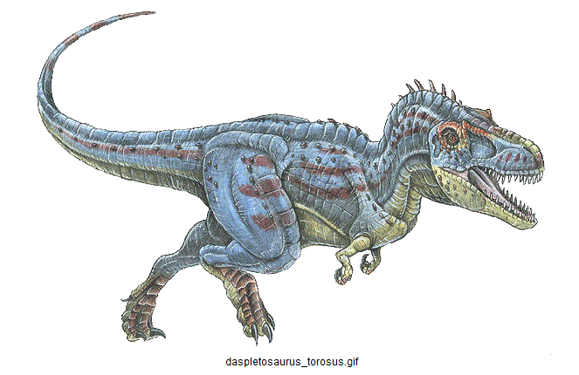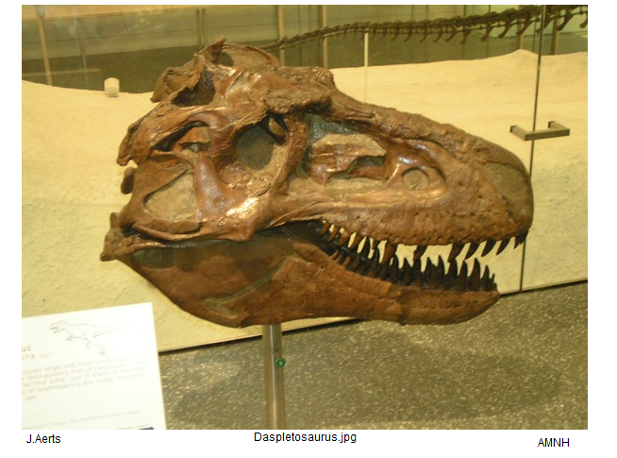
http://www.dinosaurus.net/pics/NewYork/Daspletosaurus.jpg
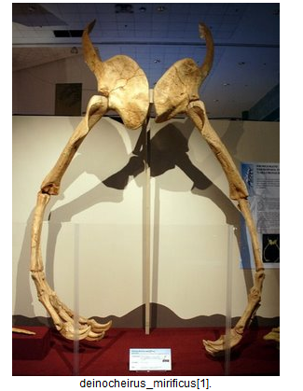
http://ombdinotopia.proboards.com/index.cgi?board=dinotopia&action=display&thread=360&page=5
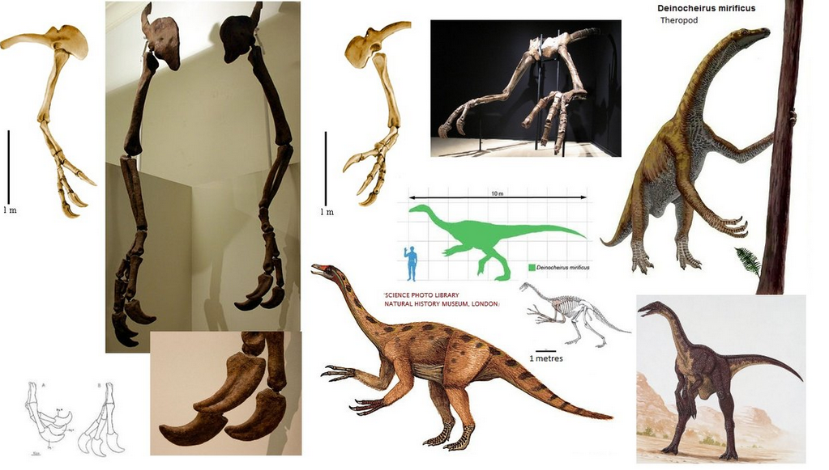

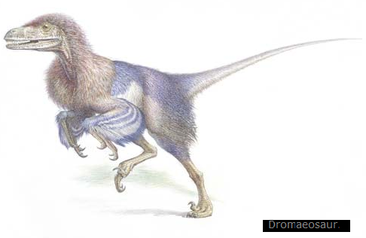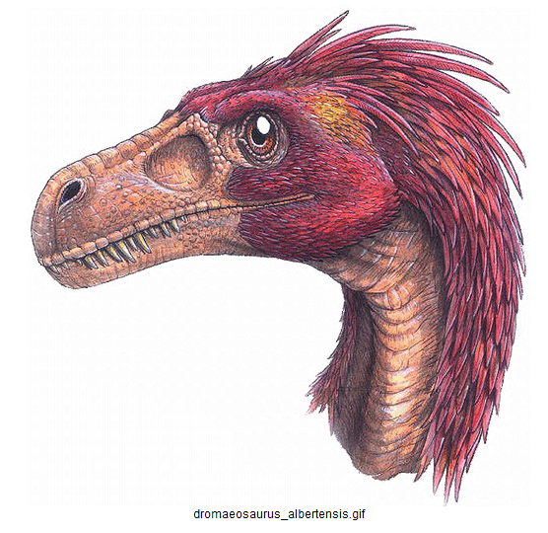

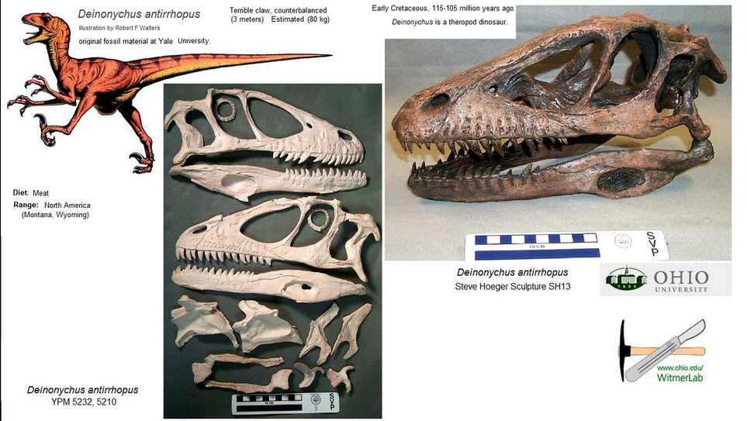

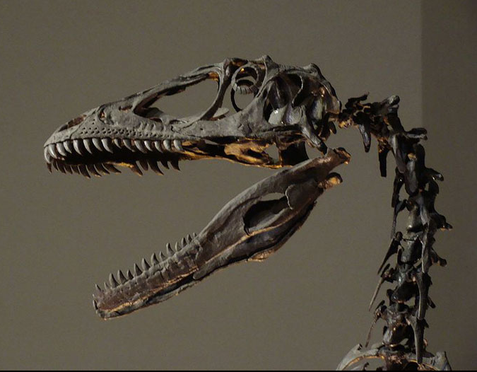
Skull and spine of Deinonychus skeleton, the photo was taken at the Philadelphia Academy of Natural Sciences.
Deinonychus was related to the Velociraptor and lived during the early Cretaceous Period (around 110 million years ago).
The first Deinonychus fossils were found in 1931 in southern Montana but it wasn’t until 1969 that studies were published
and it was officially named. Other Deinonychus fossils have since been found in Oklahoma and other parts of North America.
Deinonychus reached around 3.4 metres (11 feet) in length and 73 kg (170 lb) in weight.
Deinonychus had around 60 teeth and studies suggest that it had about the same bite force as an alligator.
Studies of the Deinonychus helped lead to the widely accepted theory that birds descended from dinosaurs.
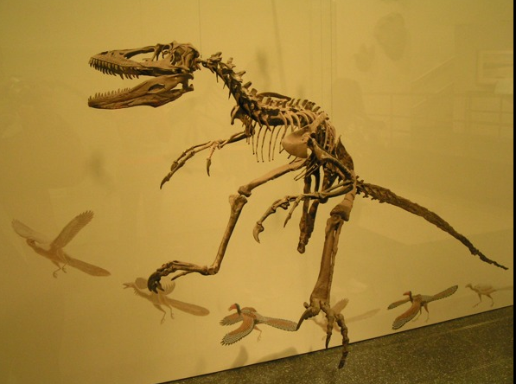
AMNH J. Aerts http://www.dinosaurus.net/pics/NewYork/Deinonychus.jpg
Het ( tot nu toe ) enige "echte "deinonychus fossil
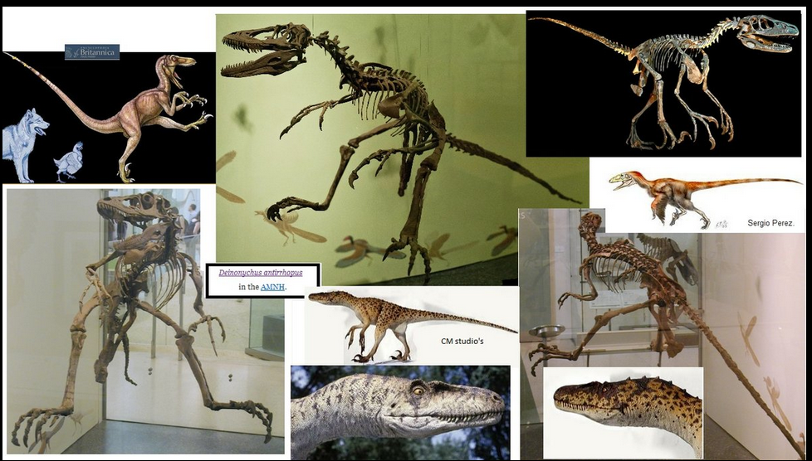
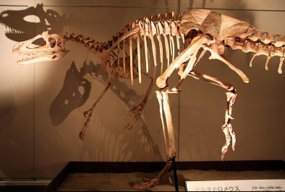 Deltadromeus agilis. Not the biggest predator but certainly very fast and able to chase down whatever it wanted to, and long arms to grab its prey.

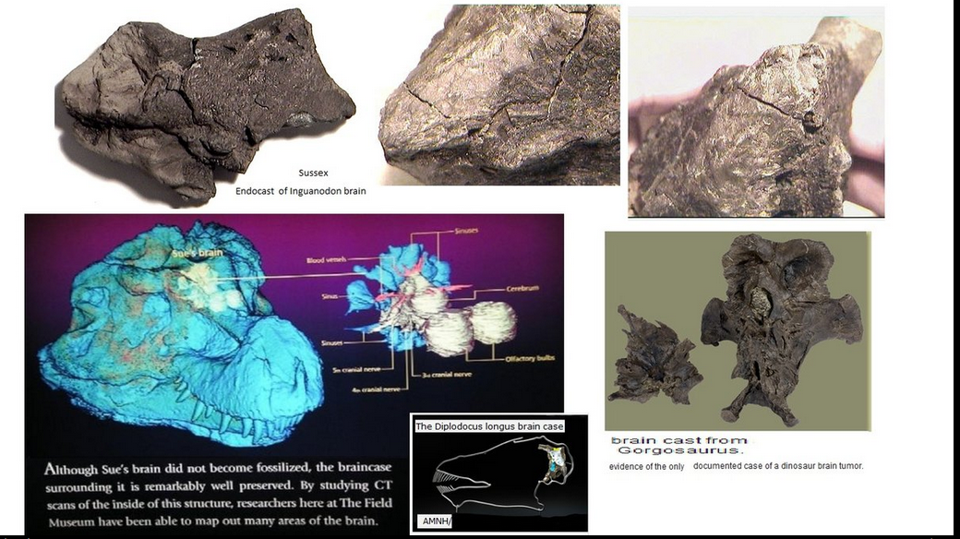
DINOBRAINS

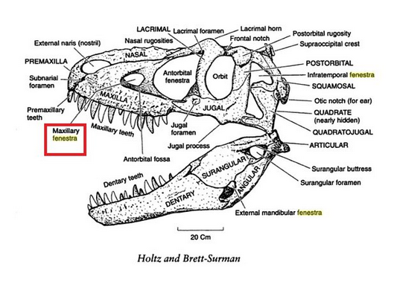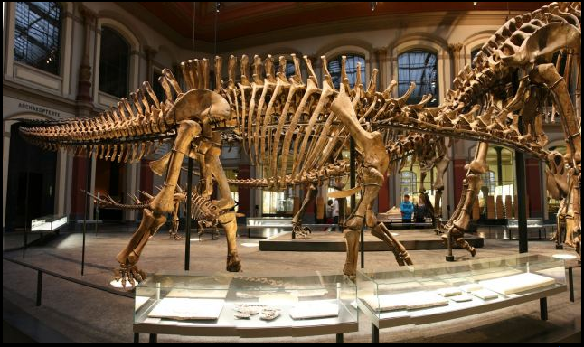
MNF Berlin : the right side of Dicraeosaurus hansemanni

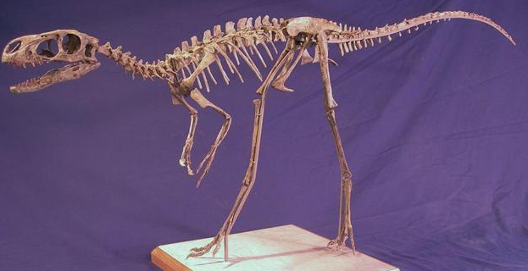
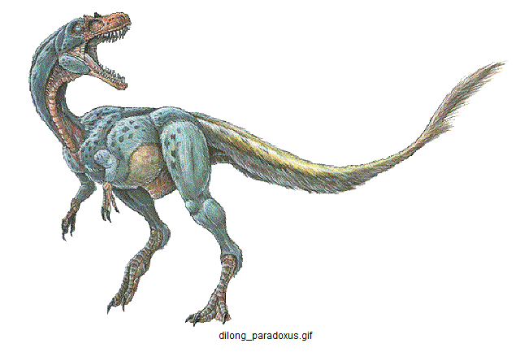

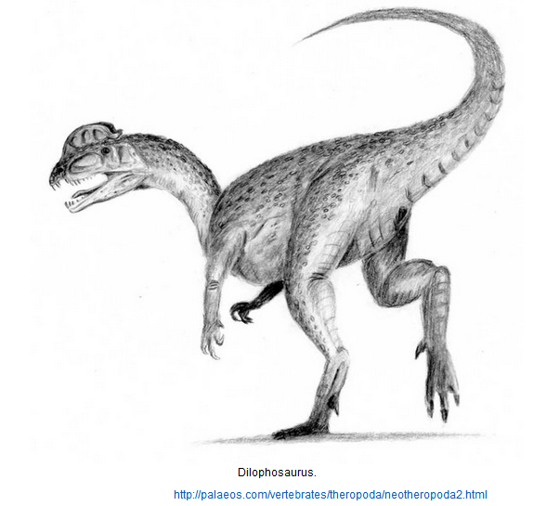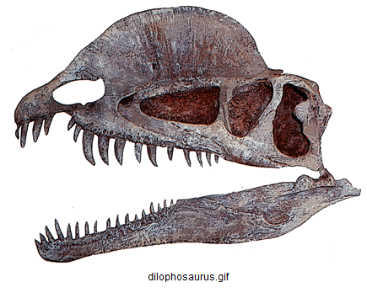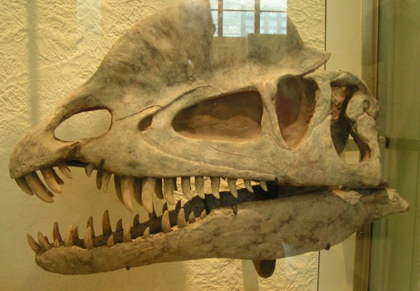

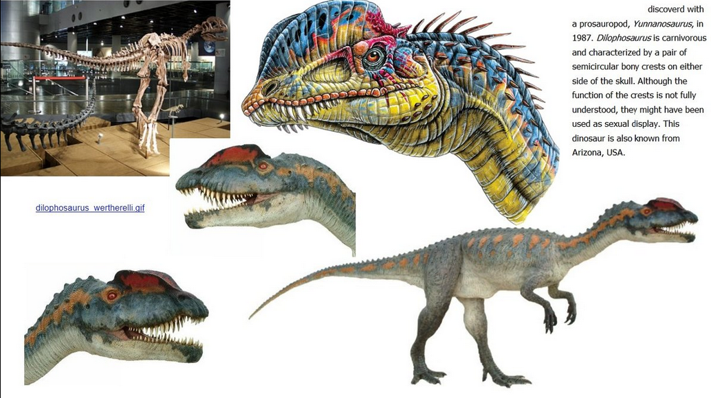

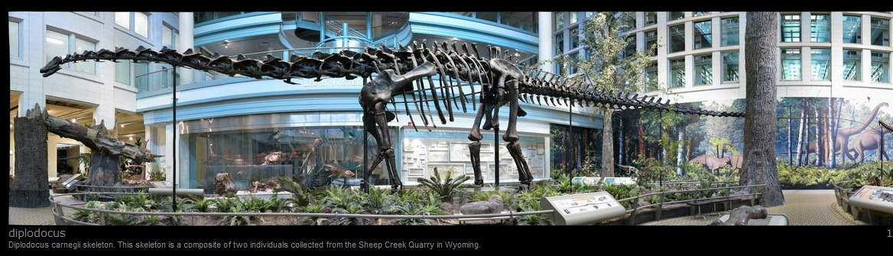

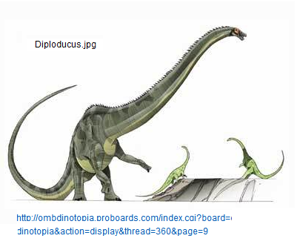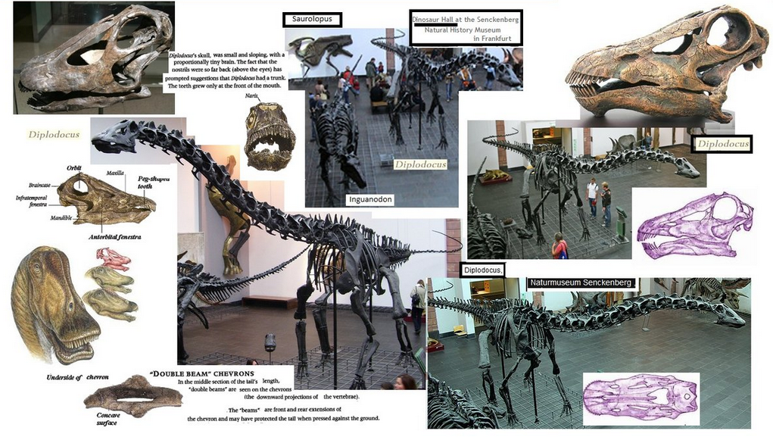
Senckenberg biplodocus

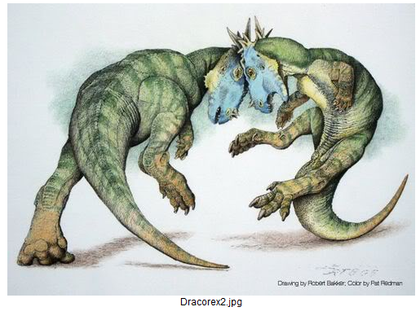
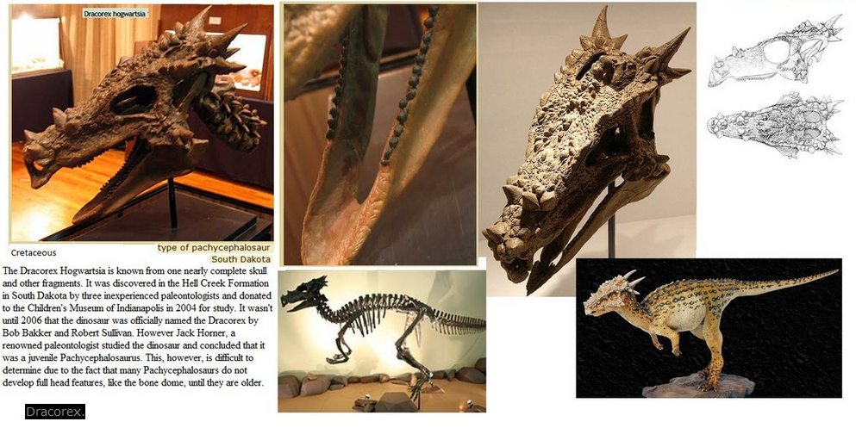

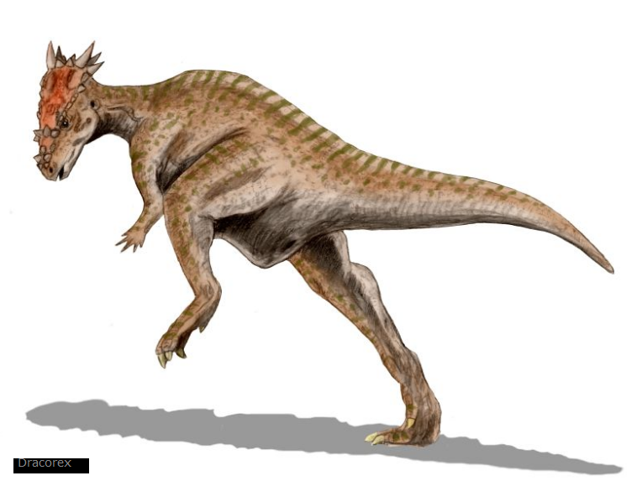

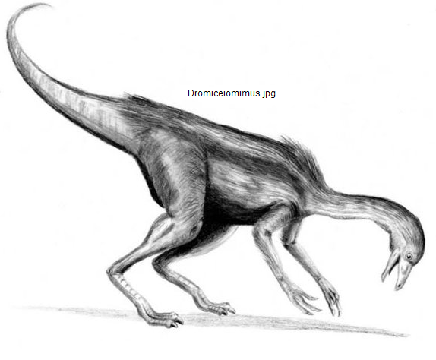
http://ombdinotopia.proboards.com/index.cgi?board=dinotopia&action=display&thread=360&page=11

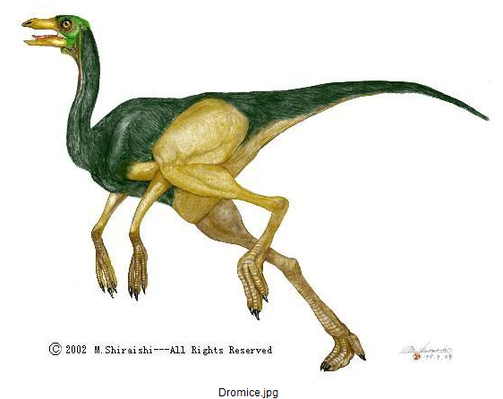

http://ombdinotopia.proboards.com/index.cgi?board=dinotopia&action=display&thread=360&page=5

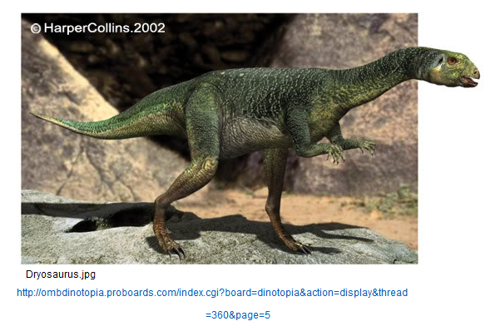

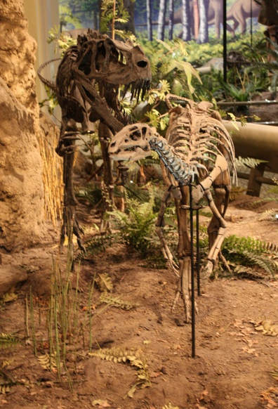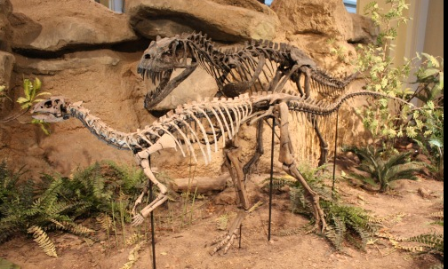
ceratosaurus & dryosaurus http://archosaurmusings.wordpress.com/2012/01/10/ceratosaurus-and-dryosaurus/

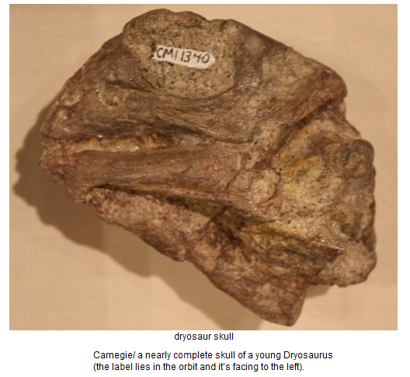

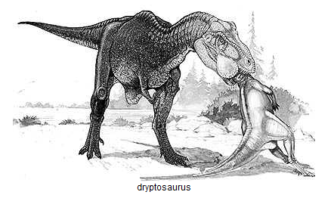

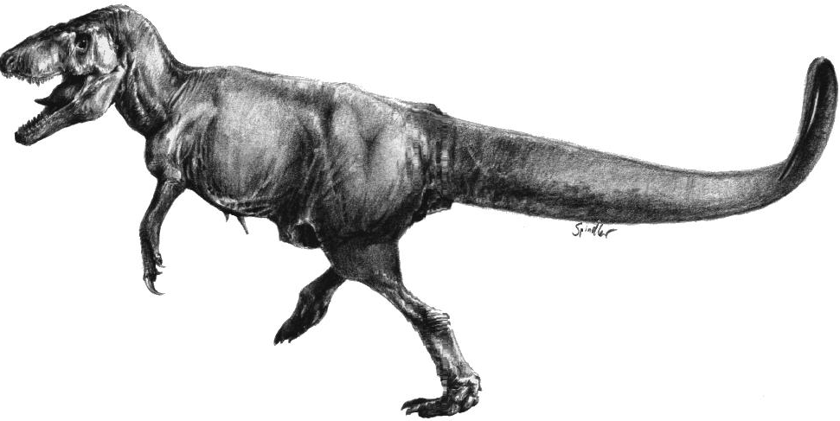

dryptosaurus.jpg
http://ombdinotopia.proboards.com/index.cgi?board=dinotopia&action=display&thread=360&page=11

